PHYLUM CHORDATA  SUBPHYLUM VERTEBRATA  CLASS AGNATHA  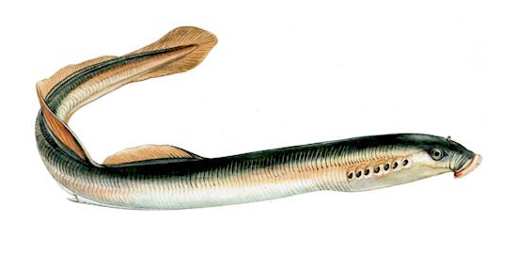 | - Jawless  - Circular Mouth  - Creates Slime Layer for Protection
PHYLUM CHORDATA  SUBPHYLUM VERTEBRATA  CLASS CONDRICHTHYES  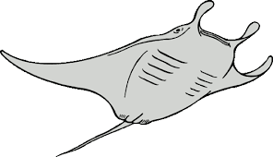 | - Skeleton Made of Cartilage  - Paired Fins  - Scales
PHYLUM CHORDATA  SUBPHYLUM VERTEBRATA  CLASS OSTEICHTHYES  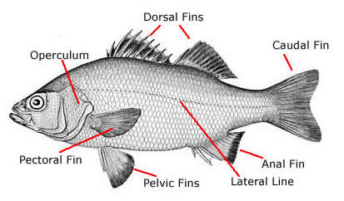 | - Majority of Fish  - Skeleton Made of Bone  - Scales  - Swim Bladder to help them float in the water
PHYLUM CHORDATA  SUBPHYLUM VERTEBRATA  CLASS AMPHIBIA  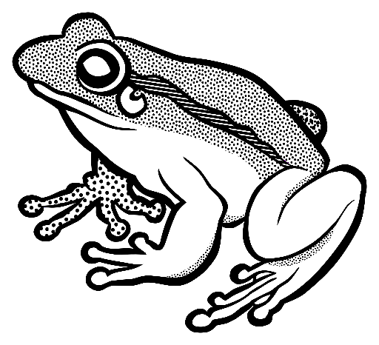 | - Live a Double Life  - Live on Land but Return to Water to Reproduce  - Moist Skin  - No Claws  - Ectothermic
PHYLUM CHORDATA  SUBPHYLUM VERTEBRATA  CLASS REPTILIA  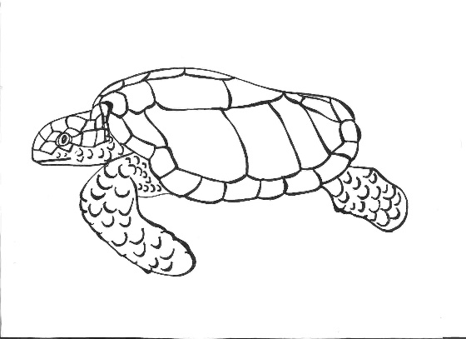 | - First to Produce Amniotic Eggs with Shells  - Has Scales and Claws  - Internal Fertilization  - Dry Skin  - Ectothermic
PHYLUM CHORDATA  SUBPHYLUM VERTEBRATA  CLASS AVES  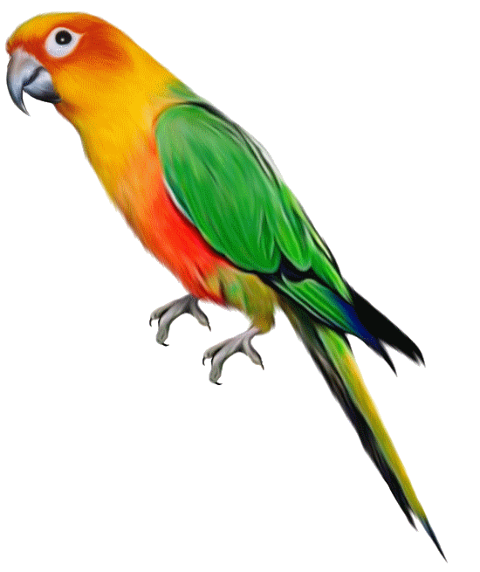 | - Feathers – Believed to Be Modified Scales  - Hollow Bones for Flight  - Amniotic Egg  - Endothermic
PHYLUM CHORDATA  SUBPHYLUM VERTEBRATA  CLASS MAMMALIA  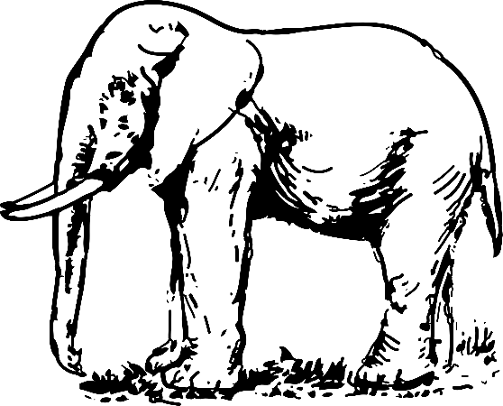 | - Hair or Fur for Insulation  - Internal Development of Young  - Mammary Glands to Nurse Young  - Endothermic

