The Cell Membrane
- Plasma membrane is the boundary that separates cells from their environment. Its function is to regulate what enters and leaves the cell.
- The plasma membrane displays a property known as ___________________ permeability.
- Selective permeability means that only __________ substances are allowed to pass through the membrane.
- It is selective for what that particular cell needs and its permeability may change.

Model of the Plasma Membrane- Phospholipids
- When viewed under a microscope the plasma membrane looks like two thin lines, and is the Lipid ______________________.
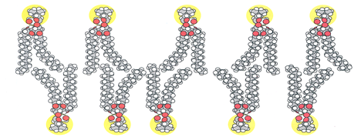
- The Lipid Bilayer is composed of two layers of phospholipids.
- In a ___________________, one fatty acid chain is replaced with a phosphate group.
- Phosphate groups are soluble in water. This determines the arrangement of phospholipids.
- The phosphate heads are ___________________ (“love water”) and point toward the ________ of the cell and the fatty acid tails are ___________________ (“fear water”) and point towards the ___________ of the membrane.
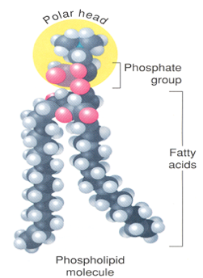
- Phospholipids are motile and move along the membrane (float around).
- In many cells, rigid molecules of cholesterol are embedded in the bilayer.
- ___________________ restricts much of the movement of phospholipids, and adds strength and flexibility to the membrane.

- Model of the Plasma Membrane- Proteins
- Proteins are scattered throughout the lipid bilayer.
- Some are embedded, called ___________________ proteins and others are on the surface, called ___________________ proteins.
- Proteins have polar and nonpolar regions that determine their position in the membrane, and are capable of motility in the membrane.
- The pattern of proteins in the membrane and the ability of proteins and phospholipids to move in the membrane give rise to what is called the __________ ___________________ Model.
- Label the parts of the Cell Membrane. Identify the polar and nonpolar regions on the cell membrane.
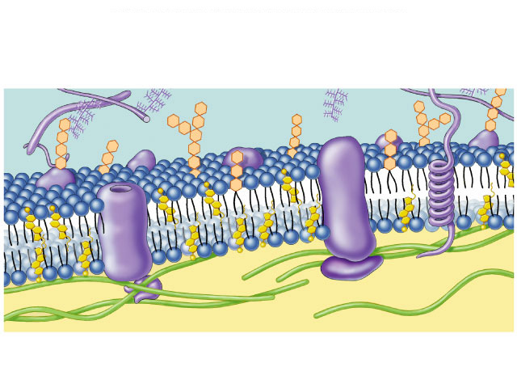

- The proteins __________ which particles pass across the membrane, can act as __________ (chemical reactions) and serve as ____________ (possibly for fighting disease or so the cell can be recognized).
Model of the Plasma Membrane- Other membrane bound organelles
- Other Organelles: enclosed in membranes display the fluid mosaic patterns.
- Their membranes are also selectively permeable to the substances that that organelle needs for its specific reactions.

Function of the Cell Membrane
- Remember that the cell membrane is selectively permeable and regulates what enters and leaves the cell.
- Random movement/___________________ Movement is unorganized (no patterns) movement of substances due to the collisions of particles which results in the even distribution of molecules.

Movement of Materials Across the Cell Membrane- Passive Transport

Passive Transport- Diffusion
- Diffusion of Particles - particles moving from an area of greater (________) concentration to an area of lesser (__________) concentration. No Energy Required!
- Example: __________________________
- The diffusion of particles continues to occur until the particles of solute become evenly distributed, at this point the ___________________ ___________________ is reached.
- Dynamic Equilibrium is the ________________ movement of particles but no overall change.
- The particles are still evenly distributed.
- Particles may diffuse through air, __________, other fluids and across membranes.
- Diffusion Through Membranes - explains the physical process by which some particles enter and leave the membrane.
- ____________ and materials dissolved in lipids can cross through the membrane. Why?
- ___________ (O₂) and _____________ (CO₂) can ________ right through the cell membrane because they are ______________.
- _________ (H₂O), _______ and other molecules must ______ through ____________ in the cell membrane.
- If there is a _______ concentration of particles ________ the cell than _______ the cell, the particles will pass through the membrane and _________ the cell.
- The particles will move ______ of the cell if there is a _________ concentration on the _______ of the cell than on the outside of the cell.
- ___________________ ___________________ is the difference in concentration of molecules from highest to lowest number of molecules.
- The concentration gradient is also the difference in concentrations from inside the cell as compared to outside the cell.
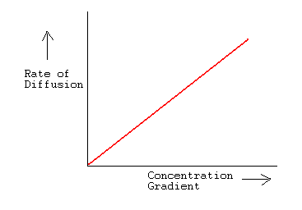
Passive Transport- Osmosis
- ___________________ is the (facilitated) ___________ of water into and out of the cell.
- For any cell to survive it must be in _____________________ with its water environment.
- Osmotic balance occurs when the movement of water _____ and _____ of a cell is equal (dynamic equilibrium occurs).
Can you explain what is going on in the diagram?

Osmotic Balance in solution and the responses of Plant and Animal Cells.
- Three types of solutions: ISOTONIC, HYPOTONIC, HYPERTONIC
- ___________________ (iso=same) equal concentrations of pure water inside and outside the cell, therefore, ___ ________ movement in water.
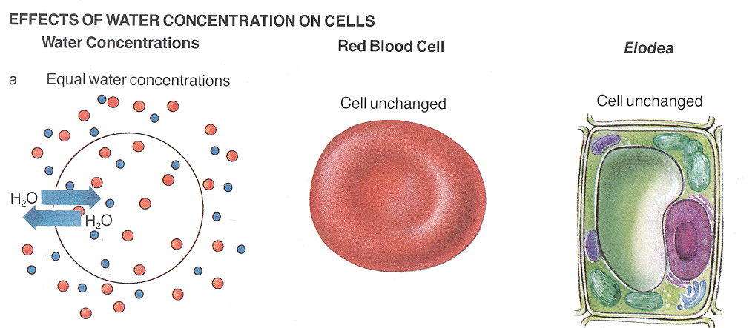
- ___________________ (hypo=under) greater concentrations of pure water outside the cell than inside, thus water will flow into the cell from a greater concentration to a lesser concentration to reach equilibrium. If the water is not removed, the animal cell may burst, while the plant cell swells to the limits of the cell wall (___________________ ___________________). This is why a plant that has been watered “stands” up and one that hasn’t been watered wilts.
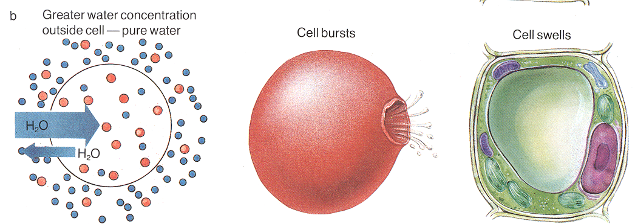
- ___________________ (hyper=above) greater concentrations of pure water inside the cell than outside, thus the cells shrink as water flows out of the cell to reach equilibrium. In plants this is called ___________________.
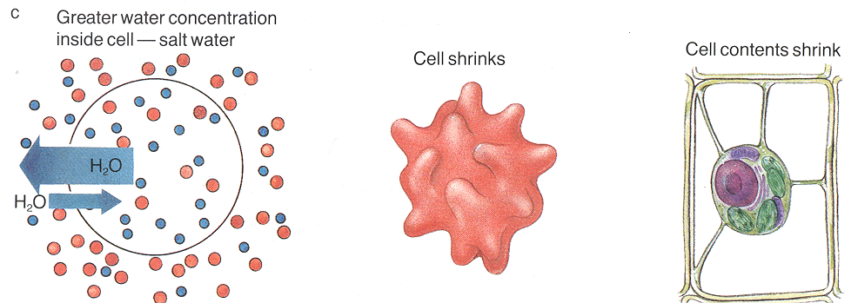
- The cell plays no active role and does no work in moving water, lipids, and lipid-soluble particles across the membrane.
- The passage of water, lipids and lipid-soluble particles across the membrane is due to their net movement from greater to lesser concentrations, this type of movement is called ___________________ Transport.
- In Passive transport the cell uses ____ energy to move particles across the membrane.

PRACTICE
1- Inside one osmosis bag, A, is a 50% glucose solution and inside bag B is a 20% glucose solution. Both bags are put into beakers containing 100% water.
A) Bag A will gain weight. D) Both bags will loose weight
B) Bag B will gain weight. E) Both bags will remain the same.
C) Both bags will gain weight.

2- A 0.9% NaCl solution is isotonic to red blood cells. Which of these describes the results if red blood cells are placed into a 9.0% solution of NaCl?
A) They will lyse. C) Nothing will happen.
B) They will shrivel. D) They will become flaccid.

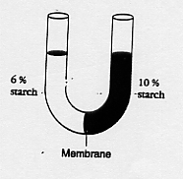
3- The U-shaped tube in the figure below is divided by a membrane that is impermeable to starch but permeable to water. Which of the following will occur?
A) Water will move from the right to the left.
B) Water will move from the left to the right.
C) Starch will move from the right to the left.
D) Starch will move from the left to the right.
E) Nothing will happen. The membrane blocks
the passage of all the molecules.

4- Wallway is a new general herbicide for aquatic plants. Its main ingredient is a marine salt solution. It is effective against freshwater but not saltwater plants. It works by breaking down the cell walls of the plants. The freshwater plants die because their cells
A) swell and burst. C) remain the same size but malfunction.
B) shrink and cease to function. D) are crushed by the weight of the plant.

Passive Transport- Facilitated Diffusion
- A form of passive transport is ___________________ Diffusion.
- Facilitated Diffusion is when ________________ proteins (proteins embedded in the plasma membrane) are used to help particles cross the membrane from greater to lesser concentrations (with the concentration gradient).
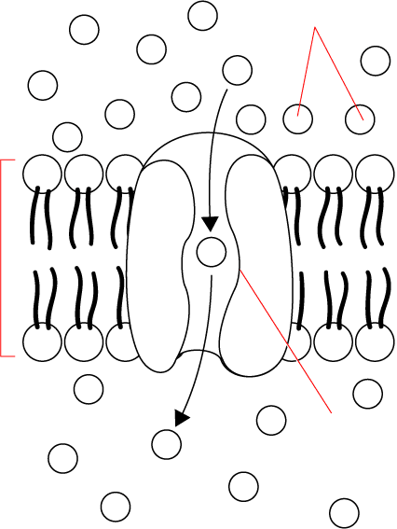
Active Transport across the cell membrane
- ___________________ Transport is the movement of substances into and out of
cells that requires the cell to expend/use energy.
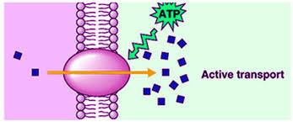
- Transport proteins known as _________ are used in active transport.
- Particular particles bind to each pump (like a “lock and key”).
- _________ is then used to alter the _________ of the pump so that the particle is moved across the membrane.
- When the particle is released the pump returns to its original shape.
For example: salt water fish getting excess salt out of their cells.

Active Transport: Moving Large Particles across the membrane
- ___________________ (exo=out) is the movement of substances out of the cell.
- ___________________ (endo=inside) the process by which the plasma membrane engulfs and takes in substances from a cell’s environment.

Two Types of Endocytosis:
- ___________________ (phag=to eat) is the movement of solids into the cell. The membrane closes around the particle and forms a ___________________.
- ___________________ is the movement of liquids with solute and small particles into cells.

Factors affecting the RATE (number of particles) of the transport across the cell membrane.

- Effects on Transport |  | Rate of Transport
Size | Large
 | Small
Temperature | Hot
 | Cold
Concentration | High
 | Low

