Name: __KEY__________________________ Period: ________ Date: ______________
DNA/RNA STUDY GUIDE
Part A: DNA History
Match the following scientists with their accomplishments in discovering DNA using the statement in the box below.
- Used a technique called x-ray diffraction
- Experimented with mice to figure out how pneumonia made people sick
- Experimented with viruses called bacteriophages
- Found that the % of adenine was equal to % of thymine
- Concluded that some factor was transforming harmless bacteria into disease-causing bacteria
- Radioactively marked the protein coat of viruses with sulfur and the DNA core with phosphorus
- Found that the % of cytosine was equal to % of guanine
- Found that DNA was composed of 2 strands, was helical and that nucleotides were in the center
- Concluded that DNA was actually the factor that was passed down from organism to organism
- Concluded that DNA was actually in the form of a double helix

1. Frederick Griffith (1928)
- Experimented with mice to figure out how pneumonia made people sick
- Concluded that some factor was transforming harmless bacteria into disease-causing bacteria
2. Hershey and Chase (1952)
- Experimented with viruses called bacteriophages
- Radioactively marked the protein coat of viruses with sulfur and the DNA core with phosphorus
- Concluded that DNA was actually the factor that was passed down from organism to organism
3. Chargoff (late 1940’s)
- Found that the % of adenine was equal to the % of thymine
- Found that the % of cytosine was equal to the % of guanine
4. Rosalind Franklin (1952)
- Used a technique called x-ray diffraction
- Found that DNA was composed of 2 strands, was helical and that nucleotides were in the center
5. Watson and Crick (1953)
- Concluded that DNA was actually in the form of a double helix
Part B: Structure of DNA
6. Where in a cell is the DNA located? nucleus
7. Does DNA ever leave this location? no
8. Do all living things contain DNA? All types of cells? yes
9. What are the complimentary base pairs that would be attached to the following ½ strand of DNA?
C G A T T A C G G C T T A A G C T
G C T A A T G C C G A A T T C G A

10. Use the following words to label 1-8 in the DNA structure below: double helix(6), hydrogen bonds(3), sugar-phosphate backbone (use twice)(1), base pairs (use twice)(2 AND 7), deoxyribose sugar(4), phosphate(5), and nucleotide(8). When you have finished labeling 1-8, fill in the complementary bases.
T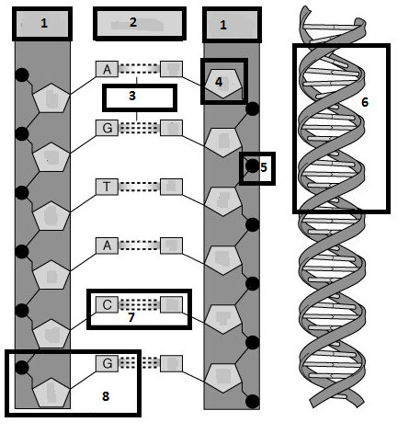
C
G
T
A
C
T
11. What are the 3 parts to a nucleotide? Deoxyribose sugar, phosphate, nitrogen base (A,T,G,C)
12. What are the 4 nitrogenous bases? Guanine, cytosine, adenine, thymine
13. How do the bases pair? A-T,
G-C
14. What type of bond holds the bases together? Weak hydrogen
15. What makes up the sides of the DNA ladder? Deoxyribose sugar and phosphate
16. What makes up the steps of the DNA ladder? Base pairs (A with T and G with C)
17. What is the shape that Watson and Crick called DNA? Double helix

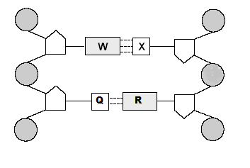
Nitrogen Bases:
Which letters represent purine?
W and R (Larger Double Ring)
Which letters represent pyrimidines?
X and Q (Smaller Single Ring)
Which bases are bonded by a triple bond?
Cytosine and Guanine (W and X)
Which bases are bonded by a double bond?
Adenine and Thymine (Q and R)
Label W, X, Q, and R. W = Guanine and X = Cytosine
R = Adenine and Q = Thymine

Part C: DNA Replication
18. Why does a cell go through the process of DNA replication? To make a copy of the DNA before the cell goes through mitosis
19. Where in the cell does DNA replication take place? Nucleus
20. What part of the cell cycle does DNA replicate? S phase of interphase
21. What enzyme unwinds and unzips DNA to begin replication? Helicase
22. What enzyme brings in the new nucleotides on both sides of the DNA? DNA polymerase
23. DNA replication is described as being semi-conservative. This means that both of the copies of DNA are composed of ½ original strand and ½ new strand.
24. Using the ½ strand of DNA below, create the other ½ strand by matching the complementary bases. These are considered the parent strands. Highlight them in yellow. Now separate the parent strands and write in the new strands on both sides. Highlight the new strands in pink. These are called the daughter strands.
Parent: A T G C C C A T T T T A C C G Parent: A T G C C C A T T T T A C C G
Parent: T A C G G G T A A A A T G G C Daughter: T A C G G G T A A A A T G G C
Daughter: A T G C C C A T T T T A C C G
Parent: T A C G G G T A A A A T G G C

Label each step number provided (you should be able to describe each step in the process)
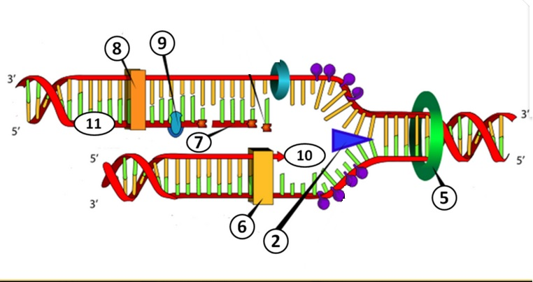

Helicase (2) breaks the weak hydrogen bonds between the two nitrogen bases, this creates a leading (10) and lagging strand (11).
As this occurs, the Topoisomerase (5) helps to relieve the increasing strain on the rest of the molecule by breaking and rebinding the unzipped portion of the strand.
Now DNA Polymerase III will bond new nucleotides to both strands. The leading strand (bottom strand) is a continuous motion, the lagging stand will occur in fragments called Okazaki Fragments (7). These fragments on the lagging strand will be bonded together in an additional step by Ligase and DNA polymerase I (9 and 8).
The final product is two identical stands that we created in a semi-conservative process, meaning that each of the double strands is ½ of the original genetic information and ½ of the newly created genetic information.

Part D. RNA
34. What are the 3 main differences between DNA and RNA?
 | DNA | RNA
Number of Strands | 2 | 1
Nitrogen Bases | Adenine, Thymine, Guanine, Cytosine | Adenine, Uracil, Guanine, Cytosine
Sugar Present in nucleotide | Deoxyribose | Ribose

35. What are the 3 types of RNA? Label them on the pictures below.
36. Which type of RNA goes into the nucleus and retrieves the genetic information from DNA? mRNA
37. Which type of RNA makes up ribosomes? rRNA
38. Which type of RNA brings amino acids in to the ribosome while the message is read? tRNA
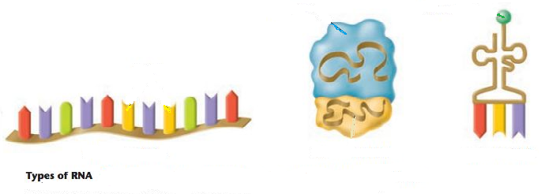
tRNA
rRNA
mRNA

39. Where in the cell is RNA found? Nucleus, ribosomes, cytoplasm
40. What are the 3 parts to an RNA nucleotide? Ribose sugar, phosphate group, nitrogen base (A, U, C, or G)
41. Can RNA leave the nucleus? yes
42. Why, then, do cells need RNA? To make proteins which carry out the directions initially coded in the DNA
43. What does making a protein have to do with your genetic traits coded by your DNA? It is a protein that expresses the trait coded by the DNA or carries out the directions of the DNA.
44. What is the monomer unit for a protein? Amino acid
45. What bases pair together when RNA matches up with DNA? A with U and C with G
46. For the characteristics below, mark (A) for DNA only, (B) for RNA only, or (C) for both DNA and RNA.
__A__ 1. Deoxyribose sugar __C__ 10. Genetic Information
__C__ 2. Phosphate groups __C__ 11. Is a nucleic acid
__B__ 3. 3 types __A__ 12. Double stranded
__C__ 4. Nitrogen bases (G, A, and C) __B__ 13. Single stranded
__C__ 5. Nucleotide is the monomer __A__ 14. Function is contains instructions for making proteins
__A__ 6. Double helix __B__ 15. Function is to copy the instructions and make proteins
__B__ 7. Single helix __A__ 16. Located in the nucleus only
__B__ 8. Nitrogen base (U) __B__ 17. Located in nucleus, cytoplasm or ribosomes
__A__ 9. Nitrogen base (T) __B__ 18. Ribose sugar

Review Topic: Genetics
Concepts:
Mendel’s Laws
Law of Dominance  The presence of a dominant allele in a genotype will mask a recessive allele | Law of Segregation  Alleles from the parental genotype will separate during gamete formation. | Law of Independent Assortment  Alleles for different genes(traits) will separate independent of each other during gamete formation.  (Easily seen in a dihybrid cross)

Compare the genotypic and phenotypic ratio for complete dominance, incomplete dominance, and codominance:
Complete dominance will have two possible phenotypes for three possible genotypes so the ratios will be different from each other. (Only two phenotypes possible) Incomplete and codominance each genotypes has its own phenotype, so the genotypic and phenotypic ratio will match each other.(Three phenotypes possible)
Which blood type is the universal donor? __O____ Universal receiver? __AB___
Which sex is most likely to be impacted by a sex-linked disorder? __Male__ why? They only have one X chromosomes, none of the disorders we discussed are found on the Y. This means that a recessive allele cannot be masked and will always be expressed.

Who does a female get a sex-linked disorder from? __Mom and Dad_____ male ?__Mom (Dad only provides the Y)___

Practice Problems
  - In fruit flies, long wings are dominant to short wings. Complete a cross between a short winged male and a heterozygous female. Fill in the phenotypes of the genotypes below. Give the genotypic and phenotypic ratios of the cross. This is an example of __complete____ dominance.
w w Genotypic ratio: 0 WW: 2 Ww : 2 ww
Ww Ww

ww ww
WW = _long___ W Phenotypic ratio: 2 long: 2 short
Ww = __long____
ww = _short__ w
  - In certain flowers, blue and yellow flowers are incompletely dominant to each other. Show the cross between a pure blue flower and a pure yellow flower. Fill in the phenotypes of the genotypes below. Give the genotypic and phenotypic ratios of the cross.
B B Genotypic ratio: 0 BB: 4 Bb : 0 bb
Bb Bb

Bb Bb
BB = _blue___ b Phenotypic ratio: 0 blue: 4 green: 0 yellow
Bb = __green____
bb = _yellow b
  - Using the same flowers as in #2, cross a green flower with a yellow flower. Give the genotypic and phenotypic ratios of the cross.
B b Genotypic ratio: 0 BB: 2 Bb : 2 bb
Bb bb

Bb bb
BB = _blue___ b Phenotypic ratio: 0 blue: 2 green: 2 yellow
Bb = __green__
bb = _yellow b
  - In some species of wildcats, black stripes and tan spots are codominant. Show the cross between a male with stripes and a female with spots and stripes . Fill in the phenotypes of the genotypes below. Give the genotypic and phenotypic ratios of the cross.
B B Genotypic ratio: 2 BB: 2 BT : 0 TT
BB BB

BT BT
BB = _black stripes___ B Phenotypic ratio: 2 black stripes: 2 spots and stripes: 0 spot
BT = __stripes and spots_
TT = _tan spots T
  - In humans, blood type is controlled by multiple alleles – A, B & O. Show the cross between a male with Type O blood and a woman with Type AB blood. What blood types will NOT show up in their offspring? You will not see type O or type AB in the
O O offspring.
AO AO

BO BO
A

B
  - In humans, male pattern baldness is a sex-linked recessive trait. Show the cross between a male that is not bald and a female that is a carrier. Fill in the male and female genotypes below using the letter b.
X^{B} Y
X^{B}X^{B} X^{B}Y

X^{B}X^{b} X^{b}Y Bb
Male genotype = ___X^{B}Y____ X^{B}
Female genotype = __X^{B}X^{b}___ b
X^{b}

7. Look at the pedigree to the right and answer the questions.
4 Aa
3 aa
2 Aa
1 aa
I.
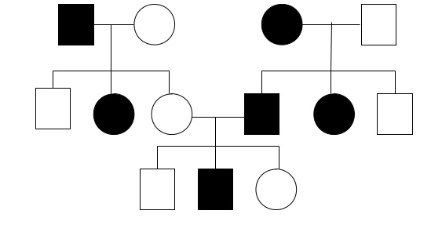
a. Label the generations and individuals correctly.
II
b. How many males? _7_ How many females? 6__
2 aa
6 Aa
5 aa
4 aa
3 Aa
1 Aa
c. How many affected males? _3__ How many affected females? _3_
III
d. Do you this trait is dominant or recessive? _it could be either__
3 Aa
2 aa
1 Aa
e. Assuming this trait is recessive, assign genotypes to each individual using the letter A.

