Name: __KEY__________________________ Period: ________ Date: ______________
DNA/RNA STUDY GUIDE
Part A: DNA History
Match the following scientists with their accomplishments in discovering DNA using the statement in the box below.
- Used a technique called x-ray diffraction
- Experimented with mice to figure out how pneumonia made people sick
- Experimented with viruses called bacteriophages
- Found that the % of adenine was equal to % of thymine
- Concluded that some factor was transforming harmless bacteria into disease-causing bacteria
- Radioactively marked the protein coat of viruses with sulfur and the DNA core with phosphorus
- Found that the % of cytosine was equal to % of guanine
- Found that DNA was composed of 2 strands, was helical and that nucleotides were in the center
- Concluded that DNA was actually the factor that was passed down from organism to organism
- Concluded that DNA was actually in the form of a double helix

1. Frederick Griffith (1928)
- Experimented with mice to figure out how pneumonia made people sick
- Concluded that some factor was transforming harmless bacteria into disease-causing bacteria
2. Hershey and Chase (1952)
- Experimented with viruses called bacteriophages
- Radioactively marked the protein coat of viruses with sulfur and the DNA core with phosphorus
- Concluded that DNA was actually the factor that was passed down from organism to organism
3. Chargoff (late 1940’s)
- Found that the % of adenine was equal to the % of thymine
- Found that the % of cytosine was equal to the % of guanine
4. Rosalind Franklin (1952)
- Used a technique called x-ray diffraction
- Found that DNA was composed of 2 strands, was helical and that nucleotides were in the center
5. Watson and Crick (1953)
- Concluded that DNA was actually in the form of a double helix
Part B: Structure of DNA
6. Where in a cell is the DNA located? nucleus
7. Does DNA ever leave this location? no
8. Do all living things contain DNA? All types of cells? yes
9. What are the complimentary base pairs that would be attached to the following ½ strand of DNA?
C G A T T A C G G C T T A A G C T
G C T A A T G C C G A A T T C G A

10. Use the following words to label 1-8 in the DNA structure below: double helix(6), hydrogen bonds(3), sugar-phosphate backbone (use twice)(1), base pairs (use twice)(2 AND 7), deoxyribose sugar(4), phosphate(5), and nucleotide(8). When you have finished labeling 1-8, fill in the complementary bases.
T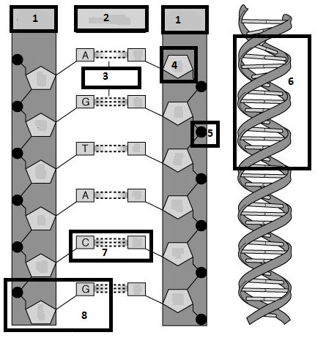
C
G
T
A
C
T
11. What are the 3 parts to a nucleotide? Deoxyribose sugar, phosphate, nitrogen base (A,T,G,C)
12. What are the 4 nitrogenous bases? Guanine, cytosine, adenine, thymine
13. How do the bases pair? A-T,
G-C
14. What type of bond holds the bases together? Weak hydrogen
15. What makes up the sides of the DNA ladder? Deoxyribose sugar and phosphate
16. What makes up the steps of the DNA ladder? Base pairs (A with T and G with C)
17. What is the shape that Watson and Crick called DNA? Double helix

Part C: DNA Replication
18. Why does a cell go through the process of DNA replication? To make a copy of the DNA before the cell goes through mitosis
19. Where in the cell does DNA replication take place? Nucleus
20. What part of the cell cycle does DNA replicate? S phase of interphase
21. What enzyme unwinds and unzips DNA to begin replication? Helicase
22. What enzyme brings in the new nucleotides on both sides of the DNA? DNA polymerase
23. DNA replication is described as being semi-conservative. This means that both of the copies of DNA are composed of ½ original strand and ½ new strand.
24. Using the ½ strand of DNA below, create the other ½ strand by matching the complementary bases. These are considered the parent strands. Highlight them in yellow. Now separate the parent strands and write in the new strands on both sides. Highlight the new strands in pink. These are called the daughter strands.
Parent: A T G C C C A T T T T A C C G Parent: A T G C C C A T T T T A C C G
Parent: T A C G G G T A A A A T G G C Daughter: T A C G G G T A A A A T G G C
Daughter: A T G C C C A T T T T A C C G
Parent: T A C G G G T A A A A T G G C
Part D. RNA
34. What are the 3 main differences between DNA and RNA?
 | DNA | RNA
Number of Strands | 2 | 1
Nitrogen Bases | Adenine, Thymine, Guanine, Cytosine | Adenine, Uracil, Guanine, Cytosine
Sugar Present in nucleotide | Deoxyribose | Ribose

35. What are the 3 types of RNA? Label them on the pictures below.
36. Which type of RNA goes into the nucleus and retrieves the genetic information from DNA? mRNA
37. Which type of RNA makes up ribosomes? rRNA
38. Which type of RNA brings amino acids in to the ribosome while the message is read? tRNA
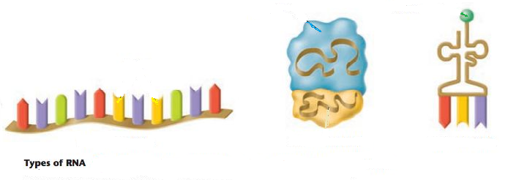
tRNA
rRNA
mRNA

39. Where in the cell is RNA found? Nucleus, ribosomes, cytoplasm
40. What are the 3 parts to an RNA nucleotide? Ribose sugar, phosphate group, nitrogen base (A, U, C, or G)
41. Can RNA leave the nucleus? yes
42. Why, then, do cells need RNA? To make proteins which carry out the directions initially coded in the DNA
43. What does making a protein have to do with your genetic traits coded by your DNA? It is a protein that expresses the trait coded by the DNA or carries out the directions of the DNA.
44. What is the monomer unit for a protein? Amino acid
45. What bases pair together when RNA matches up with DNA? A with U and C with G
46. For the characteristics below, mark (A) for DNA only, (B) for RNA only, or (C) for both DNA and RNA.
__A__ 1. Deoxyribose sugar __C__ 10. Genetic Information
__C__ 2. Phosphate groups __C__ 11. Is a nucleic acid
__B__ 3. 3 types __A__ 12. Double stranded
__C__ 4. Nitrogen bases (G, A, and C) __B__ 13. Single stranded
__C__ 5. Nucleotide is the monomer __A__ 14. Function is contains instructions for making proteins
__A__ 6. Double helix __B__ 15. Function is to copy the instructions and make proteins
__B__ 7. Single helix __A__ 16. Located in the nucleus only
__B__ 8. Nitrogen base (U) __B__ 17. Located in nucleus, cytoplasm or ribosomes
__A__ 9. Nitrogen base (T) __B__ 18. Ribose sugar

Review Topic: Cell Cycle
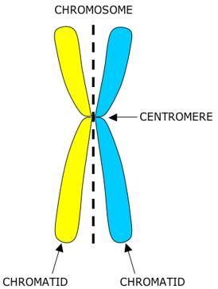
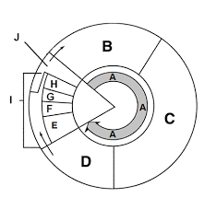
Label and Describe all the steps of the cell cycle based on the diagram provided:
A: Interphase – Growth Phase, Consists of G1, S, and G2
B: G1 – Cell continues normal cellular functions such as growth and production of proteins
C: S Phase – Replication (Synthesis) of DNA so that there will be enough for all the new cells.
D: G2 – Cell Prepares for Division
E: Prophase (Phase 1 of Mitosis) – Chromosomes become visible
F: Metaphase (Phase 2 of Mitosis) – Chromosomes align at the equator of the cell
G: Anaphase (Phase 3 of Mitosis) – Sister chromatids (two parts of a chromosome) are pulled apart at the centromere and move to opposite poles.
H: Telophase (Phase 4 of Mitosis) – Chromosomes uncoil at opposite ends of the cell and the nuclear membrane reforms.
I: Mitosis – First part of the M Phase, Division of the nucleus
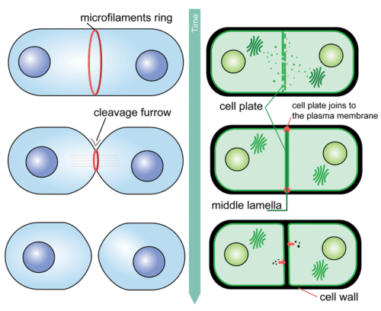
J: Cytokinesis – Second part of the M Phase, Division of the Cytoplasm. Animal cells form Cleavage Furrows and Plants form a cell plate

Compare the Products Produced by Mitosis and Meiosis
Terms to Apply: Diploid, Haploid, Genetically Different, Genetically Identical, Four, Two
Mitosis: A single diploid parent cell produces two genetically identical diploid cells through 1 division.
Meiosis: A single diploid parent cell produces four genetically different haploid cells through 2 divisions.
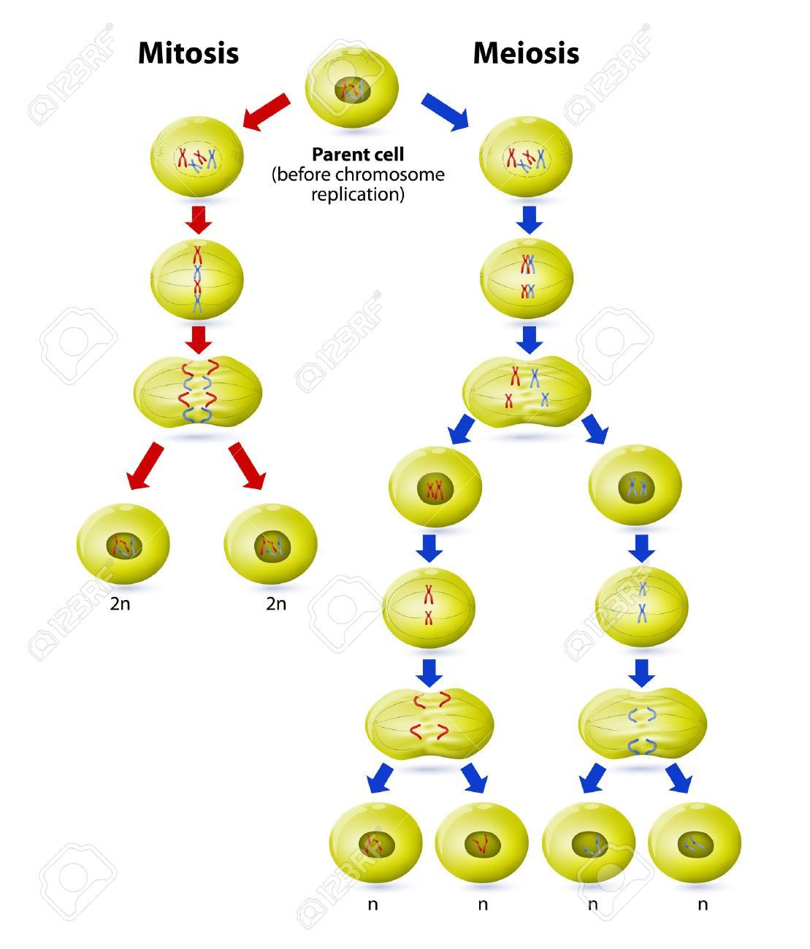
Sketch homologous chromosomes before and after crossing over:
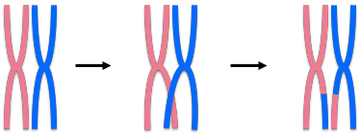
Complete the following chart comparing similarities and differences in mitosis and meiosis:
Mitosis Meiosis
Is the parent cell diploid or haploid? | Diploid | Diploid
Final Number of Cells | 2 | 4
Final Number of Chromosomes in each cell (Haploid or Diploid) | Diploid | Haploid
Number of divisions needed | 1 | 2
Number of phases needed | 4 | 4 x 2 = 8
Type of cell in which it occurs | Somatic | Gametes
Important for these life functions | Replace dead or damaged cells, help organism to grow, allow unicellular organism to quickly reproduce | Decreases chromosomes numbers to allow fertilization to occur and maintain a stable diploid number
Type of Reproduction | Asexual | Sexual
Answer these questions:
- Somatic cells are any cells in the body that are not sex cells. How many chromosomes are found in human somatic cells?
  - one set of 23 chromosomes c. two sets of 23 chromosomes
  - four sets of 23 chromosomes d. no chromosomes.

- The number of chromosomes in a gamete of an offspring is one half the number of chromosomes in a somatic cell. We call this chromosome number
  - diploid b. haploid c. zygote d. RNA

3. The cell cycle has checkpoints which ensure that replication and then division occur when they are supposed to during the cycle, if these checkpoints were to become inactive what might happen?
The cell would continue to divide uncontrollably, causing tumors to form which leads to different types of cancer.

