Name: __________________________________ Period: ________ Date: ______________
DNA/RNA STUDY GUIDE
Part A: DNA History
Match the following scientists with their accomplishments in discovering DNA using the statement in the box below.
- Used a technique called x-ray diffraction
- Experimented with mice to figure out how pneumonia made people sick
- Experimented with viruses called bacteriophages
- Found that the % of adenine was equal to % of thymine
- Concluded that some factor was transforming harmless bacteria into disease-causing bacteria
- Radioactively marked the protein coat of viruses with sulfur and the DNA core with phosphorus
- Found that the % of cytosine was equal to % of guanine
- Found that DNA was composed of 2 strands, was helical and that nucleotides were in the center
- Concluded that DNA was actually the factor that was passed down from organism to organism
- Concluded that DNA was actually in the form of a double helix

1. Frederick Griffith (1928)
____________________________________________________________________________________________________
____________________________________________________________________________________________________
2. Hershey and Chase (1952)
____________________________________________________________________________________________________
____________________________________________________________________________________________________
____________________________________________________________________________________________________
3. Chargoff (late 1940’s)
____________________________________________________________________________________________________
____________________________________________________________________________________________________
4. Rosalind Franklin (1952)
____________________________________________________________________________________________________
____________________________________________________________________________________________________
5. Watson and Crick (1953)
_________________________________________________________________ ___________________________________
Part B: Structure of DNA
6. Where in a cell is the DNA located? _______________________
7. Does DNA ever leave this location? _______________________
8. Do all living things contain DNA? All types of cells? __________
9. What are the complimentary base pairs that would be attached to the following ½ strand of DNA?
C G A T T A C G G C T T A A G C T
10. Use the following words to label 1-8 in the DNA structure below: double helix, hydrogen bonds, sugar-phosphate backbone (use twice), base pairs (use twice), deoxyribose sugar, phosphate, and nucleotide. When you have finished labeling 1-8, fill in the complementary bases.
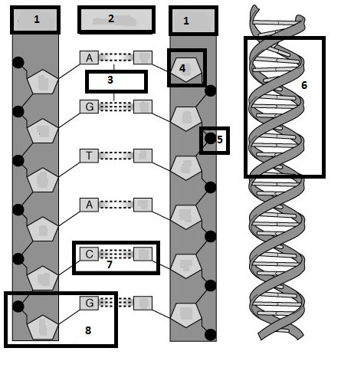
11. What are the 3 parts to a nucleotide? ___________________
_____________________________
12. What are the 4 nitrogenous bases? _______________________
_____________________________
13. How do the bases pair? ______
_____________________________
14. What type of bond holds the bases together? ________________
15. What makes up the sides of the DNA ladder? __________________
16. What makes up the steps of the DNA ladder? __________________
17. What is the shape that Watson and Crick called DNA? ___________
______________________________

Part C: DNA Replication
18. Why does a cell go through the process of DNA replication? _____________________________________________
19. Where in the cell does DNA replication take place? __________________________
20. What part of the cell cycle does DNA replicate? _____________________________
21. What enzyme unwinds and unzips DNA to begin replication? ______________________
22. What enzyme brings in the new nucleotides on both sides of the DNA? __________________________
23. DNA replication is described as being semi-conservative. This means that both of the copies of DNA are composed of ½ ____________________ strand and ½ ___________________ strand.
24. Using the ½ strand of DNA below, create the other ½ strand by matching the complementary bases. These are considered the parent strands. Highlight them in yellow. Now separate the parent strands and write in the new strands on both sides. Highlight the new strands in pink. These are called the daughter strands.
Parent: A T G C C C A T T T T A C C G Parent: A T G C C C A T T T T A C C G
Parent: Daughter:
Daughter:
Parent:
Part D. RNA
25. What are the 3 main differences between DNA and RNA?
 | DNA | RNA
Number of Strands
Nitrogen Bases
Sugar Present in nucleotide

26. What are the 3 types of RNA? Label them on the pictures below.
27. Which type of RNA goes into the nucleus and retrieves the genetic information from DNA? _______________
28. Which type of RNA makes up ribosomes? _________________
29. Which type of RNA brings amino acids in to the ribosome while the message is read? _________________
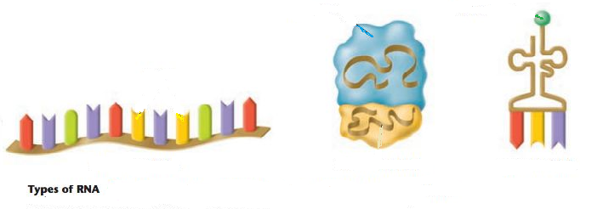

30. Where in the cell is RNA found? ___________________________________________________________
31. What are the 3 parts to an RNA nucleotide? ______________________________________________________________
32. Can RNA leave the nucleus? __________________________
33. Why, then, do cells need RNA? _________________________________________________________________________
34. What does making a protein have to do with your genetic traits coded by your DNA? ______________________________
________________________________________________________________________________________________________
35. What is the monomer unit for a protein? _________________________________________
36. What bases pair together when RNA matches up with DNA? ___________________________________________________
37. For the characteristics below, mark (A) for DNA only, (B) for RNA only, or (C) for both DNA and RNA.
______ 1. Deoxyribose sugar ______ 10. Genetic Information
______ 2. Phosphate groups ______ 11. Is a nucleic acid
______ 3. 3 types ______ 12. Double stranded
______ 4. Nitrogen bases (G, A, and C) ______ 13. Single stranded
______ 5. Nucleotide is the monomer ______ 14. Function is contains instructions for making proteins
______ 6. Double helix ______ 15. Function is to copy the instructions and make proteins
______ 7. Single helix ______ 16. Located in the nucleus only
______ 8. Nitrogen base (U) ______ 17. Located in nucleus, cytoplasm or ribosomes
______ 9. Nitrogen base (T) ______ 18. Ribose sugar

Review Topic: Cell Cycle
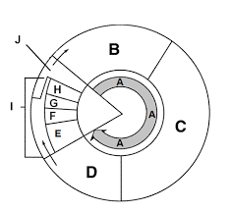
Label and Describe all the steps of the cell cycle based on the diagram provided:
A:
B:
C:
D:
E:
F:
G:
H:
I:
J:
K:

Compare the Products Produced by Mitosis and Meiosis
Terms to Apply: Diploid, Haploid, Genetically Different, Genetically Identical, Four, Two
Mitosis:

Meiosis

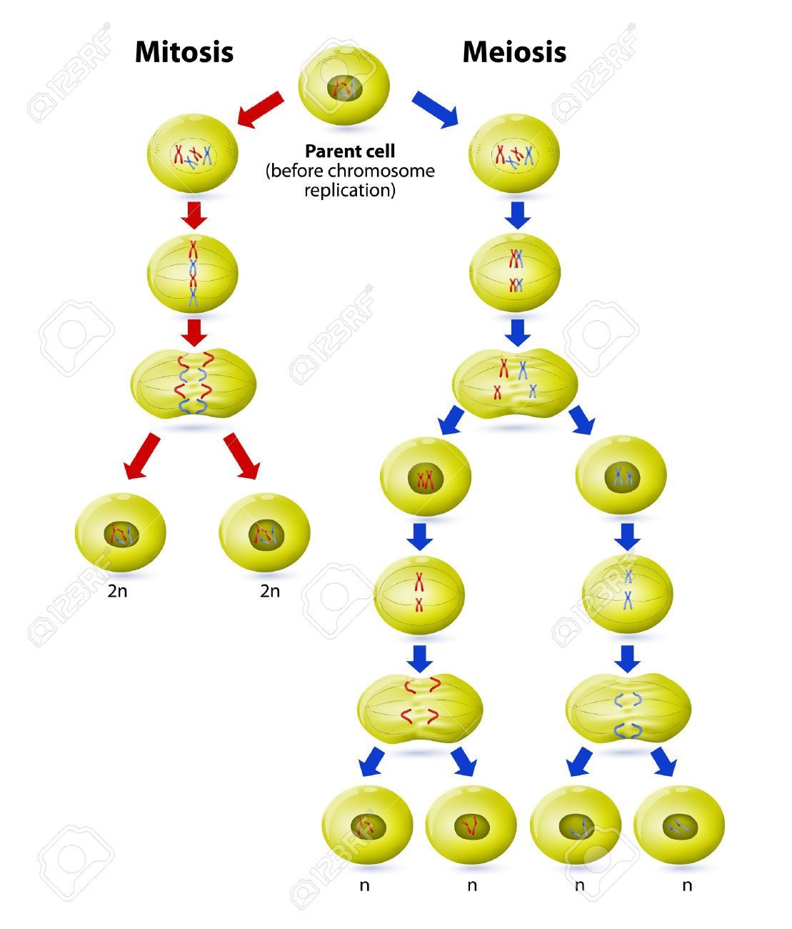
Sketch homologous chromosomes before and after crossing over:

Complete the following chart comparing similarities and differences in mitosis and meiosis:
Mitosis Meiosis
Is the parent cell diploid or haploid?
Final Number of Cells
Final Number of Chromosomes in each cell (Haploid or Diploid)
Number of divisions needed
Number of phases needed
Type of cell in which it occurs |  | .
Important for these life functions

Type of Reproduction

Answer these questions:
- Somatic cells are any cells in the body that are not sex cells. How many chromosomes are found in human somatic cells?
  - one set of 23 chromosomes c. two sets of 23 chromosomes
  - four sets of 23 chromosomes d. no chromosomes.

- The number of chromosomes in a gamete of an offspring is one half the number of chromosomes in a somatic cell. We call this chromosome number
  - diploid b. haploid c. zygote d. RNA

3. The cell cycle has checkpoints which ensure that replication and then division occur when they are supposed to during the cycle, if these checkpoints were to become inactive what might happen?

