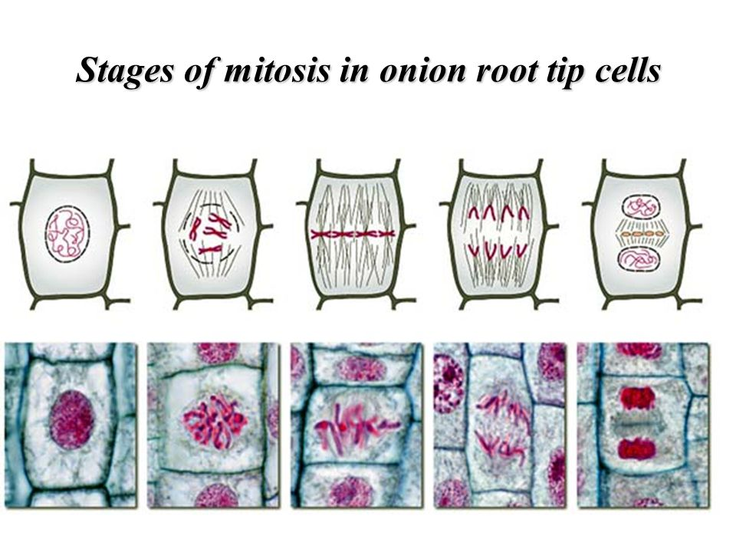
1. Explain what is happening in Metaphase.
_______________________________________________________________________
2. Which phase do the chromosomes get pulled apart and move to opposite ends of the cell?
_________________________
3. Which phase do you first see visible chromosomes?
_________________________
4. Which phase are there 2 nuclei in one cell? The cell has not split yet. A Cell Plate forms!
_________________________
5. Which phase does the nuclear membrane begin to disappear?
_________________________
6. Are the above pictures plant cells or animal cells and how do you know?
_______________________________________________________________________
7. Which phase does the onion cell grow and its DNA and organelles replicate?
_________________________

