Review Guide: Macromolecules and Introduction to Cells

Organizing Information: Place the letter for each statement into the correct area in the Venn diagram.

# A. Carbon compounds that speed up

**Carbohydrates**

**E, F, G**

# chemical reactions

B. Sugars or starches

C. Found in many living organisms

D. Used for building or repairing body parts

E. non-polar portion of the cell membrane

F. Used to store energy

G. Do not mix with water

H. Found in meats and beans

I. Fats and oils

J. Found in bread, rice & pasta

K. Monosaccharides, disaccharides &

polysaccharides

L. Amino acids, dipeptides, & polypeptides

**Proteins**

Practice Review Questions

**Lipids**

1. All organic compounds contain what element? **CARBON**

2. What are the four categories of organic compounds?  **CARBOHYDRATES, LIPIDS, PROTEINS, NUCLEIC ACIDS**

3. I had fresh fruit and hashbrowns for breakfast, which type of organic compounds would be in these foods?

Fresh Fruit: **CARBOHYDRATES**

Hashbrowns: **CARBOHYDRATES**

4. As a polar bear that lives at the North Pole, which category of organic compounds is most important to me? **LIPIDS**

5. The air is crisp, school has just started, time to make the team. As an athlete which organic compound am I trying to gain? **PROTEINS**

6. Genetic information is stored in the form of **DNA**, which fits in which organic compound category? **NUCLEIC ACIDS**

7. Your body is continually changing, there are reactions happening all the time. These reactions only happen with the help of an **ENZYMES**, which fits in the organic compound category of **PROTEINS**.

8. The monomer for carbohydrates is the **MONOSACCHARIDE**, an example is glucose. When you put two of these together you get a **DISACCHARIDE**, an example is lactose. Both of these are commonly called sugars.

When three or more sugars are combined it is no longer called a sugar, we call it a polysaccharide, or **POLYMER**.

9. The lipids category is **HYDROPHOBIC**, which means it does not mix with molecules like water.

10. Proteins are created using this monomer, **AMINO ACIDS**.

**1. Where on the enzyme do substrates bind? ACTIVE SITE**

**2. After enzyme binds to the substrate, what is made? PRODUCTS**

**3. What do enzymes do for a reaction? SPEED UP/INCREASE RATE**

**4. Can enzymes be reused? YES**

**5. What changes can denature an enzyme? pH & TEMPERATURE**

**6. Can an enzyme function if it is denatured? NO**

|  |  |
| --- | --- |
|  | **1. ENZYME**  **2. ACTIVE SITE**  **3. SUBSTRATE**  **4. ENZYME – SUBSTRATE COMPLEX.**  **5. PRODUCTS**  ***True or False?***  1. **FALSE** **Enzymes work** when they are denatured.  2. **TRUE** Products are made **after a reaction.**  3. **TRUE** E**nzymes** speed up a reaction.  4. **TRUE** Enzymes **lower** activation energy.  5. **FALSE** Enzymes **cannot** be reused.  6. **TRUE** Substrates bind with enzymes at the active site. |

1. State the three parts of the cell theory:
   1. **ALL LIVING THINGS ARE MADE OF CELLS**
   2. **CELLS COME FROM OTHER CELLS**
   3. **CELLS ARE THE BASIC UNIT OF LIFE**
2. Complete the chart below with the missing information pertaining to the scientists who researched and contributed to the discovery/study of cells.

|  |  |
| --- | --- |
| **Name of Scientist** | **Contribution/Discovery** |
| Robert Hooke | **observed cork in a microscope and called what he saw “cells”** |
| **Leeuwenhoek** | Made a more powerful microscope |
| **Schleiden** | Discovered all plants made of cells |
| Theodor Schwann | **All animals are made of cells** |
| Rudolph Virchow | **All cells come from pre-existing cells** |

1. Fill in the following chart about the two different types of cells with the information that corresponds with that cell

|  |  |  |
| --- | --- | --- |
|  | **Prokaryotic Cells** | **Eukaryotic Cells** |
| **Do these cells have a nucleus?** | **NO** | **YES** |
| **Do these cells have membrane bound organelles?** | **NO** | **YES** |
| **Which kinds of organisms are made of these cells?** | **ARCHAEBACTERIA & EUBACTERIA** | **PLANTS, ANIMALS, PROTISTS, AND FUNGI** |
| **Are these cells Unicellular, Multicellular, or both?** | **UNICELLULAR** | **BOTH UNICELLULAR & MULTICELLULAR** |

1. Using the picture below, determine if this cell is prokaryotic or eukaryotic? Explain how you were able to identify this cell as prokaryotic or eukaryotic.

**PROKARYOTIC BECAUSE IT DOES NOT HAVE A NUCLEUS OR MEMBRANE BOUND ORGANELLES.**

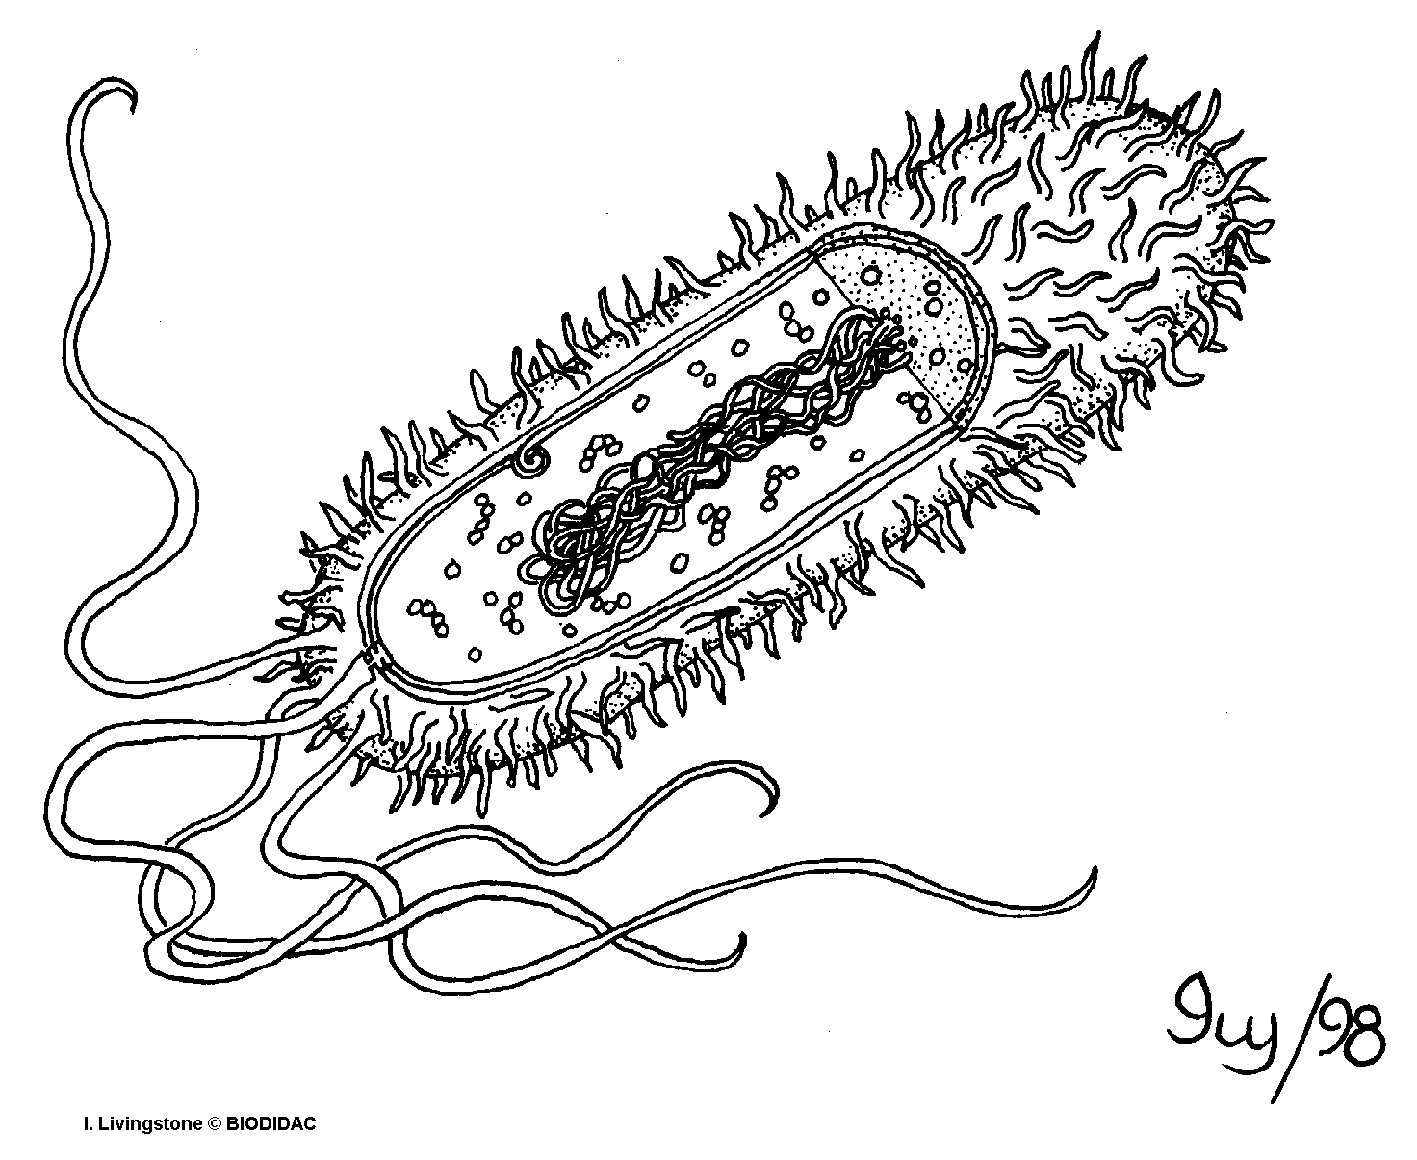

1. A scientist is observing an organism under the microscope that has never been discovered. After running additional tests, he was able to organize a chart of information about the cells of this organism. Based off the information from the chart below, what type of cell can the scientist conclude the organism is made of, prokaryotic or eukaryotic cells? Explain how you came to this conclusion.

**EUKARYOTIC BECAUSE IT HAS A NUCLEUS AND MEMBRANE BOUND ORGANELLES SUCH AS LYSOSOMES, ER, GOLGI APPARATUS, & MITOCHONDRIA**

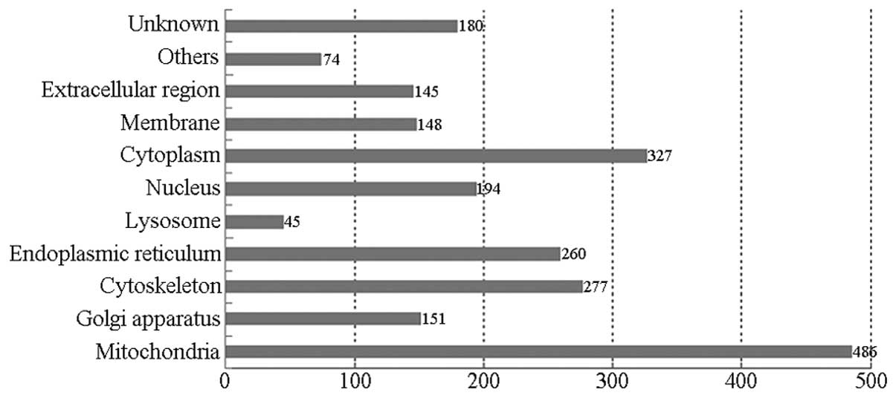

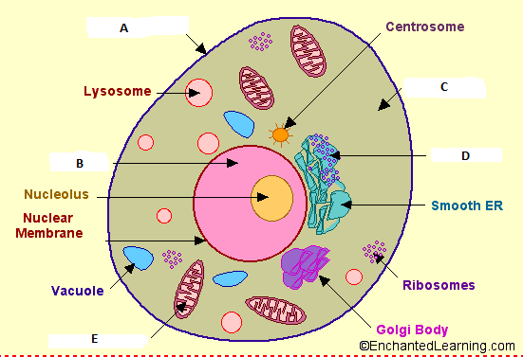

**Use the following picture above to answer questions 1-6**

1. What type of eukaryotic cell is displayed in the picture above? **ANIMAL**
2. Letter A represents the organelle that controls what comes in and out of the cell and is made of a phospholipid bilayer. Identify what organelle Letter A represents. **CELL MEMBRANE**
3. The nucleus is the brain of the cell and controls all the cell’s activities. It also houses all of our genetic material. Which letter represents the nucleus of the cell above? **B**
4. Which organelle is represented by the letter E? What is the job/function of this organelle? **MITOCHONDRIA**
5. Which letter represents the jelly-like substance in a cell that the organelles float around in inside of the cell?

**CYTOPLASM**

1. What does Letter D represent? What is the job/function of this organelle? **ROUGH ER - TRANSPORT MATERIALS IN CELL**

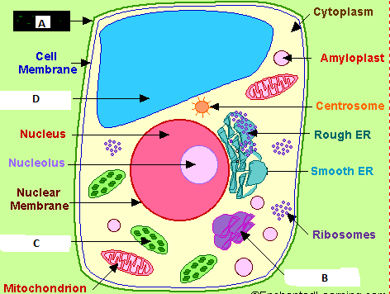

**Use the following picture above to answer questions 1-4**

1. The cell picture above is what kind of eukaryotic cell? **PLANT CELL**
2. Which two letters represent the structures that plant cells do have, but animal cells lack? What are the functions of those structures? A & C

**CELL WALL – MADE OF CELLULOSE, SUPPORT, & PROTECTION**

**CHLOROPLAST – CONVERTING LIGHT ENERGY INTO GLUCOSE (FOOD)**

1. What is the name and function of the organelle labeled Letter D?

**VACUOLE – STORE FOOD, WATER, WASTE**

1. Letter B represents the organelle that can be nicknamed “UPS.” What is the organelle? Why is it called “UPS”?

**GOLGI – PACKAGES PROTEINS**

**[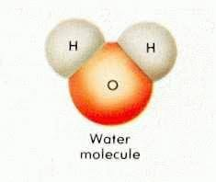](http://images.google.com/imgres?imgurl=http://www.lenntech.com/images/Water%20molecule.jpg&imgrefurl=http://www.lenntech.com/water-chemistry-FAQ.htm&h=198&w=235&sz=5&hl=en&start=4&usg=__wNiDnCR-GC8dglZEyHobrwUdoIE=&tbnid=MnLgzZa7RwUCAM:&tbnh=92&tbnw=109&prev=/images?q%3Dwater%2Bmolecule%26gbv%3D2%26hl%3Den)Properties of Water**

1) Label which element in this water molecule would be positive **(HYDROGEN)** and which would be negative **(OXYGEN).**

**True- False**

**T** 2) Water is made up of 2 atoms of hydrogen and 1 atom of oxygen to form a molecule.

**F** 3) Water contains half as many hydrogen atoms as oxygen atoms.

**T** 4) Water is a polar molecule which means it has slightly charged ends. This unique molecule is why it has so many unique properties.

**T** 5) The chemical formula for water is H2O.

6) A molecule that has electrically charged ends is called a **POLAR** molecule. This means it bonds to like molecules and ionic molecules.

7) **CAPILLARY ACTION** describes how water moves against gravity and can travel up a plants roots into its stem and leaves.

8) **SURFACE TENSION** describes how the surface of water acts like a skin and seals up quickly after being disturbed. This allows water striders and Jesus Christ lizard to appear to “walk” on water.

9) **COHESION** is the property of water that causes water molecules to “stick” to each other.

10) **ADHESION** is the property of water that causes water molecules to “stick” to other substances. Ex. Glass of water sweats and sticks to a coaster

11) A mixture forms when one substance, the **SOLUTE**, dissolves into the solvent. The property that describes the “dissolving” ability of water is **SOLUBILITY**.

12) Water is called the **UNIVERSAL SOLVENT** because of its ability to dissolve so many different substances.