Enzyme Activity Graphical Analysis

Part 1: Temperature and Enzyme Activity
Use the graph below to answer questions 1-3.

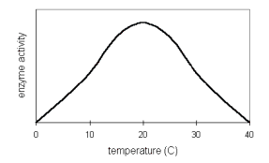

1. At what temperature does this enzyme work the fastest?

2. Why does enzyme activity increase on the left side of the graph?

3. Why does enzyme activity decrease on the right side of the graph?

4. Humans share several enzymes with thermophilic bacteria. What does the graph
below suggest about the conditions under which these thermophiles live?
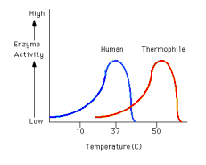

Part 2: pH and Enzyme Activity

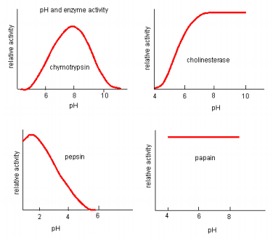
Based on the graph above:

- Which enzyme works best in neutral conditions?

- Which enzyme is not affected by pH?

- Which enzyme works under alkaline conditions?

- Which enzyme might be found in acidic gastric juices?

