Name: ___Key__________________________________ Period: ______ Date: ____________________
PROTISTA AND FUNGI STUDY GUIDE
Kingdom Protista
Prokaryotes or Eukaryotes? | Unicellular or Multicellular? | Autotroph or Heterotroph? | Cell Walls? If so, composed of? | Methods of Reproduction | Main Groups or Phyla
Eukaryotes | Mostly unicellular but most algae is multicellular | Both  (The animal-like and fungus-like are heterotrophs and the plant-like are autotrophs) | Plant like protists have cell walls of cellulose | Sexual- some can exchange DNA in a process called conjugation  Asexual- some can just split (no exchange) | 1. Animal like Know 4 Protozoan phyla  2. Plant like Know 2 algae groups (macro and micro)  3. Fungus like

Important Vocabulary:
1. protozoan- animal-like protist (there are 4 groups of these)
2. phytoplankton- plant-like protist
3. cilia- many tiny, eyelash-like projections that some animal-like protists use for movement
4. flagella- a long, whip-like tail that some animal-like protists use for movement
5. pseudopod- “false foot” structure that is an extension of the cell membrane that some protists use for movement
6. contractile vacuole- a pump that continually pumps excess water from protozoans; helps them maintain homeostasis
7. pellicle- _the term given to the cell membrane of certain protozoans
8. eyespot- a structure used in some photosynthetic protists that help them detect light
9. trichocysts- tiny projections present in some protozoans used for defense
10. gullet- another word for a mouth in certain protists
*On a separate sheet of paper, concept map the main groups in Kingdom Protista. See separate page after Fungi below.
Examples: Label the vocabulary words above on the following organisms. Each word only applies to certain organisms.
Amoeba sp. Paramecium sp. Euglena sp.
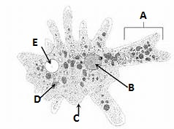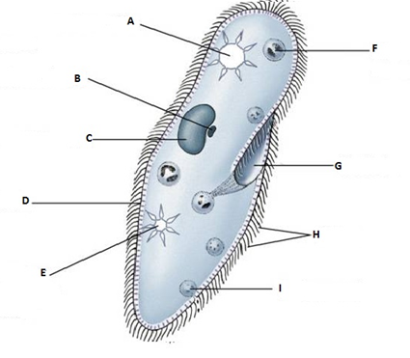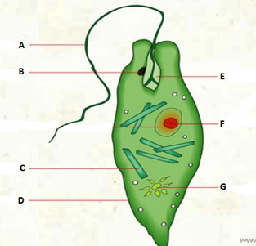
A: Pseudopod A. Contractile Vacuole A. Flagella B: Nucleus C. Nucleus F. Nucleus C: Cell Membrane D. Cell Membrane/ Pellicle D. Cell Membrane D: Food Vacuole F. Food Vacuole G. Contractile Vacuole E. Contractile Vacuole E. Contractile Vacuole

Kingdom Fungi
Prokaryotes or Eukaryotes? | Unicellular or Multicellular? | Autotroph or Heterotroph? | Cell Walls? If so, composed of? | Methods of Reproduction | Main Groups or Phyla
Eukaryotes | Multicellular (except yeast is unicellular) | Heterotrophic Decomposers | Yes, cell walls composed of chitin | Sexual- reproduce by spores  Asexual- fragmentation | 1. Zygomycota  2. Ascomycota  3. Basidiomycota  4. Deuteromycota

Important Vocabulary:
1. chitin- complex carbohydrate that makes up the cell walls of fungi
2. hyphae- tiny, thread-like filaments that are only one cell thick; may or may not contain cross walls; make up fungi
3. mycelium- mass of hyphae tangled underground
4. septa- a word that describes the cross walls inside the hyphae
5. spores- reproductive structures of fungi
6. lichen- _mutualistic relationship between a photosynthetic organism (algae) and a fungus; pioneer species
7. mycorrhizae- mutualistic relationship between a plant and a fungus
8. alternation of generations- describes the reproductive cycle of a fungus and some plants; alternates between sexual and asexual parts of its life
Examples:
1. Basidiomycota (Club Fungi) mushrooms reproduce by basidiospores
2. Ascomycota (Sac Fungi) yeast, mildews reproduce by ascospores
3. Zygomycota (Molds) bread mold reproduce by zygospores
4. Deuteromycota (Imperfect) orange “mold” Penicillium reproduce asexually only
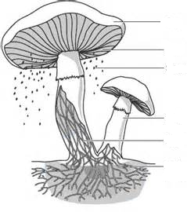
Cap
Gills
Basidiospores

Stalk or stipe
One Hyphae
Mycellium
Label the common mushroom parts to the left using the following words:
Mycelium
One hyphae
Cap
Gills
Stalk or stipe
Basidiospores
FUNGUS-LIKE PROTISTS
-heterotrophic decomposers
-Ex: slime molds and water molds
MICRO ALGAE
1. Dinoflagellates
2. Diatoms
3. Euglena
MACRO ALGAE
1. Green algae
2. Red algae
3. Brown Algae
PLANT-LIKE PROTISTS
-autotrophs
-cell walls of cellulose
SPOROZOA
-do not move
-Ex: Trypanosoma (causes African Sleeping Sickness)
ZOOFLAGELL-ATES
-move by flagella
-Ex: Plasmodium (causes malaria)
ANIMAL-LIKE PROTISTS
-also called protozoans
-classified based on how they move
-heterotrophs

SARCODINA
-move by pseudopods
-Ex: Amoeba
CILIOPHORA
-move by cilia
Ex: Paramecium
KINGDOM PROTISTA

