Name: ___________________________________________ Period: ______ Date: ____________________
PROTISTA AND FUNGI STUDY GUIDE
Kingdom Protista
Prokaryotes or Eukaryotes? | Unicellular or Multicellular? | Autotroph or Heterotroph? | Cell Walls? If so, composed of? | Methods of Reproduction | Main Groups or Phyla
 |  |  |  | Sexual-  Asexual- | 1.  2.  3.

Important Vocabulary:
1. protozoan- ______________________________________________________________________________________
2. phytoplankton- __________________________________________________________________________________
3. cilia- ___________________________________________________________________________________________
4. flagella- ________________________________________________________________________________________
5. pseudopod- _____________________________________________________________________________________
6. contractile vacuole- _______________________________________________________________________________
7. pellicle- ________________________________________________________________________________________
8. eyespot- ________________________________________________________________________________________
9. trichocysts- _____________________________________________________________________________________
10. gullet- _________________________________________________________________________________________

Examples: Label the vocabulary words above on the following organisms. Each word only applies to certain organisms.
Amoeba sp. Paramecium sp. Euglena sp.
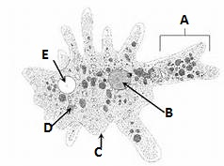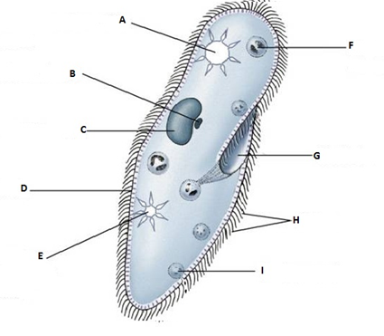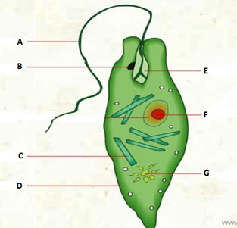

Kingdom Fungi
Prokaryotes or Eukaryotes? | Unicellular or Multicellular? | Autotroph or Heterotroph? | Cell Walls? If so, composed of? | Methods of Reproduction | Main Groups or Phyla
 |  |  |  | Sexual-  Asexual- | 1.  2.  3.  4.

Important Vocabulary:
1. chitin- __________________________________________________________________________________________
2. hyphae- ________________________________________________________________________________________
3. mycelium- ______________________________________________________________________________________
4. septa- __________________________________________________________________________________________
5. spores- _________________________________________________________________________________________
6. lichen- _________________________________________________________________________________________
7. mycorrhizae- ____________________________________________________________________________________
8. alternation of generations- _________________________________________________________________________
Examples:
1. Basidiomycota (Club Fungi) ___________________________ reproduce by basidiospores
2. Ascomycota (Sac Fungi) ______________________________ reproduce by ascospores
3. Zygomycota (Molds) _________________________________ reproduce by zygospores
4. Deuteromycota (Imperfect) ___________________________ reproduce asexually only
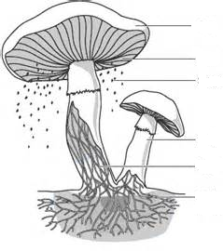
Label the common mushroom parts to the left using the following words:
Mycelium
One hyphae
Cap
Gills
Stalk or stipe
Basidiospores

