Plant Summary Notes

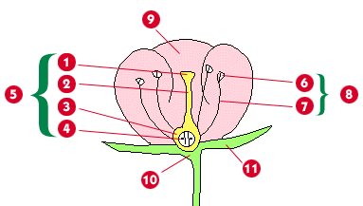

Phylum

Phylum

Phylum

Phylum

Basic Characteristics

Flower Parts

Tropisms