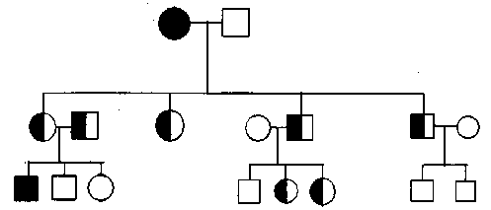
Pedigree Analysis
Pedigree 1

Use Pedigree 1 to answer the following questions. Sickle cell anemia is an autosomal recessive trait. B=normal blood cells & b= sickle blood cells. This disorder causes defective hemoglobin proteins which carry less oxygen to the body. One out of every 500 African Americans has sickle cell anemia.

- How many generations are shown in Pedigree 1? _______________________
- How many offspring did the parents in the first generation have? _________
- What does the square in generation 1 stand for? Why is it not shaded? ____
_____________________________________________________________
- Which offspring was the first in the family to have th disease? __________
- How many offspring in generation 3 carry the sickle cell trait? ___________

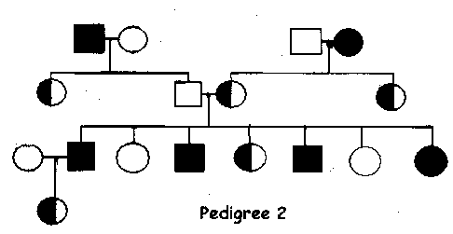
Use Pedigree 2 to answer the following questions regarding Hemophilia, a sex-linked recessive disorder that affects one in every 10,000 white males. This disorder produces a defective protein that causes the blood to not clot.

- How many marriages are show in this figure? _________________________
- What would be the phenotypes of all the fully shaded males? _____________
- What would be th e genotypes of all the fully shaded individuals? _________
- What is the genotype of a female carrier and a hemophiliac female? ________
- Hemophilia is a sex-linked disorder. Is it carried on the X or the Y chromosome? ___

