Origin of Life (History of Earth)
Early Earth Environment
- _________________, ___________________, ____________________, __________________________, ____________________________
- No major source of _________________

Atmosphere
- _________________, ___________________, ____________________,
__________________________, ____________________________
- No major source of _________________

Supporting Evidence – Miller Urey Experiment
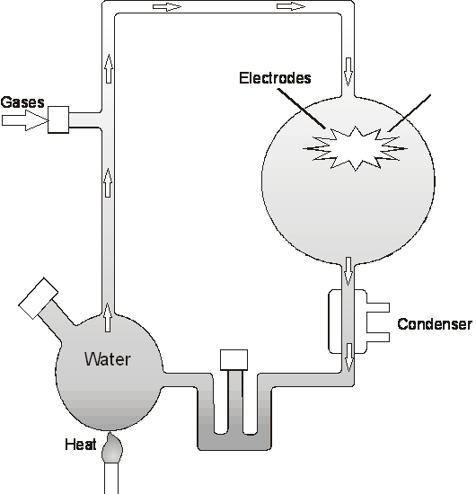
Combined the elements and conditions
found in the early atmosphere to
determine if they could produce
________________ ________.

This also led to the development of the
_______________, a large ordered
structure considered
the precursor to an actual cell.

“Let there be water…..and life.”
- The first organisms were ________________________ ________________________.
- Then _____________________________ organisms
- Once oxygen was available in the atmosphere ____________________ ______________________ became more successful, providing even more oxygen to the atmosphere.
- Finally __________________________ organisms.

Supporting Evidence – Endosymbiotic Theory
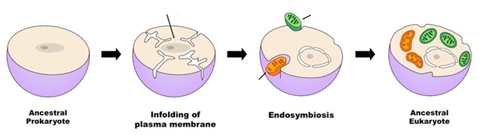

Review - Use each of the terms below just once to complete the passage.
Chemosynthesis symbiotic bacteria oxygen
amino acids chloroplast endosymbiotic hydrothermal vents
heterotrophic mitochondria photosynthesis anaerobic

Early Earth
Scientists believe that early Earth was very different from the Earth we live on today. One of the most important differences was the lack of (1)___________________. While it may seem like nothing could have existed on this early Earth Miller and Urey disproved this by an experiment that was capable of producing (2)______________ _____________, which are a major building block for a living organism. Life might have begun in a newly discovered area of the ocean called (3)_____________________ _______. These organisms did not need oxygen so they are considered (4)____________________. They obtained their food from the ocean making them (5)_____________________. Later organisms had the ability to make their own food using the process of (6)________________________ and later (7)________________________. Eukaryotes evolved through a (8)____________ relationship between different prokaryotes. This theory is called the (9)___________________ theory. It is believed that the (10)_________________ and (11)_______________, which are organelles in a eukaryotic cell were once (12)_______________________.
Where do living organisms come from? Spontaneous Generation vs. Biogenesis
Original idea proposed by Aristotle– Spontaneous Generation (Also called _____________________________)
Spontaneous Generation – Living things arise from non-living matter

Examples of this philosophy: Observation – Nile River flooded each year, when the water went away there were frogs that were left behind…..arose spontaneously from the mud.
Disproving this theory:
Redi – Maggots and the Meat  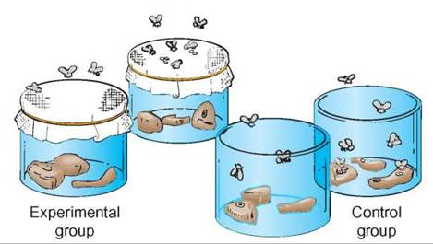  How do the results differ in the two jars?  What might you conclude from these results?  What is the purpose of a control group in science? | Pasteur – Swan neck flasks and microbes  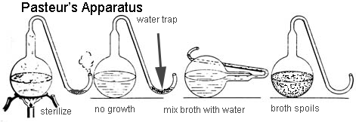  If Redi had just completed an experiment to disprove spontaneous generation, then why did Pasteur do the same thing?  How did Pasteur’s Experiment finally disprove spontaneous generation?
With multiple experiments disproving the idea of spontaneous generation a new idea was finally accepted:
Biogenesis –

Review - Use each of the terms below just once to complete the passage.
microorganisms vital force Louis Pasteur biogenesis
nonliving matter S-shaped disproved Francesco Redi
organisms broth air microscope
spontaneously spontaneous generation

Early Research
Early scientists believed that life arose from (1) ____________________ through a process they called (2) ___________________________. In 1668, the Italian physician (3) ____________________ conducted an experiment with flies that (4) ____________________ this idea. At about the same time, biologists began to use an important new research tool, the (5) ____________________. They soon discovered the vast world of (6) ____________________. The number and diversity of these organisms was so great that scientists were led to believe once again that these organisms must have arisen (7) ____________________.
By the mid-1800s, however, (8) ____________________ was able to disprove this hypothesis once and for all. He set up an experiment, using flasks with unique (9) ____________________ necks. These flasks allowed (10) ____________________, but no organisms, to come into contact with a broth containing nutrients. If some (11) ____________________ existed, as had been suggested, it would be able to get into the (12) ____________________ through the open neck of the flask. His experiment proved that organisms arise only from other (13) ____________________. This idea, called (14) ___________________, is one of the cornerstones of biology today.
Key
Review - Use each of the terms below just once to complete the passage.
Chemosynthesis symbiotic bacteria oxygen
amino acids chloroplast endosymbiotic hydrothermal vents
heterotrophic mitochondria photosynthesis anaerobic

Early Earth
Scientists believe that early Earth was very different from the Earth we live on today. One of the most important differences was the lack of (1)__oxygen___. While it may seem like nothing could have existed on this early Earth Miller and Urey disproved this by an experiment that was capable of producing (2)__amino acids__, which are a major building block for a living organism. Life might have began in a newly discovered area of the ocean called (3)___hydrothermal vents___. These organisms did not need oxygen so they are considered (4)__anaerobic__. They obtained their food from the ocean making them (5)__heterotrophic___. Later organisms had the ability to make their own food using the process of (6)__chemosynthesis____ and later (7)_photosynthesis___. Eukaryotes evolved through a (8)_symbiotic_ relationship between different prokaryotes. This theory is called the (9)__endosymbiotic__ theory. It is believed that the (10)__chloroplasts__ and (11)__mitochondria____, which are organelles in a eukaryotic cell were once (12)___bacteria___.

Review - Use each of the terms below just once to complete the passage.
microorganisms vital force Louis Pasteur biogenesis
nonliving matter S-shaped disproved Francesco Redi
organisms broth air microscope
spontaneously spontaneous generation

Early Research
Early scientists believed that life arose from (1) non-living matter through a process they called (2) spontaneous generation. In 1668, the Italian physician (3) Francesco Redi conducted an experiment with flies that (4) disproved this idea. At about the same time, biologists began to use an important new research tool, the (5) microscope. They soon discovered the vast world of (6) microorganisms. The number and diversity of these organisms was so great that scientists were led to believe once again that these organisms must have arisen (7) spontaneously. By the mid-1800s, however, (8) Louis Pasteur was able to disprove this hypothesis once and for all. He set up an experiment, using flasks with unique (9) s-shaped necks. These flasks allowed (10) air, but no organisms, to come into contact with a broth containing nutrients. If some (11) vital force existed, as had been suggested, it would be able to get into the (12) broth through the open neck of the flask. His experiment proved that organisms arise only from other (13) organisms. This idea, called (14) biogenesis, is one of the cornerstones of biology today.

