Little Girl Lost: A Case Study on Defective Cellular Organelles Name: ________________________________
Below are a few words you will come across in this case study that you may not be familiar with. With a partner, try to match up the word and its meaning.

1. respiratory infection
____. A change in DNA
____. A disorder dealing with the nervous system (brain, nerves)
____. To grow and develop well
____. A person who has inherited 1 dominant and 1 recessive trait
____. To decline or deteriorate, loss of function
____. An infection that will impact the lungs and breathing
____. A medical test to screen blood for disorders
____. A disease or sickness that can be spread by touch, air, or bodily fluids
____. A region of tissue/organ that has suffered damage from injury or disease
____. A non-dominant trait, must have 2 recessive genes to express the trait
2. metabolic screening
3. lesions
4. thrive
5. neurological disorder
6. degeneration
7. mutation
8. recessive trait
9. carrier
10. communicable

As you read each section of the provided case study answer the given questions.
Part I – Bringing Home Baby Questions
1. What does the phrase “failure to thrive” mean?

2. What are some reasons why newborn babies “fail to thrive”?

3. What was the event that triggered Nicole’s deterioration?

4. What symptoms caused her parents to take her to the doctor?

What symptoms presented while at the hospital?

5. What were the results of the metabolic tests and MRI?
Part II – The Diagnosis Questions
1. What was Nicole’s diagnosis?

What gene mutation is probably involved?

2. The mutation described above affects a protein commonly found in cellular organelles involved in energy
production. What organelle would this most likely be?

3. How many people are born with Leigh Syndrome (LS)?

4. What is the expected lifespan for LS sufferers?

5. How is it that Nicole and Kenneth’s daughter could have inherited LS even though neither of her parents
suffers from it?

6. What is the probability that they would have another affected child?

What is the probability that they would have another child who is a carrier?

7. What is the probability of having a child that doesn’t have LS and is also a non-carrier for LS?

Part III – Understanding the Cell Questions
1. What organelle is responsible for energy production in the cell?
2. What do you think will happen to the cell and the organism over time if it can’t produce energy?

3. Explain in your own words why defects in this energy producing organelle would lead to the symptoms seen in Nicole.

4. Using what you have learned so far, write the function of the organelles listed below. Then think of a person, office, or thing found in a factory that would perform the same or similar function. This would be the analog to help you remember the function of the organelle. The first two organelles were done for you.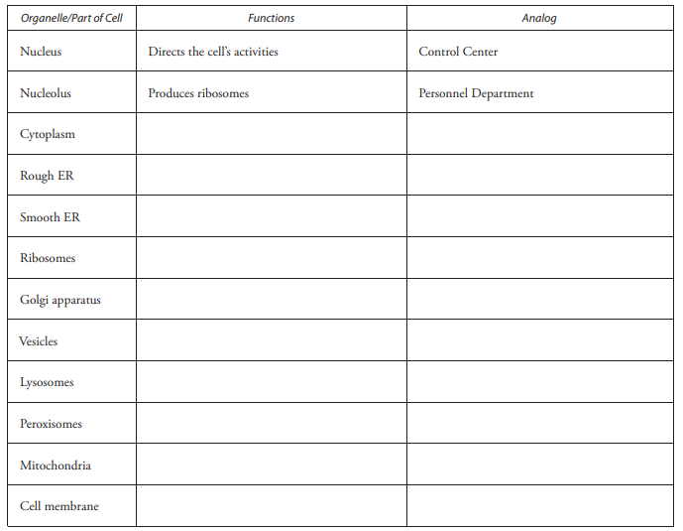
Part IV—Treatment and Prognosis Questions
1. Why does the doctor want Nicole to undergo genetic testing? How will this help Nicole?

2. What is the primary treatment for Leigh Disease? What other treatments are used?

3. The doctor named the syndromes and diseases listed below. Using what you have learned about cellular organelles, complete the table by matching the disease or syndrome with the affected organelle using the symptoms and the organelles normal function as clues.
