Name: ______________________________________ Period: ___________ Date: ______________
EVOLUTION UNIT 2 STUDY GUIDE
_____ 1. Population (same species) a. Two populations cannot interbreed due to separation by mountains or rivers
_____ 2. Speciation b. Consists of all the different genes, including all alleles, of a population for a trait
_____ 3. Reproductive Isolation c. Two populations cannot interbreed because they breed at different times
_____ 4. Geographic Isolation d. Formation of a new species
_____ 5. Behavioral Isolation e. Individuals at ONE END of a range of phenotypes curve have a higher fitness
_____ 6. Temporal Isolation f. Individuals in the CENTER of a range of phenotypes curve have a higher fitness
_____ 7. Gene Pool g. A group of organisms that can breed with one another and produce fertile offspring
_____ 8. Directional Selection h. Individuals at BOTH ENDS of a range of phenotypes curve have a higher fitness
_____ 9. Disruptive Selection i. Two populations cannot interbreed because they have different courtship rituals
_____ 10. Stabilizing Selection j. When members of two populations cannot interbreed and produce fertile offspring
____________________________________________________________________________________________________________
_____ 11. Divergent Evolution a. When a population’s size is reduced drastically due to chance in a short time period
_____ 12. Convergent Evolution b. The process of a gene pool of a population changing due to some random event
_____ 13. Coevolution c. A process where unrelated organisms become more similar over time
_____ 14. Bottleneck Effect d. Allele frequencies in a population remain constant unless some factor causes it to change
_____ 15. Founders Effect e. The idea that organisms change slowly and steadily over time.
_____ 16. Genetic Drift f. The reduced genetic diversity when a population is descended from a small number
_____ 17. Genetic Equilibrium g. A process where related organisms become more and more dissimilar over time
_____ 18. Gradualism h. The idea that there are long periods of equilibrium followed by rapid change.
_____ 19. Punctuated Equilibrium i. One species has evolved into many diverse life forms. Ex: Darwin’s finches.
_____ 20. Adaptive Radiation j. A process where two species change in response to each other over time

Part A. Natural Selection
1. Identify the following types of natural selection as directional selection, disruptive selection, or stabilizing selection.
- 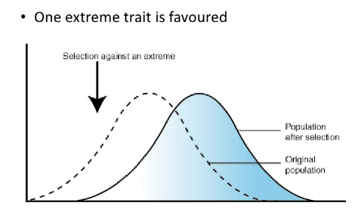 _______________________________________________
- 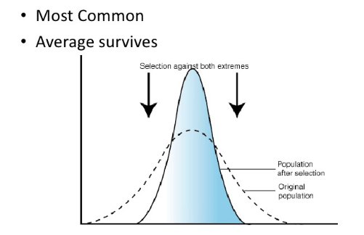 ______________________________________________
- 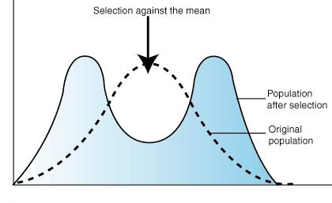 ______________________________________________

- Within a certain species of butterfly, there are the following variations in the gene pool: light colored, medium colored, and dark colored. The spruce forest the butterflies live in contain light and dark trees. The light and dark butterflies are able to survive because they blend in with the light and dark trees when hiding from predators, but the medium colored butterflies are dying out because they cannot hide from predators- they are too dark to hide on the light colored trees and too light to hide on the dark colored trees.
__________________________________________

- There are three variations of thickness of a clam shell in a certain species of clam: thin, medium, thick. The thin and medium thickness clams have shells that are easily broken open by their predators. The thick shelled clams are better able to survive and reproduce.
___________________________________________

- Infants with average birth weight are more likely to survive than those who are too small or too large.

___________________________________________

2. Classify each of the following types of reproductive isolation as geographical, behavioral, or temporal.
- The blue-footed booby shares its habitat with several other similar species but never mates with them because the male blue-footed booby has an elaborate courtship dance that the female blue-footed booby will watch for. Only after this special dance is completed will the female mate with the male.

______________________________________

- The northern spotted owl and the western spotted owl are two closely related species that both live along the western coast of the United States. The two are prevented from reproducing from one another, however, due to the barrier of mountain ranges.

________________________________

- Closely related American toads and Fowler’s toads do not interbreed, despite living in the same area, because American toads mate in early summer and Fowler’s toads mate in late summer.

________________________________

- It is difficult to distinguish between the eastern meadowlark bird and the western meadowlark based on their appearance. However, each has a distinct mating call that each type of species will only recognize.

______________________________

- Two closely related firefly species have a special pattern of light pulses to signal to the females of their species. The females will only choose males with their specific light pattern, preventing the two species from mating with each other.

_________________________________________

- The pygmy three-toed sloth is closely related to the brown-throated sloth of Ecuador. However the pygmy three-toed sloth is isolated to an island off the coast and is prevented from reproducing with the brown-throated sloth due being separated from the mainland of Panama by the Caribbean Sea.

____________________________________

- Canada lettuce and grassleaf lettuce are both closely related species of lettuce plants found in the southeastern United States. They do not interbreed, however, because Canada lettuce flowers in early summer and grassleaf lettuce flowers in early spring.

______________________________________

- There are two species of fruitflies that are closely related but do not interbreed with one another because one species breeds in the morning hours and the other species breeds in the evening hours.

___________________________________
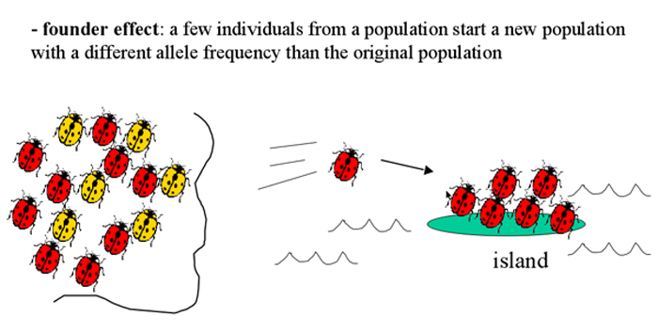
3. Genetic Drift

- Explain how the founder effect leads to genetic drift in this case with the ladybugs. __________________________________

__________________________________
___________________________________
___________________________________

____________________________________________________________________________________________________

b) What is the Bottle neck effect? ___________________________________________________________________________

_____________________________________________________________________________________________________

c) How do the numbers of variations compare in the new populations? ____________________________________________

d) Is the new population formed through natural selection or some random event? ___________________________________

____________________________________________________________________________________________________

Part B. Darwin’s Theory of Evolution
1. Darwin’s Theory of Evolution rests on two assumptions:
- That the Earth must be billions of years old. Give the age that evolutionary scientists have given the Earth:

_____________________________________
- That the sources of genetic variation between organisms must have been beneficial. Name the two sources of genetic

variations among organisms: ___________________________ and ___________________________ (during meiosis).

2. Types of Evolution
- The type of evolution that occurs when two closely related organisms become more and more dissimilar is called
____________________________________ evolution.

- The type of evolution that occurs when two unrelated organisms develop similar structures and appearances is called _______________________________ evolution.
- The type of evolution that occurs when two or more species in close interaction change in response to each other changing over time is called ____________________________________.

- ______________________ _________________________ is a type of divergent evolution where one species evolves into many diverse life forms.

- Identify the following examples as either divergent evolution, convergent evolution or coevolution.

  - Grizzly bears and polar bears are very similar, genetically speaking. They share a common ancestor, but have evolved different characteristics as adaptations in their different habitats.

_________________________________________________________
  - Giraffes have evolved a long neck through the process of natural selection. Those that had the longest necks survived better to pass on their traits. However, trees have also grown taller along with the neck of the giraffe. Trees that were tallest were less affected by giraffes, and survive better to pass on their traits.

_________________________________________________________
  - On the Galapagos Islands, Darwin studied the beaks of finches found on each island. Although fossil evidence suggests there was a single ancestral species of finch, the modern-day finches consist of a wide variety of species, each with a distinct beak shape adapted for the food present on each island.

_________________________________________________________
  - Dolphins, whales, and sharks all have similar body shapes and characteristics, adapted for life in an aquatic environment. However, dolphins and whales are mammals, and sharks are fish.

_________________________________________________________
  - Monarch butterflies have a mimic. There is another species of butterfly that looks very similar to the Monarch, but does not belong to the same species. The bold colors of the Monarch are an adaptation to avoid predators. Although the other butterfly did not always (in history) look like the Monarch, it was an adaptation to have warning coloration similar to that of the Monarch. Natural selection caused the mimic species to shift its characteristics to become more similar to the Monarch.

__________________________________________________________

- Homologous vs. Analogous Structures – Label each statement as pertaining to homologous structures or analogous structures.
i. Formed from similar tissue/same internal structure, but different function. ____________________________
ii. Formed from different tissue/different internal structure, but same function. _________________________
iii. Results from having a common ancestor. ______________________________________________________
iv. Results from having unrelated organisms that live in similar environments. ___________________________
v. Associated with divergent evolution/adaptive radiation. __________________________________________
vi. Associated with convergent evolution. ________________________________________________________
vii. Formed when related organism look different due to differing environmental pressures. _______________
viii. Formed when unrelated organisms look similar due to similar environmental pressures. _______________

3. Gradualism vs. Punctuated Equilibrium
a. The idea that organisms change slowly and steadily over time is known as __________________________.
b. The idea that for most of the time, species are stable. But every now and then there is a disruptive event that promotes rapid change is known as ____________________________________.
c. In the box below, label which change in the bird organisms are represented by gradualism and which is represented by punctuated equilibrium.
