Molecule of Life- Water
- H₂O is a ____________ molecule.
  - The ___________ does _________ ________ the electrons ___________ with H and creates an area of charge
  - The area of charge (poles) creates a force called a Hydrogen bond.
  - +H attracted to –O
  - creates a __________ molecule
- Special properties of water
1. cohesion & adhesion
2. good solvent-
3. lower density as a solid
4. high specific heat
5.high heat of vaporization

1-Cohesion and Adhesion
- Cohesion
  - Hydrogen bonding ___________ H₂O molecules
  - water is “sticky”
    - ___________ _____________
    - drinking straw
- Adhesion
  - H bonding between H₂O & _________ substances
    - _______________ action
    - meniscus
    - water climbs up
paper towel or cloth

Transpiration-

2-Water is the ____________ of life
- Polarity makes H₂O a good ______________
  - polar H₂O molecules surround ________ & ____________ ions
  - solvents ________________ solutes creating solutions
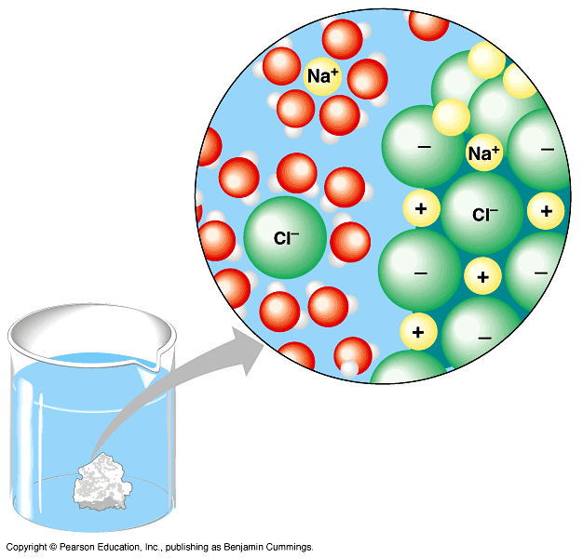
What is the solute?

How is the water turned?
What dissolves in water?
- __________________
  - substances have attraction to H₂O
polar or non-polar?
- Hydrophobic
  - substances that __________ have an attraction to H₂O
polar or non-polar?
3- Ice
- Most (all?) substances are ____________ dense when they are solid, but not water…
- Ice ____________! H bonds form a crystal. How is this a benefit?
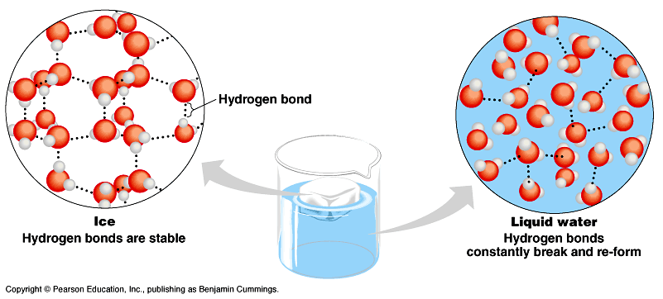
4- Specific Heat
- H₂O ________________ changes in temperature
  - high specific heat
  - takes a lot to heat it up
  - takes a lot to cool it down
- H₂O moderates ____________________ on Earth

5- High Heat of Vaporization- heat is absorbed as the substance evaporates.
Evaporation __________ body heat and _______ the organism.
How do we cool off?

Water and the pH scale
- Water _____________
  - H⁺ splits off from H₂O, leaving OH–
    - if [H⁺] = [⁻OH], water is_____________
    - if [H⁺] > [⁻OH], water is _____________
    - if [H⁺] < [⁻OH], water is _____________
- pH scale- measures the H+ in solution
  - how acid or basic a solution is
  - Sometimes when substances are dissolved in water they ________________ extra H+ or OH-
- pH of cells must be kept ~________
  - pH affects _____________ of molecules
  - shape of molecules __________ ____________
  - pH affects ____________ function

