Name: ____________________________________ Period: ______ Date: ______________
MEIOSIS STUDY GUIDE
Part A: Vocabulary Matching
_____ 1. Chromatin a. two identical chromosomes that have been replicated during interphase
_____ 2. Chromosome b. central part holding two sister chromatids together
_____ 3. Sister Chromatid c. the form of DNA found beginning in prophase; coiled and condensed
_____ 4. Centromere d. organelle in animal cells that anchors the spindle to the poles of the cell
_____ 5. Centriole e. the form of DNA found in interphase; uncoiled and disorganized
_____________________________________________________________________________________
_____ 6. Haploid a. two homologous chromosomes that have paired up in prophase I of meiosis
_____ 7. Diploid b. the full amount of chromosomes; 2 sets; 2N
_____ 8. Homologous c. occurs in prophase I of meiosis; homologous chromosomes swap DNA
_____ 9. Tetrad d. half of the full amount of chromosomes; 1 set; 1N
_____ 10. Crossing-Over e. describes chromosomes that are similar in size and shape
_____________________________________________________________________________________
_____ 11. Gametes a. another word for body cells (cells that are not reproductive)
_____ 12. Somatic Cells b. the male gamete
_____ 13. Ova c. another word for reproductive or sex cells; sperm and egg
_____ 14. Sperm d. thread-like fibers that pull chromosomes apart in mitosis and meiosis
_____ 15. Spindle e. another word for egg; the female gamete

Part B. Multiple Choice
16. How many divisions does meiosis have?
a. 1 b. 2 c. 3 d. 4
17. Meiosis results in what kind of daughter cells?
a. somatic cells b. gametes c. sperm and egg d. both b and c
18. The daughter cells in meiosis are:
a. haploid b. diploid c. both d. neither
19. The daughter cells in meiosis are:
a. genetically identical to the parent cell b. genetically different from the parent cell
20. How many daughter cells are produced in meiosis?
a. 1 b. 2 c. 3 d. 4
Part C: Modeling Meiosis
21. For the cells below, draw in the appropriate number of chromosomes in each cell for an organism with a diploid number of 4. Show what the stages of meiosis would look beginning with four chromosomes. You should end up with 2 chromosomes in each of the daughter cells.
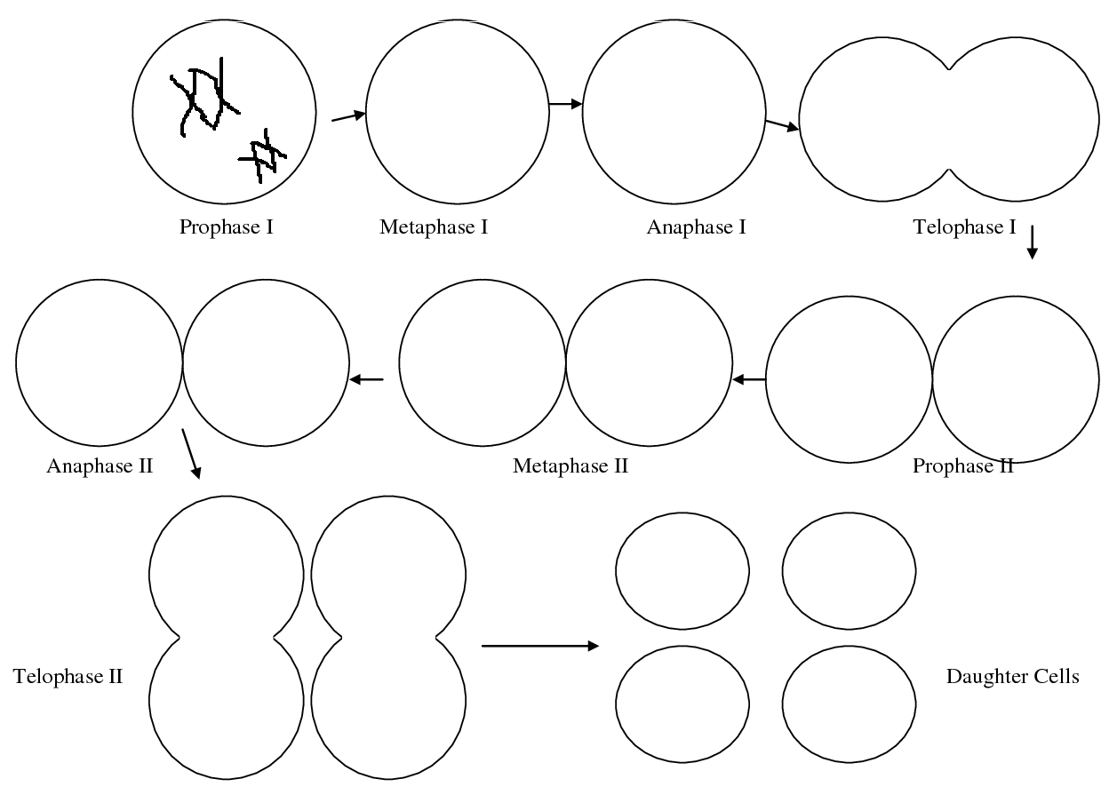

Part D. Summary Questions
22. Why, if the parent cell begins with the diploid number of chromosomes, does meiosis need to go through 2 divisions? __________________________________________________________________________________________
23. What will the four daughter cells turn into in a male? ___________________________________________
24. What will the four daughter cells turn into in a female? _________________________________________
25. Why do we want the gametes formed to have half of the correct number of chromosomes? __________________________________________________________________________________________

