Meiosis Notes

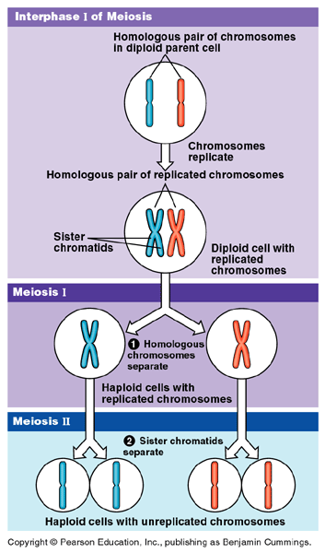

**Meiosis** - cell division where one diploid somatic cell produces four haploid gametes

After the chromosomes replicate once, the diploid cell divides **TWICE**, yielding four haploid daughter cells.

**MEIOSIS I** – separates homologous chromosomes (chromosome reduction).

**MEIOSIS II** – separates sister chromatids (cell division).

Meiosis in males = Spermatogenesis (making of sperm)

Meiosis in females = Oogenesis (making of eggs)

The gametes can be involved in fertilization (egg cell & sperm cell joins) later…but they don’t HAVE to be used!

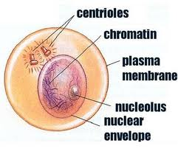

Interphase :

_________________________

_________________________

_________________________

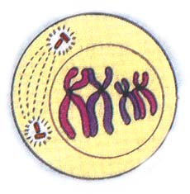Prophase I:

________________________

________________________

________________________

________________________

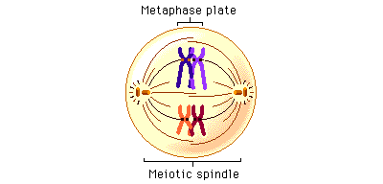Metaphase I:

________________________

________________________

________________________

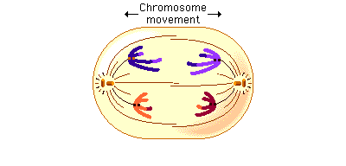Anaphase I:

________________________

________________________

________________________

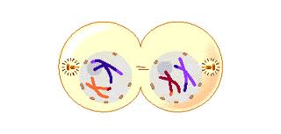

Telophase I:

________________________

________________________

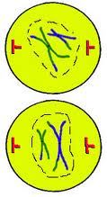________________________

**Meiosis II**

Prophase II:

_______________________

_______________________

_______________________

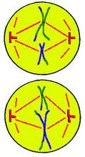

Metaphase II:

______________________

______________________

______________________

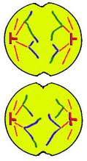Anaphase II:

________________________

________________________

________________________

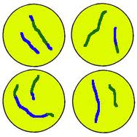

Telophase II:

_______________________

_______________________

_______________________

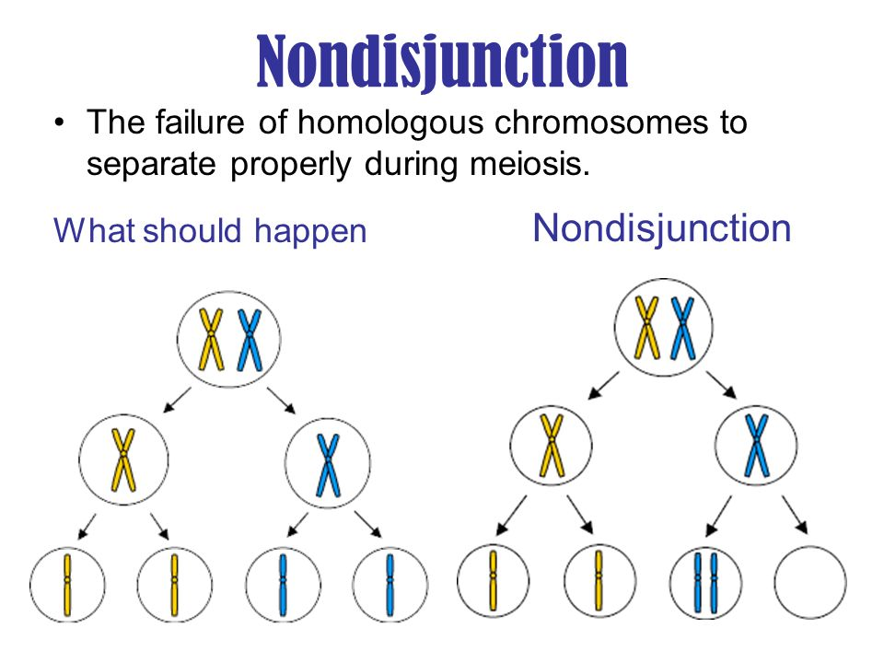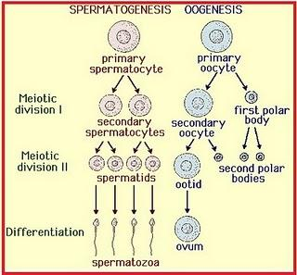 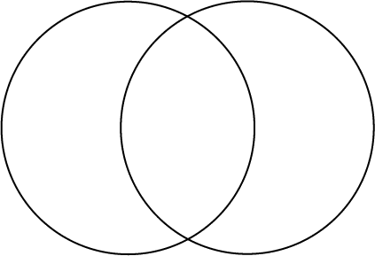

**MALES VS FEMALES**

* In spermatogenesis, meiosis results in four equal-sized gametes – sperm.
* In oogenesis, only one large egg is made. The other three cells, called **polar bodies**, are reabsorbed by the organism and the materials recycled….
  + The reason for this in the female is the **need for more space and organelles in order to support the development of a new organism**

**Mitosis VS Meiosis**

IPMAT + Cytokinesis IPMAT + PMAT + Cytokinesis

Asexual vs. Sexual Reproduction

