Macromolecules Review Name: __________________________________________

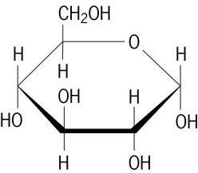
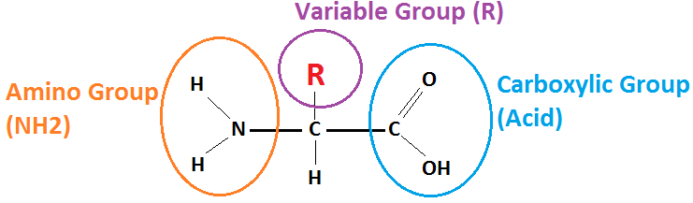
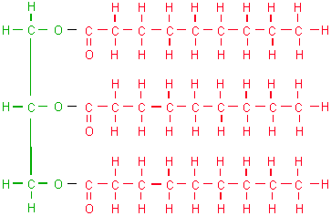
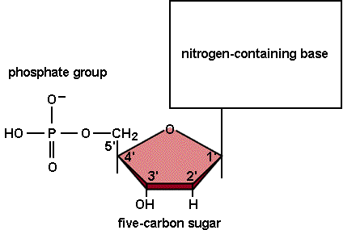
First label each of the given pictures, in the provided box, with the correct category of macromolecule: Lipid, Nucleic Acid, Protein, or Carbohydrate.
#3
#4
#1
#2

Now that you have labelled each picture let’s determine how you did it.
- Picture #1 Questions
- This monomer is called an _____________ acid. How many of them are there?
- What is their major function?

- Picture #2
- This monomer is called a __________________________, it is made up of a glycerol backbone and __________ fatty acid chains.
- What letter is this macromolecule shaped like?

- Based on all of the H-C connections, single bonds, is this a saturated or unsaturated fat?

- What is the major function of this compound in living organisms?

- Picture #3
- What basic geometric shape is this monomer shaped like?

- The monomer for this organic compound is the monosaccharide, like glucose. If there are two in a chain it is called a______________________________________. IF there are more than 2 it is called a ________________________________.
- What is the major function of this compound in living organisms?

- Picture #4
- This monomer is called a ___________________________________, it is an important part of each living organisms RNA and ________.

- What are the three basic parts of this monomer?

- What are the 5 nitrogen bases which make up the part of this monomer shown in the box on the picture?

