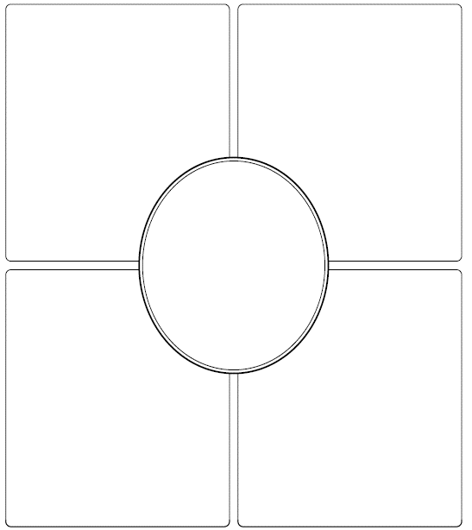

Monomer

Function

Elements

Types/Sources of this Macromolecule

Monomer

Function

Elements

Types/Sources of this Macromolecule