Macromolecule Review Guide KEY

 | Carbohydrates | Lipids | Nucleic Acids | Proteins
Examples of this Macro-molecule | Monosaccharide (Ex: Glucose)  Disaccharide (Ex: Sucrose)  Polysaccharide (Ex: Starch)  “sugars and starches”  Found in bread, pasta, fruit, cake | Saturated Fats  Unsaturated Fats  Oils  Steroids  Waxes | DNA  RNA | Found in meats, eggs, beans  Enzymes are proteins.
Main Functions: | Quick source of energy | Long term energy storage  Insulation  Cushion/Protection | Contains genetic information and protein synthesis | Structural component of skin, hair, nails, bone, muscle  Enzymes
Elements that Make it Up: | C, H, O in a ratio of 1:2:1 | C, H, O in no specific ratio | C, H, O, N, P | C, H, O, N, S
Monomer Unit is called: | Monosaccharide | Triglyceride (composed of glycerol + 3 fatty acids) | Nucleotide | Amino Acid
Polymer is called: | Polysaccharide |  |  | Polypeptide
Diagram or Sketch of Monomer: | 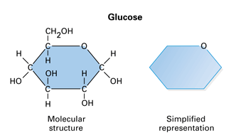 | 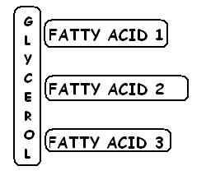 | 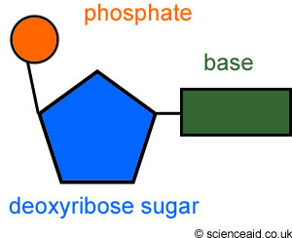 | 