Kingdom Protista
Domain: Eukarya
Eukaryotic Cell (Has a nucleus)
Unicellular and Multicellular
Autotrophic and Heterotrophic
May or May Not Have A Cell Wall (Made of Cellulose)

Organized into three different groups: 1 – Fungus Like
2 – Animal Like
3 – Plant Like

- Pyrrophyta (Fire Plants) – Ex) Dinoflagellate
Autotrophic or Heterotrophic
Has a flagella
Can be luminescent
Algal bloom (Red Tide – produces toxin)

- Bacillariophyta (Diatoms) – Unicellular
Cell Wall of Silicon not Cellulose
Most Abundant Organisms on Earth
Commonly Called Phytoplankton
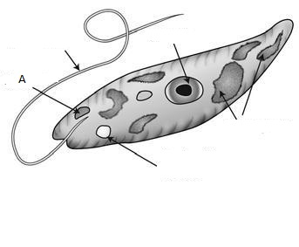
- Euglenophyta (Euglena) – Unicellular
No Cell Wall
Autotrophic & Heterotrophic
Uses a flagella to move
around to find food and light

Plant-Like Protists
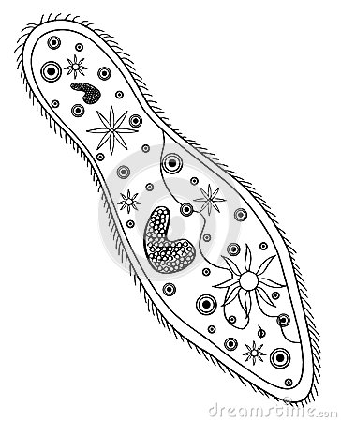
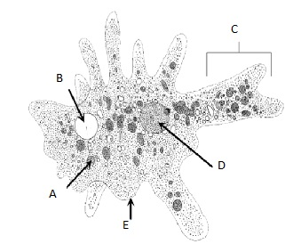

- Heterotrophic
- Lacks a Cell Wall
- Unicellular

Organized Based on How they Move (Obtain Energy)
- Sarcodina - Ex) Amoeba (Ameba)
Uses pseudopodia/pseudopods (false foot) to move and
gain energy
Can cause amebic dysentery
- Ciliophora (Ciliates)- Ex) Paramecium and Stentor
Uses small hair like projections called cilia to move
and obtain energy
- Sporozoans – Ex) Plasmodium (Causes Malaria)
Do not move on their own
Mostly Parasitic
- Zooflagellates – Ex) Trypanosoma (African Sleeping Sickness)
Trichonympha (Symbiotic Relationship with Termites)
Giardia (Causes Giardiasis)
Uses Flagella to Move

Animal-Like Protists

- Autotrophic
- Unicellular or Multicellular
Classified Based on Chlorophyll (Coloration)
- Chlorophyta (Green Algae) – Ex) Volvox, Spirogyra, Ulva
Ancestor to Modern Plants
Chlorophyll A and B
Used in cosmetics and paints and food
May be unicellular or multicellular
- Rhodophyta (Red Algae) - Mostly multicellular
Lives at Great Depths (Absorbs Blue Light)
Used in ice cream and pudding
Important to coral formation

- Phaeophyta (Brown Algae) – Ex) Kelp
Multicellular
Largest Algae (Up to 60 meters long)
Uses a swim bladder to stay upright

- Heterotrophic Decomposers (External Digestion)
- Found in Damp Moist Environments (Commonly called Molds)
- Reproduce by Spores (Asexual) or Alternation of Generations (Sexual)
- Phylums: Acrasiomycota, Myxomycota, Oomycota
- Caused the Great Potato Famine

Fungus-Like Protists

