 | Kingdom  Archaebacteria | Kingdom  Eubacteria | Kingdom  Protista | Kingdom  Fungi | Kingdom  Plantae | Kingdom  Animalia
Prokaryotes or Eukaryotes | PRO | PRO | EU | EU | EU | EU
Unicellular or Multicellular | UNI | UNI | Animal-like uni, most plant-like multi | MULTI EXCEPT YEAST | MULTI | MULTI
Energy Source/Food | AUTOTROPH  HETEROTROPH  DECOMPOSER | AUTOTROPH  HETEROTROPH  DECOMPOSER | Animal-like, heterotroph  Plant-like, autotroph  Fungus-like, decomposer | DECOMPOSER | AUTOTROPH | HETEROTROPH
Reproduction: Asexual/Sexual | Asexual = Binary Fission  Sexual = Conjugation | Asexual = Binary Fission  Sexual = Conjugation | Asexual = Binary Fission  Sexual = Conjugation | Mostly sexual by using spores | Sexual by either spores or seeds | Asexual or Sexual
Important Facts or Vocabulary Words
Major groups | Example Types:  1. Thermophiles  2. Halophiles  3. Acidophiles  Kingdom Archaebacteria Continued | 3 Shapes:  1. Coccus- round  2. Bacillus- rod  3. Spirillum- spiral  3 Arrangements:  1. Strepto- chains  2. Staphylo- clusters  3. Diplo- or Di- two  Kingdom Eubacteria Continued | 1. Animal-like  -unicellular and heterotrophs and no cell wall  Ex: a. Amoeba  b. Paramecium  2. Plant-like  -uni or multi and autotrophs and cell wall of cellulose  Ex: a. Macro-algae  b. Micro-algae  3. Fungus-like  -decomposers  Kingdom Protista Continued | 1. Zygomycota  a. bread mold  b. reproduces by zygospores  2. Ascomycota  a. Yeast  b. reproduces by ascospores  3. Basidiomycota  a. mushrooms  b. reproduces by basidiospores  4. Deuteromycota  a. Imperfect Fungi such as Penicillium (orange mold)  b. only fungus that reproduces asexually only, no spores  Kingdom Fungi Continued | 1. Bryophyta  a. moss  b. no seeds, reproduces by spores  c. no vascular tissue  2. Pterophyta  a. ferns  b. no seeds, reproduces by spores  c. does have vascular tissue  3. Coniferophyta  a. conifers (gymnosperms)  b. reproduce by seeds  c. does have vascular tissue  4. Anthophyta  a. angiosperms  b. reproduce by seeds  c. vascular tissue  Kingdom Plantae Continued | Invertebrates:  1. Porifera  a. sponges  b. sessile, filterers  2. Cnidaria  a. jellyfish  b. stinging cells  3. Platyhelminthes  a. tapeworm  b. flatworms  4. Nematoda  a. hookworms, pin  b. parasitic, round  5. Annelida  a. earthworms  b. segmented  6. Mollusca  a. octopus, snails, clams  b. muscular foot  7. Arthropoda  a. insects, lobsters  b. exoskeleton  8. Echinoderms  a. starfish, sand dollars, sea urchins  Kingdom Animalia Continued
 | Label a typical bacteria cell.  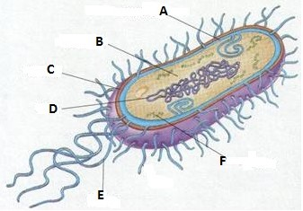  A. cell membrane  B. DNA region  C. cell wall  D. DNA  E. flagella  F. ribosomes | Draw the following examples:  1. Streptococcus  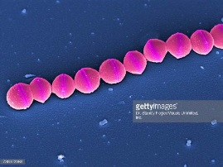  2. Streptobacillus  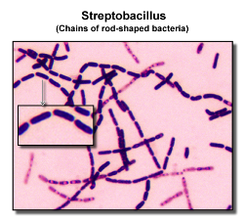  3. Staphylococcus  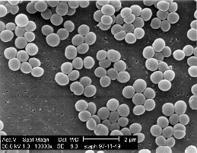 | Label the amoeba and paramecium.  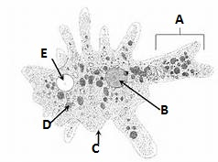  A. pseudopod  B. nucleus  C. cell membrane  D. food vacuole  E. contractile vacuole  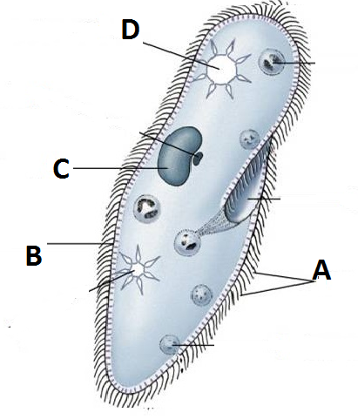  A. cilia  B. cell membrane called a pellicle  C. nucleus  D. contractile vacuole | Label the mushroom.  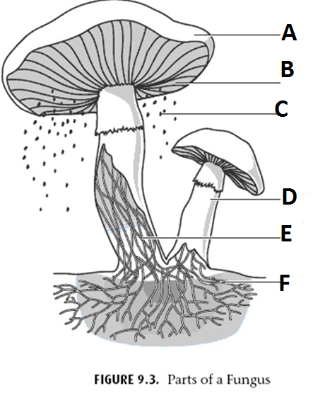  A. cap  B. gills  C. spores  D. stalk  E. hyphae- one single filament  F. mycelium- a mass of underground hyphae | Diagram  Phototropism: plants grow and bend toward light  Diagram Gravitropism: roots always grow down toward gravity no matter what direction you turn the plant.  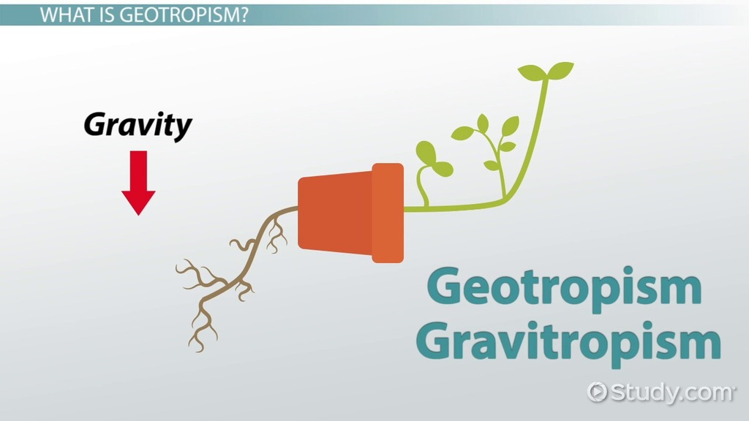 | Vertebrates:  1. Agnatha  a. jawless fish  b. lamprey  2. Chondrichthyes  a. cartilage skeleton  b. sharks  3. Osteichthyes  a. bony skeleton  b. salmon, trout  4. Amphibia  a. frogs  b. double life  5. Reptilia  a. snakes, lizards  b. amniotic eggs  6. Aves  a. birds  b. feathers  7. Mammalia  a. cat, dog, bear  b. hair and mammary glands

