 | Kingdom  Archaebacteria | Kingdom  Eubacteria | Kingdom  Protista | Kingdom  Fungi | Kingdom  Plantae | Kingdom  Animalia
Prokaryotes or Eukaryotes
Unicellular or Multicellular
Energy Source/Food

Reproduction: Asexual/Sexual

Important Facts or Vocabulary Words
Major groups | Example Types:  1.  2.  3.  Kingdom Archaebacteria Continued | 3 Shapes:  1.  2.  3.  3 Arrangements:  1.  2.  3.  Kingdom Eubacteria Continued | 1. Animal-like  -unicellular and heterotrophs and no cell wall  Ex: a.  b.  2. Plant-like  -uni or multi and autotrophs and cell wall of cellulose  Ex: a.  b.  3. Fungus-like  -decomposers  Kingdom Protista Continued | 1. Zygomycota  a.  b.  2. Ascomycota  a.  b.  3. Basidiomycota  a.  b.  4. Deuteromycota  a.  b.  Kingdom Fungi Continued | 1. Bryophyta  a.  b.  c.  2. Pterophyta  a.  b.  c.  3. Coniferophyta  a.  b.  c.  4. Anthophyta  a.  b.  c.  Kingdom Plantae Continued | Invertebrates:  1. Porifera  a.  b.  2. Cnidaria  a.  b.  3. Platyhelminthes  a.  b.  4. Nematoda  a.  b.  5. Annelida  a.  b.  6. Mollusca  a.  b.  7. Arthropoda  a.  b.  8. Echinoderms  a.  Kingdom Animalia Continued
 | Label a typical bacteria cell.  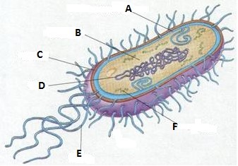  A.  B.  C.  D.  E.  F. | Draw the following examples:  1. Streptococcus  2. Streptobacillus  3. Staphylococcus | Label the amoeba and paramecium.  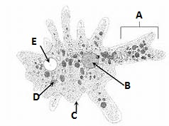  A.  B.  C.  D.  E.  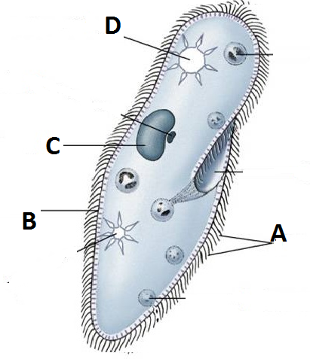  A.  B.  C.  D. | Label the mushroom.  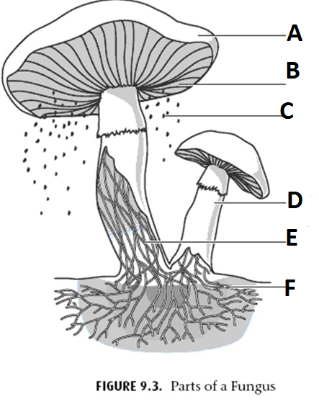  A.  B.  C.  D.  E.  F. | Diagram  Phototropism:  Diagram Gravitropism: | Vertebrates:  1. Agnatha  a.  b.  2. Chondrichthyes  a.  b.  3. Osteichthyes  a.  b.  4. Amphibia  a.  b.  5. Reptilia  a.  b.  6. Aves  a.  b.  7. Mammalia  a.  b.

