Kingdom Plantae
Prokaryotes or Eukaryotes? | Unicellular or Multicellular? | Autotroph or Heterotroph? | Cell Walls? If so, composed of? | Methods of Reproduction | Main Groups or Phyla (Divisions)
Eukaryotes | Multicellular | Autotrophs | Yes, composed of cellulose | 1. Mosses and Ferns have an alternation of generations with spores  2. Conifers and Flowering Plants reproduce by seeds | 1. Bryophyta (mosses)  2. Pterophyta (ferns)  3. Coniferophyta  (conifers)  4. Anthyphyta  (flowering plants)

Important Vocabulary:
1. Vascular tissue- system of transport tubes inside a plant for water and food; examples are xylem and phloem
2. Xylem- tube that transports water and minerals up from the roots
3. Phloem- tube that transports food down from the leaves
4. Stomata- openings in the leaf that allow for gas exchange for photosynthesis
5. Ethylene- hormone that stimulates the ripening of fruits
6. Phototropism- plant behavior that causes it to bend/grow toward light
7. Gravitropism- plant behavior that causes roots to grow down and stems to grow up no matter the direction of the seed
8. Geotropism- similar to gravitropism
9. Thigmotropism- plant behavior that causes it to respond to touch
10. Equation for Photosynthesis- 6CO2 + 6H2O + sunlight C6H12O6 + 6O2
Examples:
For the equation of photosynthesis above, highlight the needed reactants in yellow and the products released in green.
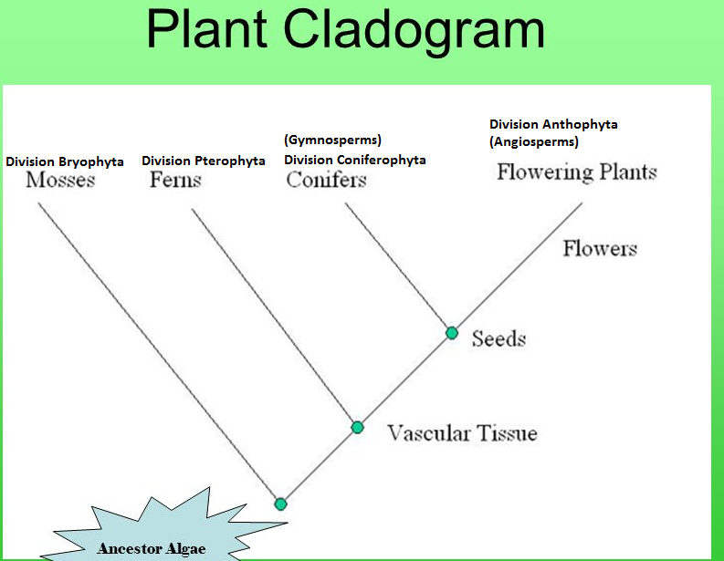
1. The ancestor of land plants is green algae according to the above cladogram.
2. Which division is non-vascular (no xylem or phloem)? Division Bryophyta (mosses)
3. If a plant is non-vascular, what does that mean for the plant? It must live close to ground; it will be small
3. Which divisions contain vascular tissue? Divisions Pterophyta, Coniferophyta, Anthophyta
4. What is the advantage of having vascular tissue? Can grow taller due to transportation system for food/water
5. Which divisions have seeds? Divisions Coniferophyta and Anthophyta
6. What is the advantage of having seeds? Plants do not need water in order to reproduce
3. Which division is known as gymnosperms and produce seeds in cones? Division Coniferophyta
4. Which division is known as angiosperms and produce seeds in fruits? Division Anthophyta

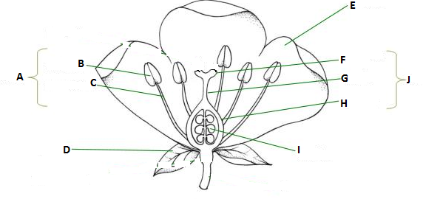
Common Flower (Angiosperm) Diagram. Label the parts of the flower and give their function.
A- stamen- male reproductive organ; made up of anther and filament
B- anther- produces pollen (the male gamete)
C- filament- stalk that raises the anther
D- sepals- protects the flower before it grows
E- petals- brightly colored to attract pollinators
F- stigma- sticky to attract pollen
G- style- contains pollen tube so pollen attracted to the stigma can fall down to the ovules (eggs)
H- ovary- produces ovules (eggs- the female gamete)
I- ovules- (eggs) female haploid gamete
J- pistil (also called carpel)- female reproductive organ; made up of stigma, style, ovary, ovules

Kingdom Animalia
Prokaryotes or Eukaryotes? | Unicellular or Multicellular? | Mode of Nutrition | Cell Walls? If so, composed of? | Methods of Reproduction | Main Groups or Phyla
Eukaryotes | Multicellular | Heterotrophs | No cell walls | Some do asexual, some do sexual, some can do both | 1. Invertebrates  2. Vertebrates

Important Vocabulary:
1. Vertebrate- animals that have a backbone
2. Invertebrate- animals that do not have a backbone
3. Bilateral Symmetry- body plan in which a single imaginary line would split the organism into two equal halves
4. Radial Symmetry- body plan in which body parts repeat around the center of the body
5. Sessile- describes an organism that cannot move
6. Motile- describes an organism that can move
7. Cephalization- a concentration of nerve cells at the anterior (front) end of an organism
8. Notochord- long, supporting rod that runs through a chordate’s body just below the nerve cord
9. External fertilization- sperm and egg fertilization outside of the mother’s body
10. Internal fertilization- sperm and egg fertilization inside the mother’s body
11. Ectothermic- regulating an organisms heat by responding to its environment; lizard moving into sun to heat up
12. Endothermic- an organism that can internally regulate its body temperature
13. Exoskeleton- skeleton outside of the organism’s body; tough covering for support and protection
14. Endoskeleton- skeleton/structural support inside the body of an animal
Examples. For each of the taxons below, give what organisms belong to the group and one or two distinguishing characteristics of that group.
Invertebrates
1. Phylum Porifera- sponges characterized by sessile and filter feeders
2. Phylum Cnidaria- jellyfish characterized by stinging cells
3. Phylum Platyhelminthes- flatworms like tapeworms characterized by flat body plan; 2 body openings
4. Phylum Nematoda- roundworks like hookworms characterized by round body plan; 2 body openings
5. Phylum Annelida- segmented worms like earthworms characterized by round and segmented body plan; 2 openings
6. Phylum Mollusca- snails, octopus, clams characterized by muscular foot
7. Phylum Arthropoda- insects characterized by jointed appendages (also have a segmented body)
8. Phylum Echinodermata- starfish characterized by radial symmetry
9. Phylum Chordata- mostly vertebrates characterized by dorsal nerve cord, notochord, pharyngeal gill slits
a. Subphylum Vertebrata- animals with a vertebrae characterized by backbone
i. Class Agnatha- jawless fish characterized by fish without jaws
ii. Class Chondrichthyes- sharks characterized by fish with jaws and a cartilage skeleton
iii. Class Osteichthyes- perch, trout, etc. characterized by fish with jaws and a bony skeleton
iv. Class Amphibia- frogs characterized by four limbs, first organisms on land, still have to reproduce in water
v. Class Reptilia- snakes, turtles, lizards characterized by amniotic egg; no longer need water to reproduce
vi. Class Aves- birds characterized by feathers, first endotherms, four-chambered heart
vii. Class Mammalia- mammals characterized by body hair and mammary glands; care for young
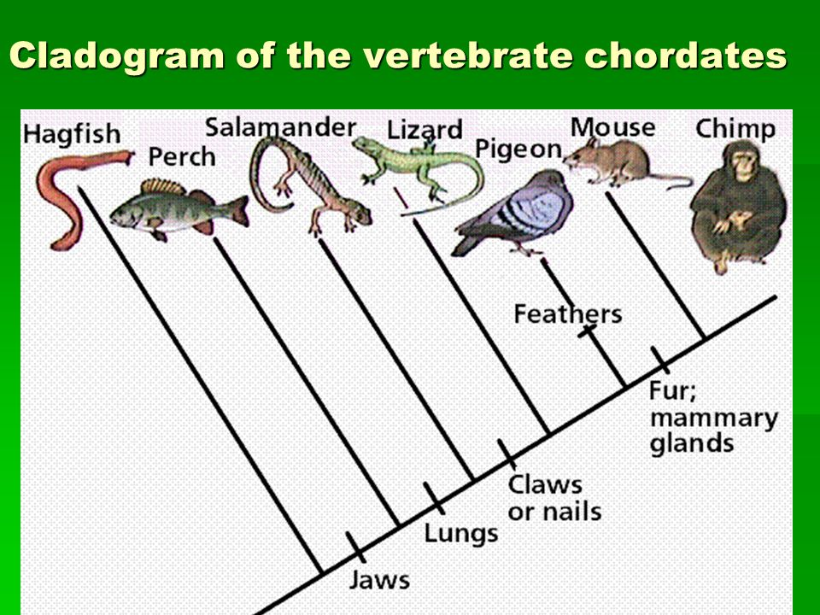
1. What class is the most primitive group of fishes and what example is given here? Agnatha; jawless fish
2. What trait distinguishes bony fish like the perch from the hagfish? Having jaws
3. What trait allowed amphibians to be the first land animals? Lungs and four limbs
4. Amphibians are tied to water to reproduce. What trait makes reptiles different from amphibians when it comes to reproduction? Amniotic eggs contain water inside so they don’t have to lay eggs in water
5. What distinguishes the birds from other groups? feathers
6. What other traits to birds possess that reptiles do not? Four-chambered heart; endothermic
____________________________________________________________________________________________
7. What trait do mammals possess that other animals do not? Fur and mammary glands
8. What is the advantage of having these traits? Mammary glands feed young; fur keeps animals warm

