Name: ___________________________________________ Period: ______ Date: ____________________
PLANTAE AND ANIMALIA STUDY GUIDE
Kingdom Plantae
Prokaryotes or Eukaryotes? | Unicellular or Multicellular? | Autotroph or Heterotroph? | Cell Walls? If so, composed of? | Methods of Reproduction | Main Groups or Phyla (Divisions)
1.

2.

3.

4.

Important Vocabulary:
1. Vascular tissue- __________________________________________________________________________________
2. Xylem- _________________________________________________________________________________________
3. Phloem- ________________________________________________________________________________________
4. Stomata- _______________________________________________________________________________________
5. Ethylene- _______________________________________________________________________________________
6. Phototropism- ___________________________________________________________________________________
7. Gravitropism- ___________________________________________________________________________________
8. Geotropism- ____________________________________________________________________________________
9. Thigmotropism- __________________________________________________________________________________
10. Equation for Photosynthesis- ______________________________________________________________________
Examples:
For the equation of photosynthesis above, highlight the needed reactants in yellow and the products released in green.
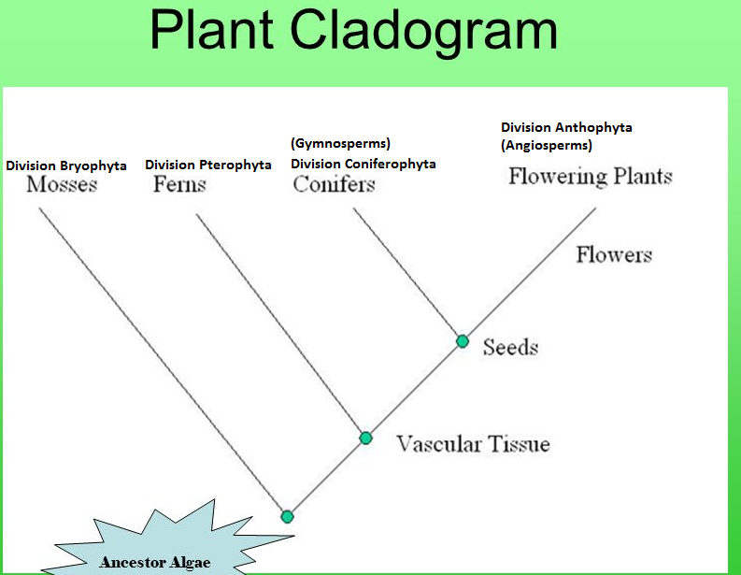

1. The ancestor of land plants is _______________ according to the above cladogram.
2. Which division is non-vascular (no xylem or phloem)? ________________________________________________
3. If a plant is non-vascular, what does that mean for the plant? _________________________________________
3. Which divisions contain vascular tissue? __________________________________________________________
4. What is the advantage of having vascular tissue? ___________________________________________________
5. Which divisions have seeds? ____________________________________________________________________
6. What is the advantage of having seeds? ___________________________________________________________
3. Which division is known as gymnosperms and produce seeds in cones? __________________________________
4. Which division is known as angiosperms and produce seeds in fruits? ___________________________________

In the boxes write the correct flower part and its function.

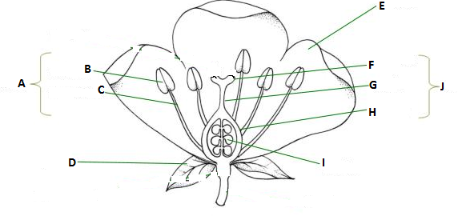

Kingdom Animalia
Prokaryotes or Eukaryotes? | Unicellular or Multicellular? | Mode of Nutrition | Cell Walls? If so, composed of? | Methods of Reproduction | Main Groups or Phyla
1.

2.

Important Vocabulary:
1. Vertebrate- _____________________________________________________________________________________
2. Invertebrate- ____________________________________________________________________________________
3. Bilateral Symmetry- _______________________________________________________________________________
4. Radial Symmetry- ________________________________________________________________________________
5. Sessile- _________________________________________________________________________________________
6. Motile- _________________________________________________________________________________________
7. Cephalization- ___________________________________________________________________________________
8. Notochord- ______________________________________________________________________________________
9. External fertilization- ______________________________________________________________________________
10. Internal fertilization- _____________________________________________________________________________
11. Exothermic- ____________________________________________________________________________________
12. Endothermic- ___________________________________________________________________________________
13. Exoskeleton- ___________________________________________________________________________________
14. Endoskeleton- __________________________________________________________________________________
Examples. For each of the taxons below, give what organisms belong to the group and one or two distinguishing characteristics of that group.
Invertebrates
1. Phylum Porifera- ______________________ characterized by _____________________________________________
2. Phylum Cnidaria- ______________________ characterized by _____________________________________________
3. Phylum Platyhelminthes- ________________ characterized by ____________________________________________
4. Phylum Nematoda- ____________________ characterized by _____________________________________________
5. Phylum Annelida- ______________________ characterized by ____________________________________________
6. Phylum Mollusca- ______________________ characterized by ____________________________________________
7. Phylum Arthropoda- ____________________ characterized by ____________________________________________
8. Phylum Echinodermata- _________________ characterized by ____________________________________________
9. Phylum Chordata- _____________________ characterized by _____________________________________________
a. Subphylum Vertebrata- ______________________ characterized by _________________________________
i. Class Agnatha- _______________________ characterized by _________________________________
ii. Class Chondrichthyes- ________________ characterized by _________________________________
iii. Class Osteichthyes- __________________ characterized by _________________________________
iv. Class Amphibia- _____________________ characterized by _________________________________
v. Class Reptilia- _______________________ characterized by _________________________________
vi. Class Aves- _________________________ characterized by _________________________________
vii. Class Mammalia- ____________________ characterized by _________________________________
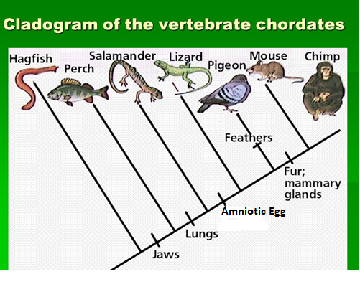
1. What class is the most primitive group of fishes and what example is given here? _______________________
2. What trait distinguishes bony fish like the perch from the hagfish? ___________________________________
3. What trait allowed amphibians to be the first land animals? ________________________________________
4. Amphibians are tied to water to reproduce. What trait makes reptiles different from amphibians when it comes to reproduction? _______________________________________________________________________
5. What distinguishes the birds from other groups? _________________________________________________
6. What other traits to birds possess that reptiles do not? ____________________________________________
____________________________________________________________________________________________
7. What trait do mammals possess that other animals do not? ________________________________________
8. What is the advantage of having these traits? ____________________________________________________

