PHYLUM PORIFERA  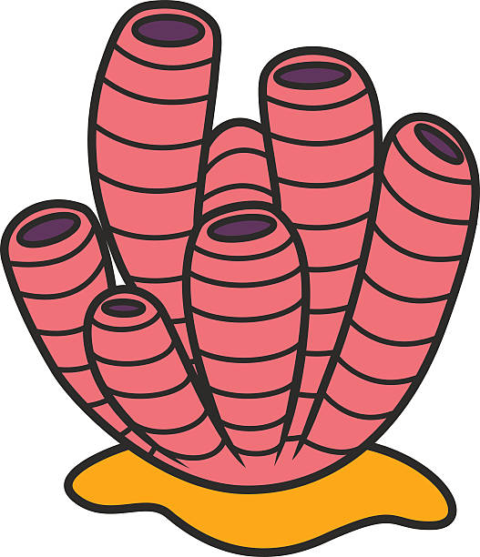 | - “pore bearers”  - asymmetrical  - sessile  - filter feeders  - can reproduce asexually by budding and sexually by producing both sperm and eggs (hermaphrodites)
PHYLUM CNIDARIA  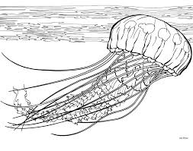 | - radial symmetry  - stinging cells  - two tissue layers (both endoderm and ectoderm)  - one body opening
PHYLUM PLATYHELMINTHES  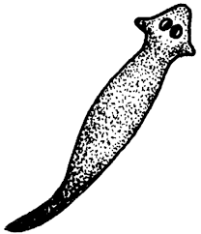 | - bilateral symmetry  - three tissue layers (endoderm, ectoderm, mesoderm)  - asexual reproduction by regeneration and sexually by producing sperm and eggs (hermaphrodites)  - one body opening  - worms that are completely flat
PHYLUM NEMATODA  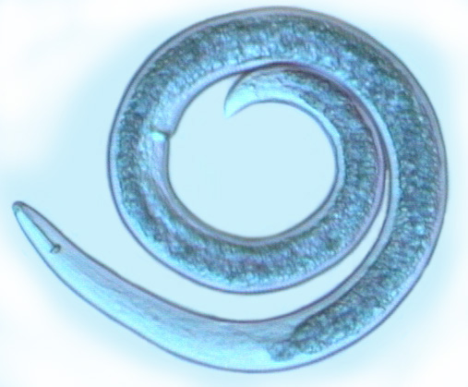 | - bilateral symmetry  - roundworms  - 2 body openings  - all members are parasitic  - hookworms, pinworms
PHYLUM ANNELIDA  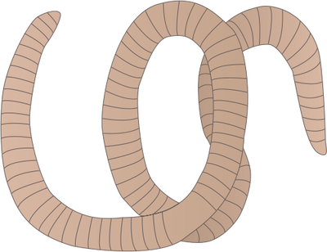 | - bilateral symmetry  - segmented worms  - 2 body openings  - first group to have a coelom (body cavity)
PHYLUM MOLLUSCA  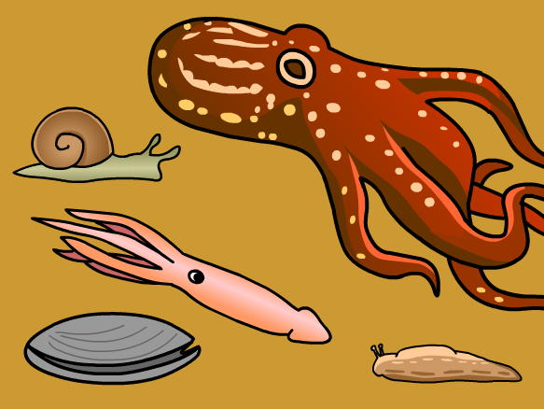 | - characterized by a muscular foot  - bilateral symmetry  - may have an internal or external shell
PHYLUM ARTHROPODA  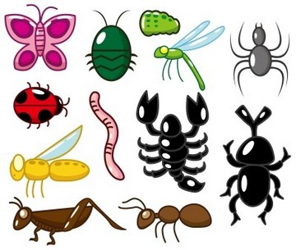 | - jointed appendages  - exoskeleton  - must molt to grow  - bilateral symmetry
PHYLUM ECHINODERMATA  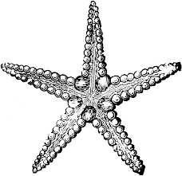 | - spiny skin  - radial symmetry  - endoskeleton  - water vascular system  - asexual reproduction by regeneration and sexual reproduction by producing

