Review Guide: Macromolecules and Introduction to Cells Name: __________________________________

Organizing Information: Place the letter for each statement into the correct area in the Venn diagram.

# A. Carbon compounds that speed up

# chemical reactions

B. Sugars or starches

C. Found in many living organisms

D. Used for building or repairing body parts

E. non-polar portion of the cell membrane

F. Used to store energy

G. Do not mix with water

H. Found in meats and beans

I. Fats and oils

J. Found in bread, rice & pasta

K. Monosaccharides, disaccharides &

polysaccharides

L. Amino acids, dipeptides, & polypeptides

Practice Review Questions

1. All organic compounds contain what element?

2. What are the four categories of organic compounds?

3. I had fresh fruit and hash browns for breakfast, which type of organic compounds would be in these foods? What reagent test could be used to support the identification?

Fresh Fruit: Hash browns:

4. As a polar bear that lives at the North Pole, which category of organic compounds is most important to me?

5. The air is crisp, school has just started, time to make the team. As an athlete which organic compound am I trying to gain?

6. Genetic information is stored in the form of _________, which fits in which organic compound category?

7. Your body is continually changing, there are reactions happening all the time. These reactions only happen with the help of an __________, which fits in the organic compound category of _________.

8. The monomer for carbohydrates is the _______________, an example is glucose. When you put two of these together you get a _______________, an example is lactose. Both of these are commonly called sugars.

When three or more sugars are combined it is no longer called a sugar, we call it a polysaccharide, or __________.

9. The lipids category is __________________, which means it does not mix with molecules like water.

10. Proteins are created using this monomer, _________________.

1. _____________

2. _____________

3. _____________

4. _____________

5. _____________

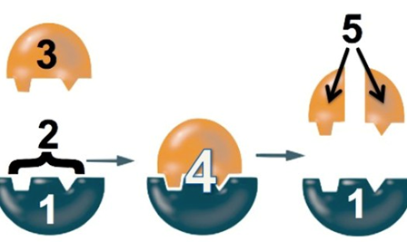Enzymes

1. Where on the enzyme do substrates bind?

2. After enzyme binds to the substrate, what is made?

3. What do enzymes do for a reaction?

4. Can enzymes be reused?

5. What changes can denature an enzyme?



Cell Structures

1. State the three parts of the cell theory:

A.

B.

C.

2. Complete the chart below with the missing information pertaining to the scientists who researched and contributed to the discovery/study of cells.

|  |  |
| --- | --- |
| Name of Scientist | Contribution/Discovery |
| Robert Hooke |  |
|  | First scientist to describe organisms under a microscope, “Animalcules” |
|  | Discovered all plants made of cells |
| Theodor Schwann |  |
| Rudolph Virchow |  |

3. Fill in the following chart about the two different types of cells with the information that corresponds with that cell

|  |  |  |
| --- | --- | --- |
|  | Prokaryotic  Cells | Eukaryotic  Cells |
| Do these cells have a nucleus? |  |  |
| Do these cells have membrane bound organelles? |  |  |
| Which kinds of organisms are made of these cells? |  |  |
| Are these cells Unicellular, Multicellular, or both? |  |  |

4. Using the picture below, determine if this cell is prokaryotic or eukaryotic? Explain how you were able to identify this cell as prokaryotic or eukaryotic.

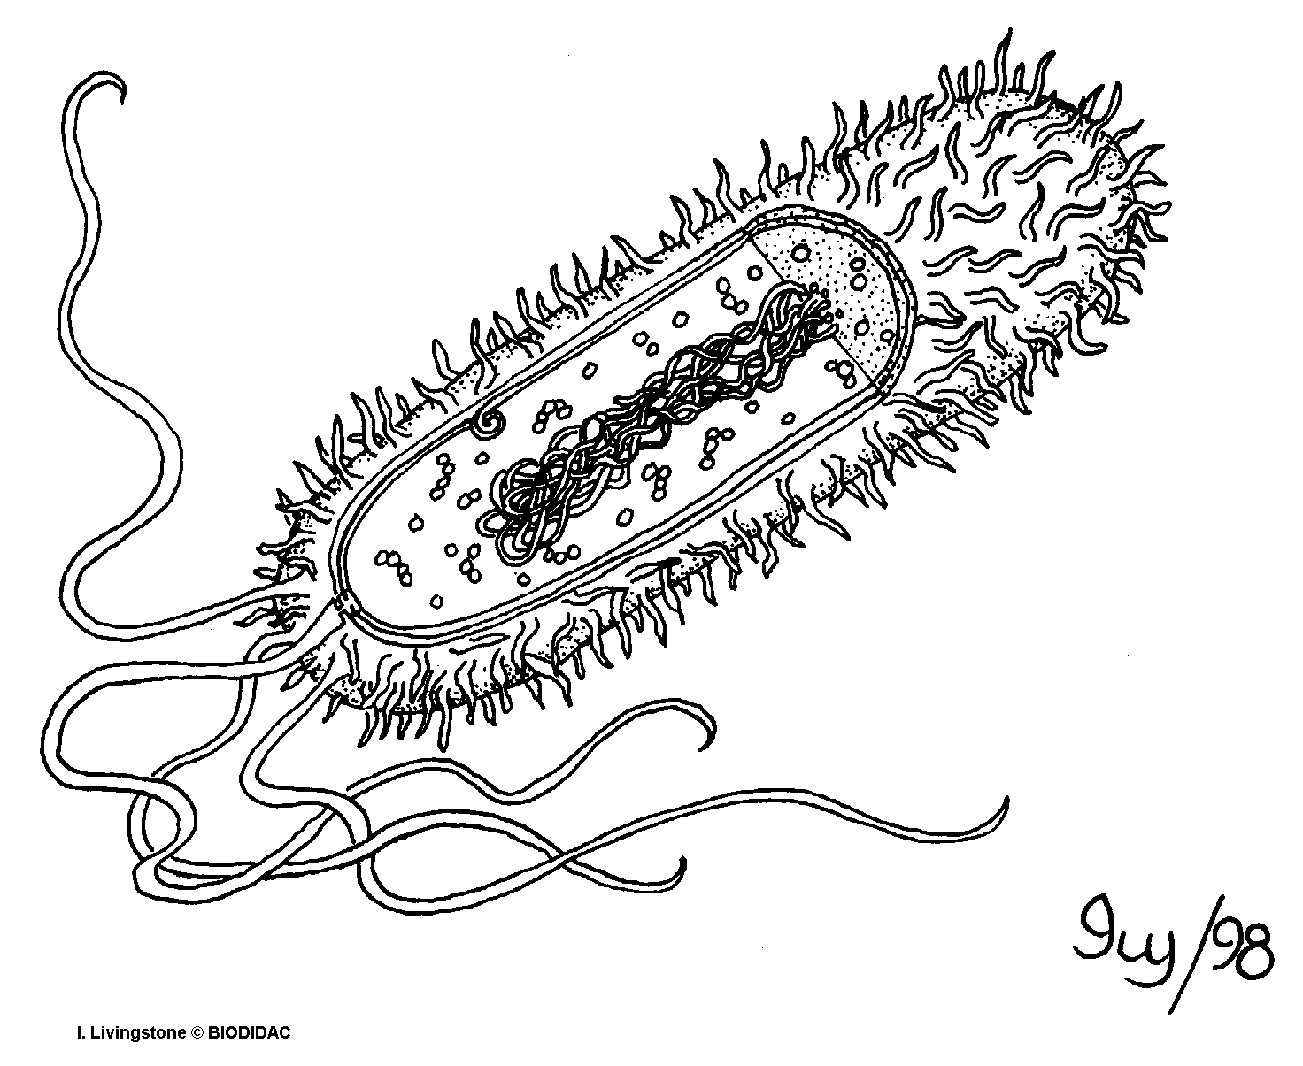

5. A scientist is observing an organism under the microscope that has never been discovered. After running additional tests, he was able to organize a chart of information about the cells of this organism. Based off the information from the chart below, what type of cell can the scientist conclude the organism is made of, prokaryotic or eukaryotic cells? Explain how you came to this conclusion.

______________________________________________________________________________________________________________________________________________________________________________________________________________________________________________________

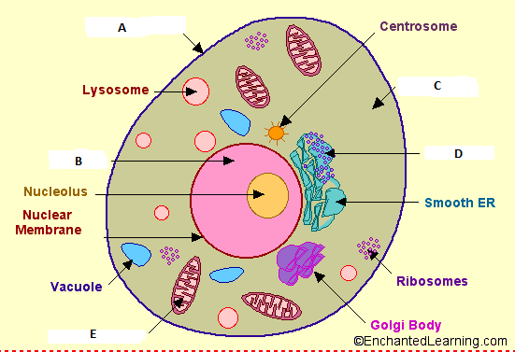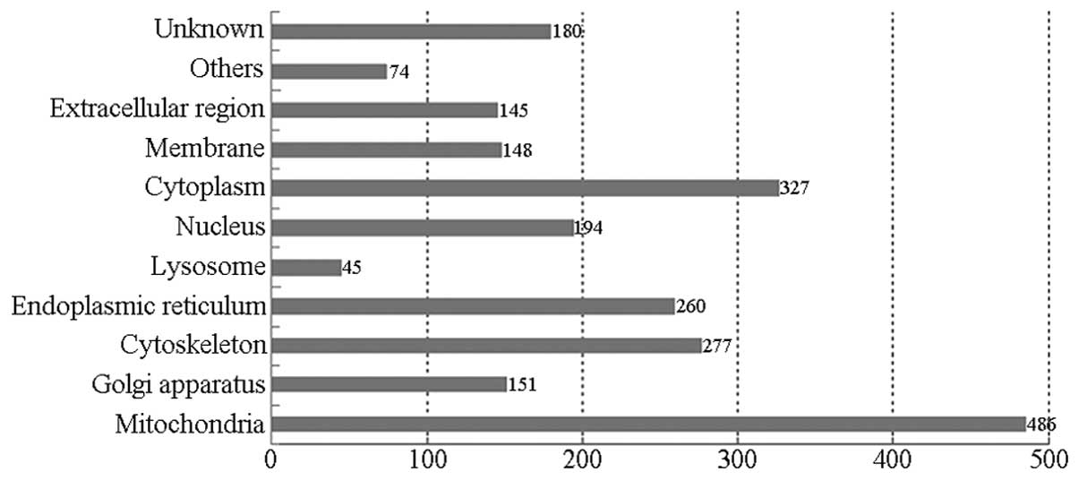

Use the picture to the left to answer the following questions:

1. What type of eukaryotic cell is displayed in the picture above? _________________________________
2. Letter A represents the organelle that controls what comes in and out of the cell and is made of a phospholipid bilayer. Identify what organelle Letter A represents. _____________________
3. The nucleus is the brain of the cell and controls all the cell’s activities. It also houses all of our genetic material. Which letter represents the nucleus of the cell above? ________

4. Which organelle is represented by the letter E? _____________________

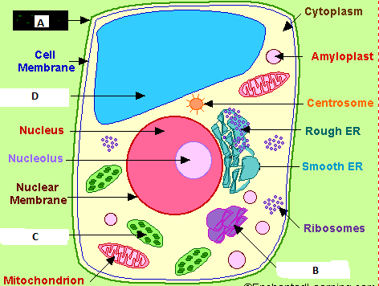 What is the job/function of this organelle? _________________________________

5. Which letter represents the jelly-like substance in a cell that the organelles float around in inside of the cell? _______ 6. What does Letter D represent? _____________________

What is the job/function of this organelle?

Use the following picture above to answer questions 1-4

The cell picture above is what kind of eukaryotic cell?

____________________________

Which two letters represent the structures that plant cells do have, but animal cells lack? ______ and _________

What are the functions of those structures?

_______________________________

What is the name and function of the organelle labeled Letter D? ________________________________

Letter B represents the organelle that can be nicknamed “UPS.”

What is the organelle? _____________________________________________________

Why is it called “UPS”? _____________________________________________________

**[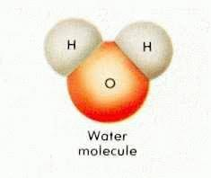](http://images.google.com/imgres?imgurl=http://www.lenntech.com/images/Water%20molecule.jpg&imgrefurl=http://www.lenntech.com/water-chemistry-FAQ.htm&h=198&w=235&sz=5&hl=en&start=4&usg=__wNiDnCR-GC8dglZEyHobrwUdoIE=&tbnid=MnLgzZa7RwUCAM:&tbnh=92&tbnw=109&prev=/images?q%3Dwater%2Bmolecule%26gbv%3D2%26hl%3Den)Properties of Water**

1) Label which element in this water molecule would be positive and which would be negative.

**True- False**

___2) Water is made up of 2 atoms of hydrogen and 1 atom of oxygen to form a molecule.

___3) Water contains half as many hydrogen atoms as oxygen atoms.

___4) Water is a polar molecule which means it has slightly charged ends. This unique molecule is why it has so many unique properties.

___5) The chemical formula for water is H2O.

6) A molecule that has electrically charged ends is called a _____________ molecule. This means it bonds to like molecules and ionic molecules.

7) ____________ _______________ describes how water moves against gravity and can travel up a plants roots into its stem and leaves.

8) ____________ __________________ describes how the surface of water acts like a skin and seals up quickly after being disturbed. This allows water striders and Jesus Christ lizard to appear to “walk” on water.

9) _________________ is the property of water that causes water molecules to “stick” to each other.

10) ___________________ is the property of water that causes water molecules to “stick” to other substances. Ex. Glass of water sweats and sticks to a coaster

11) A mixture forms when one substance, the _________________, dissolves into the solvent. The property that describes the “dissolving” ability of water is______________________.

12) Water is called the ______________ ________________ because of its ability to dissolve so many different substances.

Practice Multiple Choice

1. Which of the following statements is/are true regarding the chemical reaction illustrated below?

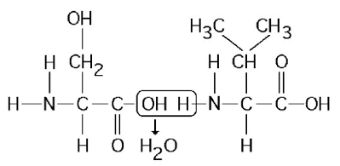

a. It is a hydrolysis reaction. c. It is a hydrolysis reaction and it results in a peptide bond.

b. It results in a peptide bond. d. It is a hydrolysis reaction, it results in a peptide bond, and it joins two fatty acids together.

2. A biologist wants to use a radioactive isotope of nitrogen to radiolabel certain molecules in a culture of cells she is growing. If the biologist uses 15N, which of the following groups of macromolecules will be labeled in the culture of cells?

a. Phospholipids b. Proteins. c. Nucleic acids d. Nucleic acids and proteins

3. Tay-Sachs disease is a human genetic abnormality that results in cells accumulating and becoming clogged with very large and complex lipids. Which cellular organelle must be involved in this condition?

a. the endoplasmic reticulum b. the lysosome. c. the Golgi apparatus d. membrane-bound ribosome

4- What would happen to the changes in energy if this reaction was controlled by an enzyme?

a. I would increase c. I and IV would decrease

b. II would decrease d. II and III would decrease

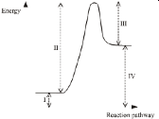

5- Which of the following effects is produced by the high surface tension of water?

a. Lakes don't freeze solid in winter, despite low temperatures

b. A water strider can walk across the surface of a small pond.

c. Organisms resist temperature changes, although they give off heat due to chemical reactions.

d. Water flows upward from the roots to the leaves in plants.