Honors Benchmark #1 Review Name: _______________________________________

Topic/Question | Answer
Scientific Method

Independent/Dependent Variables – What are they? Where on a graph?

Characteristics of Living Things
Homeostasis
Stimuli

What is not a
characteristic?

Viruses  Parts  Reproduction  Provirus (Prophage)  Dormant  DNA vs. RNA Virus  Vaccinations | 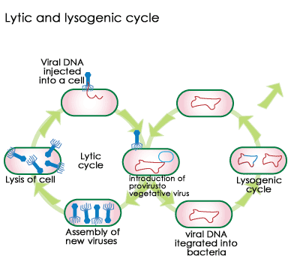
Parts of a Prokaryote | 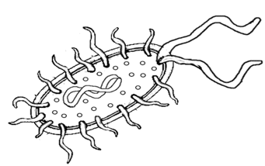
Bacteria

Basics –
Reproduction/Energy

Bacterial Shapes

Uses

Endospore

Archaebacteria v.
Eubacteria
Cell Wall

Locations

Examples?

Protists  Fungus Like  Animal Like  Plant Like  Special Structures – Cilia, Flagella, Contractile Vacuole, Pseudopods | 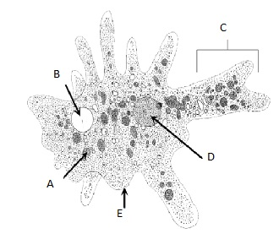  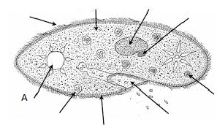
Fungi
Basics – Energy
Hyphae
Mycelium

4 Phylums
Common Name
Examples

Plants  Characteristics of Each  Division  Tropisms | 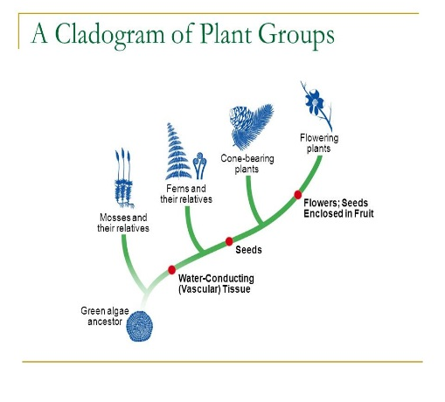
Flower Parts and Functions | 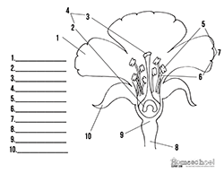
Animal
Basics
Radial, Bilateral, or
Asymmetrical

Segmented Body Plan

Endothermic

Invertebrates (8)

Phylum Chordata
Vertebrates (7)

Classification Basics  Taxonomic Levels  Binomial  Nomenclature  Dichotomous Key | 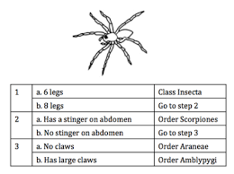
Scientific Tools  Cladograms | 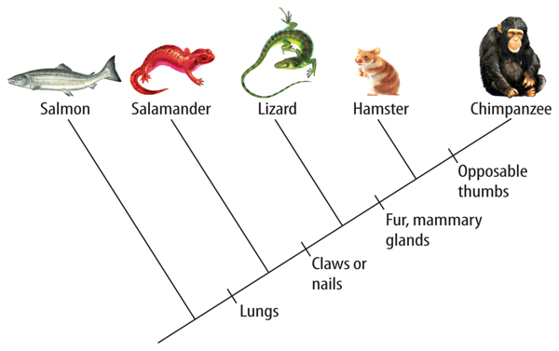
Chemistry of Life

Parts of an Atom

Elements that make up all living things

Types of Bonds found in compounds

Water’s chemical formula

Polar Molecules

Hydrophilic vs hydrophobic

Properties of water and examples

pH scale

Acids

Bases

