Name: _KEY____________________________ Period: __________ Date: ______________

**Biology Test 1 Study Guide**

Characteristics of Living Things, Viruses, Classification of Living Things

**I. Review Concepts**

A. Lab Safety: *For each of the lab safety scenarios below, highlight what the student did wrong, and write what the student should have done in the spaces below.*

1. The teacher was not in the room yet. Jake began weighing chemicals, touching them with his hands. His nose itched, so he rubbed it. Don’t touch anything until the teacher tells you to. If you get chemical on your hands, wash them first.

2. Cindy broke a test tube. Carefully, she picked up the pieces with one hand and placed them in the other hand. Then she dumped the glass pieces into the trash can. If you break glass, don’t touch it. The teacher will put it in the broken glass container.

3. The cuff of Sam’s long sleeved shirt caught fire. He ran to show his teacher. Wear short sleeve shirts. If your clothing catches fire, don’t run, either stop, drop and roll or use a fire blanket to smother the flames.

B. Scientific Method: *Read the scientific scenario below and answer the questions that follow.*

Maggie read that some plants grow better if the soil is acidic. She can’t believe that a plant can grow when exposed to acid. Maggie decides to test if the plants she has will grow better when acid is added to the soil. She puts potting soil in two planting containers and transplants two of her geraniums that seem about the same size into the pots. She puts the pots in the same location so that they both get the same sunlight each day, are at the same temperature and she makes sure they get the same amount of water. However, Maggie puts a tablespoon of vinegar in the water she gives to one of the plants. She measures the growth of the plants every week for five weeks and records the results in a data table below:

|  |  |  |
| --- | --- | --- |
| **Week** | **Height of plants in container WITH vinegar**  **(cm)** | **Height of plants in container WITHOUT vinegar (cm)** |
| **1** | 10.0 | 10.0 |
| **2** | 12.4 | 11.5 |
| **3** | 14.8 | 13.0 |
| **4** | 18.0 | 15.7 |
| **5** | 21.4 | 17.8 |

1. Hypothesis: _If I add vinegar to my plant’s water supply, the plants will grow taller._

2. Independent Variable: _type of water given (either vinegar water or plain water__

3. Dependent Variable: _the height of the plants__

4. Experimental Group: __the group of plants that received vinegar water___

5. Control Group: __the group of plants that received the plain water____

6. Constants: __sunlight, amount of water, temperature__

**II. Characteristics of Living Things**

A. Characteristics of Living Things: *List the eight characteristics of living things in the spaces below.*

1. Composed of cells 3. Obtain materials and use energy 5. Contain a universal genetic code 8. Grow/

2. Reproduction 4. Evolve/Adapt 6. Maintain homeostasis 7. Respond to stimuli Develop

B. Vocabulary Matching: *Match the vocabulary word with its correct definition.*

__F__ 1. Unicellular a. A cell that does not contain a nucleus or membrane-bound organelles

__K__ 2. Multicellular b. The genetic code for all living things

__A__ 3. Prokaryote c. Two organisms combining DNA to produce a genetically different offspring

__H__ 4. Eukaryote d. A change in an organism in response to its environment

__C__ 5. Sexual Reproduction e. Carbohydrates, Proteins, Lipids, Nucleic Acids found in all living things.

__N__ 6. Asexual Reproduction f. Composed of only one cell

__D__ 7. Adapt g. Getting bigger by adding more cells

__J__ 8. Metabolism h. A cell that does contain a nucleus and membrane-bound organelles

__B__ 9. DNA i. The ability to keep a constant internal environment

__E__ 10. Macromolecules j. Taking in food and using it for energy

__I__ 11. Homeostasis k. Composed of many cells

__L__ 12. Stimulus l. Something that produces a response in an organism

__G__ 13. Grow m. Changing from one form to another

__M__ 14. Develop n. One organism producing an offspring that is genetically identical

C. Applying Concepts: *For each of the statements below, write the characteristic of living things that BEST applies.*

1. A bear eats a great amount of food in the summer and fall to prepare for hibernation in the winter.

Metabolism—taking in food and utilizing energy

2. Bacteria are the only prokaryotic organisms. All organisms are composed of one or more cells.

3. My neighbor is having twins. Reproduction

4. A butterfly starts as an egg, then enters the larval stage (caterpillar), then pupates, then becomes an adult.

Development

5. The fur of arctic polar bears has become thinner over the years due to slightly warmer temperatures in the arctic.

Adapting to the environment through natural selection

6. A protist, known as Euglena sp., is photosynthetic and thus will swim toward light. Response to stimuli

7. I begin sweating when I go out to exercise in the 104 degree heat. Maintaining homeostasis

8. A crime scene is investigated by using gel electrophoresis, a technique that compares the DNA of the victim to the DNA of potential suspects. All organisms are based on a universal genetic code, which is DNA.

*** IS motility a characteristic of living things? No organisms do not have to be motile to be alive.

*** Something must possess all 8 characteristics in order to be considered living. (True or False)

**III. Viruses**

A. Vocabulary: *Match the vocabulary term with its proper definition.*

__E__ 1. Capsid a. A virus that infects a bacterium

__F__ 2. Viral Nucleic Acid b. Viral cycle that involves the virus inserting its DNA into the host DNA

__G__ 3. Provirus c. The only way to prevent against a virus (antibiotics don’t help!)

__A__ 4. Bacteriophage d. A living cell that is taken over by a virus and used to replicate new viruses

__D_ 5. Host cell e. Outer protein coat of a virus

__C__ 6. Vaccine f. Either DNA or RNA but never both

__H__ 7. Lytic g. Viral DNA that is inserted into host cell DNA

__B__ 8. Lysogenic h. Viral cycle that involves disabling host DNA and then using the host cell to lyse new viruses

B. Labeling: *Label each of the diagrams below.*

1. Label the virus below using the following words: 2. Label the 5 stages of lytic cycle below and tell what

sheath, tail fibers, capsid, DNA. is happening in each stage.

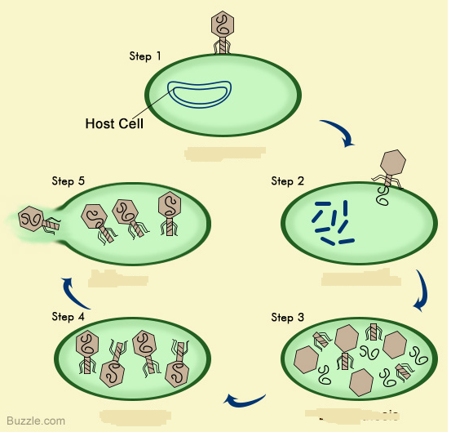

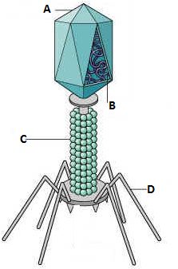

**A. CAPSID**

**B. DNA OR RNA**

**C. SHEATH**

**D. TAIL FIBERS**

**Step 1: Attachment- virus attaches to the host cell.**

**Step 2: Entry- virus injects DNA into host cell.**

**Step 3: Replication- viral DNA commands host to make more virus parts.**

**Step 4: Assembly- virus parts are put together**

**Step 5: Lysis- Host cell bursts open releasing new viruses.**

3. Tell how the lysogenic cycle is different from the lytic cycle above, and tell how it is similar.

Differences Provirus formation and Cell Division Similarities Attachment, Entry, Replication, Assembly and Lysis

**III. Classification**

A. Vocabulary: *Match the vocabulary word with its proper definition.*

__H__ 1. Taxonomy a. The smallest taxon

__C__ 2. Taxon b. The first person to develop a classification system based on color and movement

__E__ 3. Binomial Nomenclature c. A group or level of organization in taxonomy; a taxonomic category

__J__ 4. Kingdom d. Father of modern taxonomy

__A__ 5. Species e. A system of naming organisms with two names, a genus and a species

__B__ 6. Aristotle f. The study of comparing organisms based on a common ancestor

__D__ 7. Linnaeus g. Comparing the DNA and RNA sequences of different organisms

__F__ 8. Phylogeny h. The science of classifying organisms

__I__ 9. Comparative Embryology i. Comparing the embryo stages of different organisms

__G__ 10. Comparative Biochemistry j. The largest taxonomic category, other than the domain

B. Applications: *Answer the following questions or fill out the appropriate information.*

1. List the 7 taxa from largest to smallest, beginning after domain.

Domain, Kingdom, Phylum, Class, Order, Family, Genus, Species

2. When naming an organism using binomial nomenclature, which two levels of taxa are given to an organism? Genus and species

3. How are they written? Which one is capitalized? Genus is capitalized, species is lowercase, either underlined or italics

4. Using the scientific name of a human, *Homo sapiens*, which one is the genus? Which is the species? *Homo* is the genus and *sapiens* is the species

5. Use the chart below to answer the questions. 6. Identify the insect order below using the

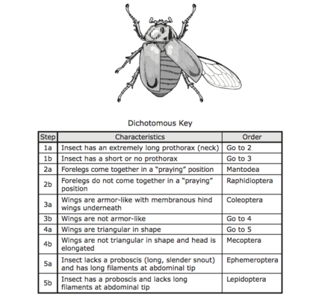 dichotomous key below. Order Coleoptera

|  |  |  |  |
| --- | --- | --- | --- |
| **TAXA** | **ALMOND** | **PEANUT** | **GREEN BEAN** |
| Kingdom | Plantae | Plantae | Plantae |
| Phylum | Angiosperms | Angiosperms | Angiosperms |
| Class | Rosids | Rosids | Rosids |
| Order | Rosales | Fabales | Fabales |
| Family | Rosaceae | Fabaceae | Fabaceae |
| Genus | *Prunus* | *Arachis* | *Phaseolus* |
| Species | *dulcis* | *hypogaea* | *vulgaris* |

a. Which organism is least related to the others? almond

b. Which two organisms are most closely related? Peanut and green bean

c. Why? They share more taxa

d. At which level do all three organisms differ? Genus level

Bacteria Review Guide Key

Vocabulary Matching:

__L__ 1. Archaebacteria a. Long, whip-like tail used for movement by some bacteria

__O__ 2. Eubacteria b. Round, spherical shape of bacteria

__H__ 3. Bacillus c. Arrangement of bacteria in clusters like grapes

__B__ 4. Coccus d. Form of sexual reproduction in bacteria producing genetically different cells

__K__ 5. Spirillum e. Bacteria that causes a disease

__P__ 6. Strepto- f. Bacteria that do not need to use or cannot have oxygen

__C__ 7. Staphylo- g. Dormant, tough, protective shell produced by some bacteria when conditions are unfavorable

__A__ 8. Flagella h. Rod shape of bacteria

__N__ 9. Binary Fission i. A weakened or dead form of pathogen injected into an organism to elicit an immune response

__D__ 10. Conjugation j. A chemical drug that kills bacteria

__M__ 11. Aerobic k. Corkscrew or spiral shape of bacteria

__F__ 12. Anaerobic l. Bacteria that do not have peptidoglycan in their cell walls; halophiles and methanogens

__G__ 13. Endospore m. Bacteria that need or use oxygen

__I___ 14. Vaccine n. Form of asexual reproduction in bacteria producing genetically identical cells

__J__ 15. Antibiotic o. Bacteria that do have peptidoglycan in their cell walls; *Streptococcus aureus*

__E__ 16. Pathogen p. Arrangement of bacteria in chains

17. Label the following parts of a bacterium below using the following word bank: cell wall, cell membrane, DNA, flagella, ribosomes, cytoplasm.

18. Draw the following shapes and arrangements of bacteria:

a. *Streptococcus*



b. *Staphylococcus*

c. *Streptobacillus*

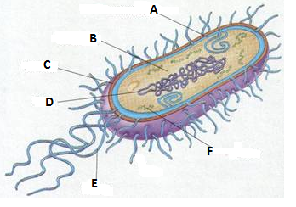

Ribosomes

Flagella

DNA

Cell wall

Cytoplasm

Cell membrane

19. Name 3 beneficial uses of bacteria: _some make medicines, food production, recycling, cleaning up oil spills__

20. List the two main differences between prokaryotes and eukaryotes:

a. Prokaryotes do not have a membrane bound nucleus and eukaryotes do have a membrane bound nucleus.

b. Prokaryotes do not have membrane bound organelles and eukaryotes do have membrane bound organelles.