Gel Electrophoresis Reading Questions Name: ___________________

1) What is the purpose of Gel Electrophoresis?

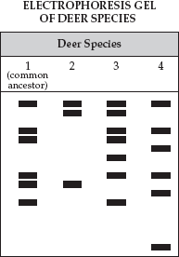
2) What type of material is a gel made from?

3) What causes the DNA in the wells to move?

4) DNA moves towards the positive end of the gel. Why is this?

5) Which pieces of DNA would move the furthest in the gel?

6) On the image provided label the shortest and longest fragments.

7) List 4 different uses for Gel Electrophoresis. (Read entire paragraph)

8) Using the deer species gel provided, determine which species 2, 3, or 4 is most closely related to the
common ancestor?

9) How many bands do these two (common ancestor and answer to #8) have in common?

10) Where do the variations in DNA between these deer species come from, in other words what caused
these changes in DNA?

