KINGDOM
PHYLUM FUNGI
ZYGOMYCOTA CHARACTERISTICS

PHYLUM FUNGI
ASCOMYCOTA EXAMPLES

PHYLUM FUNGI
BASIDIOMYCOTA VOCABULARY

PHYLUM ECOLOGICAL
DEUTEROMYCOTA IMPORTANCE

1. “Molds”
BASIC STRUCTURE OF A MUSHROOM:

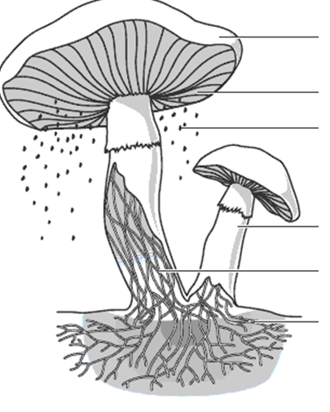
2. Ex:
3. Type of Spores:
4. Rhizoids:
5. Stolon:

1.
2. “Sac Fungi”
3. Ex:
4. Type of Spores:

1. Hyphae “Club Fungi”
2. Mycelium- Ex:
3. Fruiting Body- Type of Spores:

DIGESTION IN FUNGI:
Extracellular-
Fungi can either be:
1. Saprophytes-
2. Parasites-
1. Lichen- “Imperfect Fungi”
Ex:
2. Mycorrhizae- Type of Spores:

