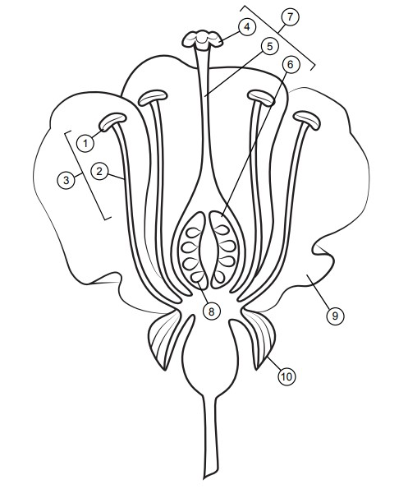**Milestone Practice with Flower Parts**

**Filament – Light Green**

**Sepal – Dark Green**

**Style – Light Blue**

**Anther – Yellow**

**Ovary – Dark Blue**

**Petal – Pink, Red, or Purple**

**Ovule – Gray**

**Stigma – Orange**

**DIRECTIONS:** The parts of an angiosperm have been labeled. Your challenge is to write the correct name for each part as well as to color each part the correct color.