Evolution Recap: _____________________, not _____________ evolve.
Darwin’s Theory
1)

2)

3)

4)

Evidence of Evolution
1) Fossils
2) Biochemical Evidence
3) Vestigial Structures
4) Embryonic Development
5) Homologous Structures

Patterns in Evolution
Convergent Evolution | Divergent Evolution

Selection Patterns
Directional Disruptive Stabilizing

Genetic Drift Speciation
Temporal

Behavioral

Geographic
Evolution Recap: Populations, not individuals evolve.
Darwin’s Theory
1) Organisms overproduce ex) Fish and Insects
(Why? Struggle for existence because of competition)

2) There is variation in all populations (Variations means differences)
Ex) Peppered Moths

3) Some of these variations are better suited to the environment then other
variations, this gives these organisms a higher fitness level.
Higher fitness = better chance of survival

4) Those with better variations (called adaptations) are more likely to pass on
these traits
Inheritance of beneficial traits = change population gene pool over time.
Types of Adaptations: Structural (Beak),
Behavioral (Using Tools),
Physiological (Produce chemicals like poison/enzymes)

Evidence of Evolution
1) Fossils – Relative (Comparison to each other) and Radiometric Dating (More accurate)

2) Biochemical Evidence – Most reliable, DNA, RNA, and Proteins

3) Vestigial Structures – Existing structures which are no longer used.
Ex) Appendix in humans

4) Embryonic Development – Look at embryo (early stages) and it is hard to tell
them apart.

5) Homologous Structures – Structures which look similar but no longer serve the
same purpose.
Ex) Human Arm and Cat Front Leg

Patterns in Evolution
Convergent Evolution  No common ancestor but have similar traits due to their similar environmental pressures  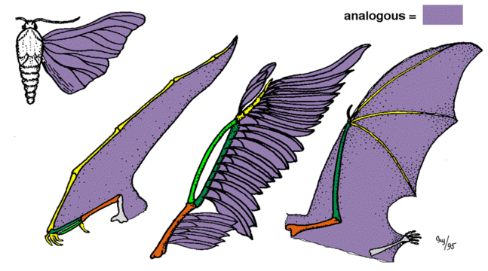  Analogous Structures – Different structure, same function | Divergent Evolution  Common ancestor but have evolved variations due to different selection pressures such as food source.  Ex) Adaptive Radiation of Darwin’s Finches  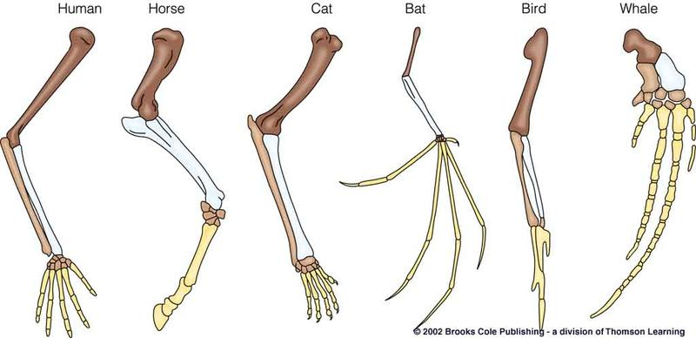  Homologous Structures – Same structure, different function.

Selection Patterns
Directional Disruptive Stabilizing
Favors one extreme Favors both extremes Favors the average
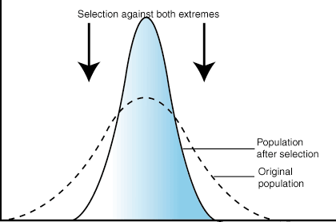
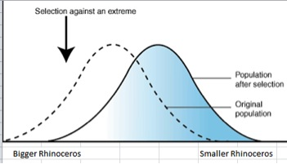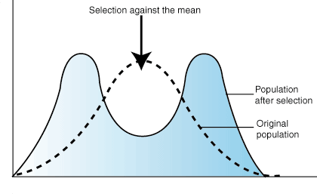

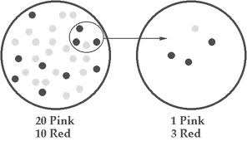
Genetic Drift
By chance
Small pop isolated from remaining members
New population lacks variation

Speciation = Formation of a New Species (Require Reproductive Isolation)
Temporal – Different Mating Times

Behavioral – Different Mating Patterns

Geographic – Physical Barrier Separates Them from Each Other

