Enzymes
Type of Macromolecule: Enzymes are an example of a ___________________
Purpose:
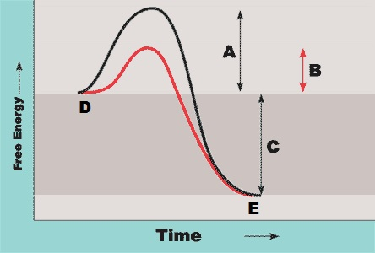
Label each part of the graph (A-E).
Explain the difference between each line in the
graph.

Is this reaction endergonic or exergonic?

Describe what is happening at all stages using the correct terminology and associated letters.
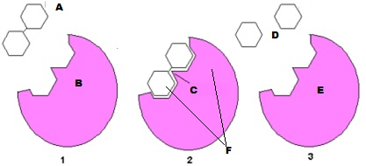
1.
H₂O

2.

3.
What type of reaction is occurring here, dehydration synthesis or hydrolysis?
Explain the graphs in terms of impact on the activity of the enzyme:
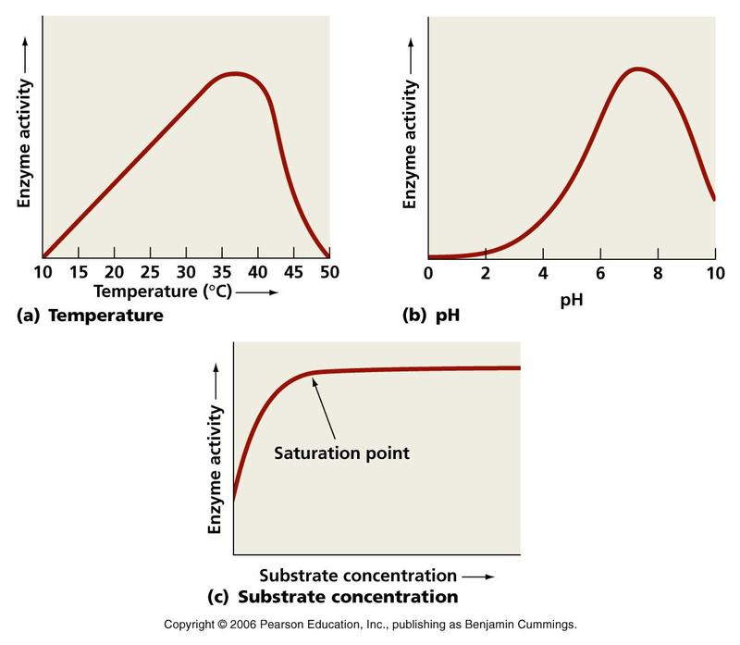
Graph A:

Graph B:

Graph C:

