|  |  |
| --- | --- |
| What’s an Enzyme? |  |
| What slows down enzyme activity?  What can speed up enzyme activity? |  |
| What are chemical reactions? |  |
| What are the 2 different types of chemical reactions? |  |
| Why do we need enzymes? |  |
| Label the graph showing enzyme activity. |  |
| How do enzymes work? |  |
| What is the lock and key mechanism? | Label the diagram below with “Enzyme”, “Substrate”, and “Active Site”:  animation of induced fit |
| What reaction is shown in this diagram?  Sucrose, the sugar, is being broken down by the enzyme ______________ to make _____________ and ____________. | http://fig.cox.miami.edu/~cmallery/150/metab/EScomplex.jpg  Write the chemical equation for this reaction: |
| What are endergonic and exergonic reactions? |  |

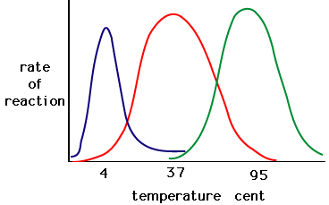1) Temperature

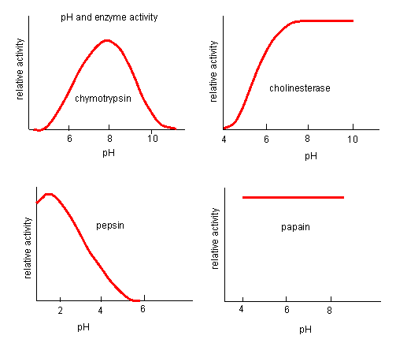

2) pH

3) Concentration (Amount) of Substrate or Concentration of enzyme

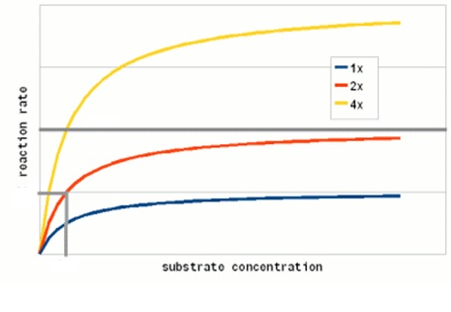

Enzyme Graphing

An experiment was conducted to measure the reaction rate of the human salivary enzyme -amylase. Ten mL of a concentrated starch solution and 1.0 mL of -amylase solution were placed in a test tube. The test tube was inverted several times to mix the solution and then incubated at 25°C. The amount of product (maltose) present was measured every 10 minutes for an hour. The results are given in the table below.

|  |  |
| --- | --- |
| Time (minutes) | Maltose Concentration (M) |
| 0 | 0 |
| 10 | 5.1 |
| 20 | 8.6 |
| 30 | 10.4 |
| 40 | 11.1 |
| 50 | 11.2 |
| 60 | 11.5 |

1. **Graph** the data on the axes provided and **calculate** the rate of the reaction for the time period

0 to 30 minutes.

|  |  |  |  |  |  |  |  |  |  |  |  |  |  |  |  |  |  |  |  |
| --- | --- | --- | --- | --- | --- | --- | --- | --- | --- | --- | --- | --- | --- | --- | --- | --- | --- | --- | --- |
|  |  |  |  |  |  |  |  |  |  |  |  |  |  |  |  |  |  |  |  |
|  |  |  |  |  |  |  |  |  |  |  |  |  |  |  |  |  |  |  |  |
|  |  |  |  |  |  |  |  |  |  |  |  |  |  |  |  |  |  |  |  |
|  |  |  |  |  |  |  |  |  |  |  |  |  |  |  |  |  |  |  |  |
|  |  |  |  |  |  |  |  |  |  |  |  |  |  |  |  |  |  |  |  |
|  |  |  |  |  |  |  |  |  |  |  |  |  |  |  |  |  |  |  |  |
|  |  |  |  |  |  |  |  |  |  |  |  |  |  |  |  |  |  |  |  |
|  |  |  |  |  |  |  |  |  |  |  |  |  |  |  |  |  |  |  |  |
|  |  |  |  |  |  |  |  |  |  |  |  |  |  |  |  |  |  |  |  |
|  |  |  |  |  |  |  |  |  |  |  |  |  |  |  |  |  |  |  |  |
|  |  |  |  |  |  |  |  |  |  |  |  |  |  |  |  |  |  |  |  |
|  |  |  |  |  |  |  |  |  |  |  |  |  |  |  |  |  |  |  |  |
|  |  |  |  |  |  |  |  |  |  |  |  |  |  |  |  |  |  |  |  |
|  |  |  |  |  |  |  |  |  |  |  |  |  |  |  |  |  |  |  |  |
|  |  |  |  |  |  |  |  |  |  |  |  |  |  |  |  |  |  |  |  |
|  |  |  |  |  |  |  |  |  |  |  |  |  |  |  |  |  |  |  |  |
|  |  |  |  |  |  |  |  |  |  |  |  |  |  |  |  |  |  |  |  |
|  |  |  |  |  |  |  |  |  |  |  |  |  |  |  |  |  |  |  |  |
|  |  |  |  |  |  |  |  |  |  |  |  |  |  |  |  |  |  |  |  |
|  |  |  |  |  |  |  |  |  |  |  |  |  |  |  |  |  |  |  |  |

B. **Explain** why a change in the reaction rate was observed after 30 minutes.

C. **Draw** and **label** another line on the graph to predict the results if the concentration of -amylase was

doubled. **Explain** your predicted results.

D. **Identify** TWO environmental factors that can change the rate of an enzyme-mediated reaction.

**Discuss** how each of those two factors would affect the reaction rate of an enzyme.