**Levels of Organization**

Smallest to Largest

|  |  |
| --- | --- |
| Individual (Species) | A single living organism which demonstrates all the characteristics of living things.  Species – must be able to interbreed and produce fertile offspring. |
| Population | A group of the same species of organism living in the same place at the same time. |
| Community | All the living organisms in a defined area. (Only Biotic Factors)  Biotic – Living Organisms |
| Ecosystem | All of the living and non-living factors in a defined area.  Biotic – Living Organisms Abiotic – Non-living |
| Biome | A group of ecosystems that have the same climate and similar communities. |
| Biosphere | All of Earth that is inhabitable. (Where organisms can survive) |

**Practice: Levels of Organization**

Use the diagram to place the levels of organization in order, include an example starting with the organism of your choice.

Create a chart of biotic and abiotic factors you might find in an ocean ecosystem.

|  |  |
| --- | --- |
| **Biotic** | **Abiotic** |
|  |  |

Answer the questions using the provided diagram (1-4 label the levels of organization).



**Level of Organization: Number One – Individual**

What do humans, roses, and bacteria all have in common? All three of them are living, and these unique organisms display seven key characteristics that all living things have in common.

**Characteristic #1: All living things are composed of _cells_.**

Two Types

1. _prokaryotic__ - does not have a nucleus Ex. _bacteria__

2. _eukaryotic___ - contains a nucleus. Ex. Humans

These types of cells are divided into two categories

1. _plant__ cells – ex. a tree
2. _animal_ cells – ex. a dog

**Characteristic #2: All living things obtain and use energy .**

Organisms acquire this energy in different ways.

1. _Autotroph__ - organisms make their own energy
2. _Heterotroph__ - organisms that cannot make their own energy

**Characteristic #3: All living things _reproduce__.**

Two types

1. _Asexual_ - production of new offspring involving only one parent.
2. _Sexual___ - production of new offspring involving two parents.

**Characteristic #4: All living things respond to _stimuli (external signals)__.**

This means they react to the environment around them.

Ex. If a cat chases a mouse, it automatically runs the other way.

What is an example of a plant’s response to their

environment?

**Characteristic #5: All living things evolve and _adapt__.**

In other words the organism best fit for the environment will be the

one that survives in this environment. We call the traits that make

it best fit _adaptations__.

Ex. A cheetah’s ability to run faster than other cats.

**Characteristic #6: All living things maintain __homeostasis__.**

This means that they can keep their **internal** environment stable.

Ex. You sweat to cool off your body and lower your temperature.

**Characteristic #7: All living things grow and develop_.**

A good example of this is humans.

We **develop** as we go from infant to toddler, to

child, to teen, to young adult. Ex. Puberty

We **grow** as we get taller or gain weight.

**Characteristic #8: All living things ___share a universal genetic code____**

DNA contains all the information needed to live, grow, and

reproduce.

Practice with Characteristics of Living Things

_______________________________ A person sweats when hot and shivers when cold

_______________________________ Some birds can lay 15 eggs.

_______________________________ A cactus is able to live in the desert with very little water.

_______________________________ A child is 5 centimeters taller in a year

_______________________________ Carnivores, like lions, eat meat to survive.

_______________________________ Nerve, muscle, and skin are part of the human body

_______________________________A plant’s root absorb water from the soil

_______________________________A hummingbird drinks nectar from flowers

_______________________________Cats mate and produce kittens

_______________________________A runner sweats on a hot day

_______________________________Fireflies produce flashes of light to find a mate

_______________________________A bear hibernates when it is cold

_______________________________A tadpole changes into a frog

**Level of Organization: Number Two – Population**

**Population** - Group of organisms that are the same species in the same area at the same __time__.

**Population Density** – number of individuals per unit area.

Ex. Number of Deer Per Square Mile

**Population Growth –** Change in Overall Population Size

**When a Population Size Stays there is Zero Population Growth = ZPG**

Populations very seldom stay the same.

Things that change this population density or size.

1. Movement out of the area - emigration

Movement into the area - immigration

1. Number of organisms born - __birth__ rate

Number of organisms that die - __death__ rate

**For ZPG to occur:**

**Birth Rate and Immigration (In) = Death Rate and Emigration (Out)**

**Cause Pop Size to Increase Cause a Pop Size to Decrease**

Usually population sizes change; scientists study the overall trends in changing populations.

Trend Number 1: Exponential Growth

J-Shaped Curve

* Ideal environmental conditions
* No limiting factors, so there is an abundance of resources

Ex. Food and Water

* Growth rate is constant

Trend Number 2: _Logistic_Growth

S-Shaped_ Curve

* Logical Growth
* Limits on Population Size based on resources, limiting factors are present.
* An area can only maintain so much and remain stable

This type of growth will show a carrying capacity, which is the number of organisms that an area can maintain over time.

What happened to this population?

It exceeded its carrying capacity,

this caused it to quickly run out

of resources and so the population drastically

decreased in size.

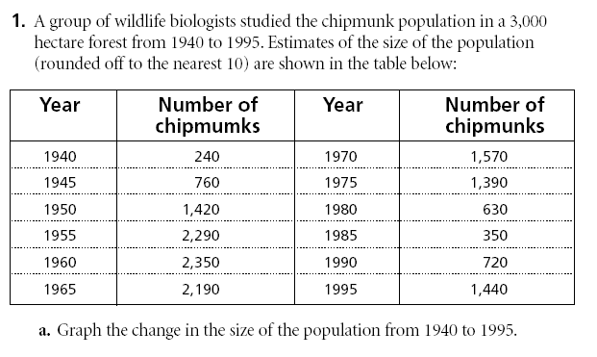



**Limiting Factors on Population Growth**

* _Decrease_ the Growth Rate of a Population
* So the population growth starts to level off, meaning it will begin to reach the carrying capacity

2 Types of Factors:

a. Density Dependent - Do not affect all populations the same

“May not always be a factor, depends on population size.”

Examples: Food, Space, Mates, Disease, Parasitism, Competition

b. Density Independent - Affect all populations the same despite population size.

Examples: Natural Disasters, Unusual Weather (Drought/Excessive Rain), or Human Activities

Scenario: Rabbit Statistics

Scenario 1: Small Island = 5 Rabbits

Climate –

Food Supply –

Predation –

Scenario 2: Small Island = 500 Rabbits

Climate –

Food Supply –

Predation –

Summary: Depends on Population Size –

Density ______________

Ex.

Does not Depend on Population Size –

Density ______________

Ex.

Aphid Growth Graph Analysis: Explain Growth from April to April

th of Aphids

Exponential

growth

Steady

population

size

Peak

population

size

Rapid decline

Steady

population

size

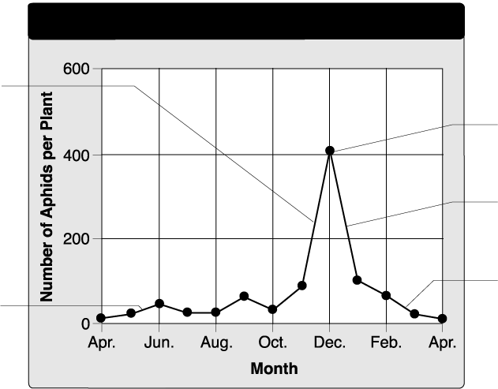

**Growth of Aphids**

1. __________________________________________________________

__________________________________________________________

2. __________________________________________________________

__________________________________________________________

3. __________________________________________________________

__________________________________________________________

4. __________________________________________________________

_________________________________________________________

More graph questions:

How do you explain the exponential growth…what factors affected this growth?

How do you explain the then drastic decline?

**Level of Organization: Number Three – Community**

Community is all the living organisms (Biotic Factors) in an area.

**Community Topic One: Niche vs. Habitat**

Habitat_– Where the organism lives.

Ex. Frog is an amphibian.

It lives in the water and on land (location).

Niche - The organism’s role in the community.

Ex. It is a predator of insects and it catches this prey with

its sticky tongue.

This frog is the prey for larger reptiles.

**Community Topic Two: Competition**

Competition – Compete (Fighting) for Resources

What do they compete for? Resources such as food, space, mates.

Intraspecific – Competition within the same species.

Ex. Males competing for mating rights

Sea Anemones fighting for light

Interspecific – Competition between different species

Ex. Lion and the Hyena competing for food.

Animals drinking for the same watering hole

Birds attempting to build nests in the same tree.

Explain what is going on in each picture to the right.

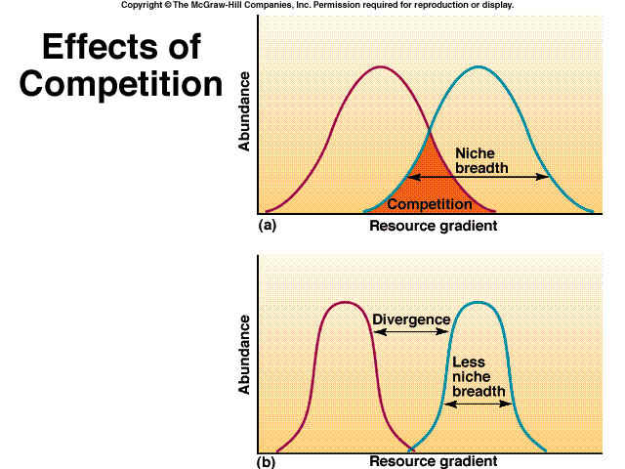

Picture 1

Picture 2

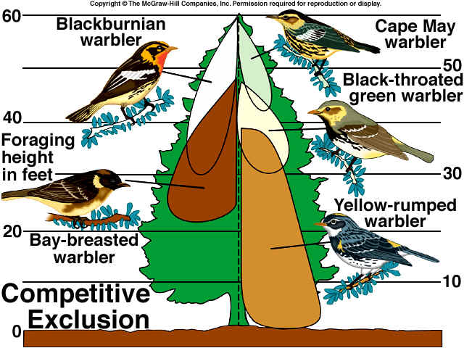

Which bird has the largest feeding range in the tree? ___________________

The Bay-breasted warbler is competing with which other warbler? ___________________

Which bird has the most competition? ________________________

Specific niches for feeding have decreased the amount of ____________ each bird must come in contact with.

**Community Topic Three: Symbiotic Relationships**

Symbiosis – A close relationship between two or more individuals that are different species.

At least 1 organism benefits from the relationship.

|  |  |  |
| --- | --- | --- |
| Symbiosis | Definition | Example |
| Mutualism | Both organisms benefit from this relationship. +/+ Relationship | Flower and the Honeybee  Honeybee gets nectar and the flower gets its pollen for reproduction spread around. |
| Commensalism | One organism benefits and the other is neither harmed or helped.  +/0 relationship | Barnacles on the Whale  The barnacles can filter feed on the moving whale they are attached to. The Whale gets nothing from this relationship but is not harmed. |
| Parasitism | One organism benefits and the other is harmed.  -/- relationship | Flea and a Dog  The Flea feeds on the dog, which is beneficial to the flea but harmful to the dog. |

Practice: Symbiotic Relationships

|  |  |  |
| --- | --- | --- |
| **Organisms:** | **Type of**  **symbiotic relationship**  **identified & why** | **Description of symbiotic relationship involved between orgs** |
| Barnacle/whale |  | Barnacles create home sites by attaching themselves to whales. This neither harms nor benefits the whales. |
| Human/Tapeworm |  | The tapeworm attaches itself to a human’s intestines, extracting nutrients as they pass through the digestive system. The human is not able to absorb the necessary nutrients for survival. |
| Honey guide bird/badger |  | Honey guide birds alert and direct badgers to bee hives that contain honey. The badger then expose the hives and feed on the honey first. Then the honey guide bird eats. |
| Remora/Shark |  | Remora’s attach themselves to a shark’s body. They then travel with the shark and feed on the left-over food scraps from the shark’s meal. There is also the possibility that the remora’s help keep the shark’s skin healthy. |
| Ostrich/gazelle |  | Ostriches and gazelles feed next to each other. They both watch for predators and alert each other to danger. Since the visual abilities of the two species are different, they can each identify animals the other might not see. |
| Bee/marabou stork |  | The stork uses its saw-like bill to cut up the dead animals it eats. As a result, the dead animal carcass is accessible to some bees for food and egg laying. |
| Cowbird/song birds |  | Female cowbirds lay eggs in the nests of various songbirds. Either the mother cowbird or the cowbird hatchling will force the songbird eggs/hatchlings out of the nest. |
| Oxpecker/rhinoceros |  | Oxpeckers feed on the ticks found on a rhino. |
| Silverfish/army ants |  | Silverfish live and hunt with army ants. They share the prey. |
| Hermit crab/snail shells |  | Hermit crabs live in shells made by and then abandoned by snails. |

Ecological Succession

Ecological succession explains the events that take place where communities and ecosystems change over time.

Primary succession involves the gradual establishment of biotic communities in lifeless areas where there is **no** soil.

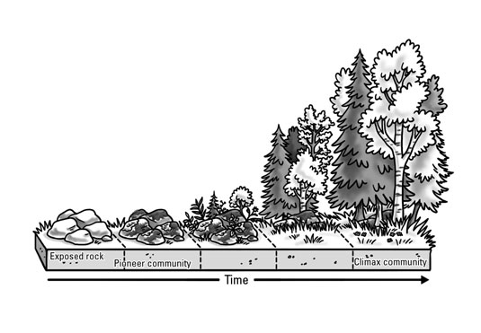

1. **Pioneer species**, like lichen and mosses, are the first species to colonize these barren areas. Their seeds or spores fly in and will attach themselves to the bare rock. Over time, they will break down the rock to create soil. As they secrete wastes and die, they add nutrients to the growing layer of soil.
2. After soil has formed, plant species such as grasses and small shrubs can colonize the area. As they grow and create shade, the lichens and mosses die due to lack of sunlight.
3. Next, trees that need lots of sunlight (pines, spruces, aspens, etc.) replace the grasses and shrubs.
4. The early tree species are replaced by shade-tolerant trees such as oaks and hickory. This is considered the climax **community**.

**Practice:** Go back to the picture of primary succession above and describe what is happening at each stage.

**Secondary succession** begins in an area where an ecosystem has been disturbed, removed, or destroyed, but soil is present.

Since soil is still present, new vegetation can germinate, usually within a few weeks, from seeds already in the soil and those imported by wind, birds or other animals.

Regrowth of vegetation follows the same pattern as seen in primary succession beginning with grasses and small shrubs, then sunlight tolerant trees, then shade tolerant trees (climax community).

**Practice**: The picture below represents secondary succession. Describe what is happening in each stage.

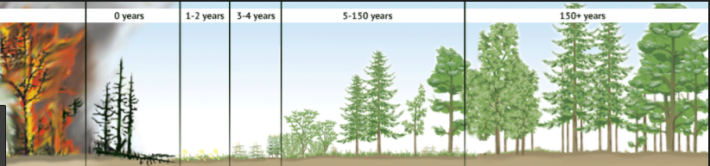

**Practice:** Determine whether primary or secondary succession would follow each of the disturbances below.

Volcanic Eruption: primary

Abandoned Neighborhood: secondary

Forest Fire: secondary

Tornado: secondary

Abandoned Highway: primary

Come Up With Your Own Example: ____________________________________________