Insect Karyotype Analysis Name: ___________________________
Directions: Color in each circle of chromosomes a different color. One by one cut them out and line them up with their pair in the provided box (The center line represents the centromere location). Make sure you put them in order pair #1, pair #2, then the sex chromosomes just like the example karyotypes.
Insect #1 Sex: ________________ Insect #2 Sex: _________________

Disorder: _________________________ Disorder: _________________________

Insect #3 Sex: ________________ Insect #4 Sex: _________________

Disorder: _________________________ Disorder: _________________________

Insect #5 Sex: ________________ Insect #6 Sex: _________________

Disorder: _________________________ Disorder: _________________________
Insect Karyotype Lab Questions
1. How many insects showed a genetic disorder based on their karyotype analysis? _______
2. a. How many insects were male? _______ b. How many insects were female? _______
3. How many pairs of chromosomes does this species of insect have? __________
4. What would be this organisms haploid number? _______
5. Which disorder(s) were associated with the sex chromosomes? __________________________________
6. What type of chromosomal abnormality would be the most difficult to detect using a karyotype?
___________________________ Why? ________________________________________________________
__________________________________________________________________________________________
Karyotype Lab Part 2: Identifying Human Disorders from Karyotypes
Normal Male and Female Karyotype
Label the following normal karyotypes as male and female. How do you know which is male and which is female?
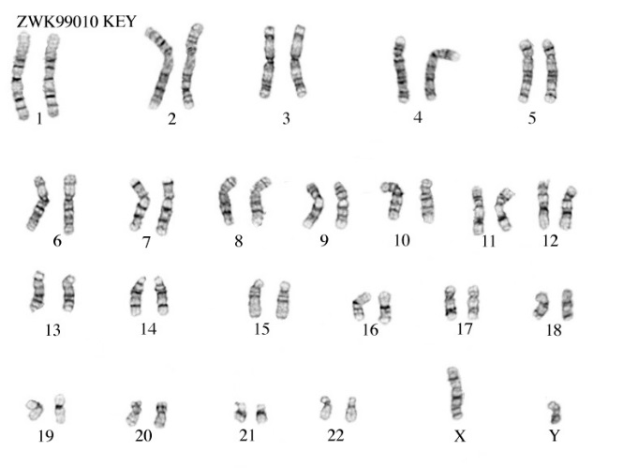
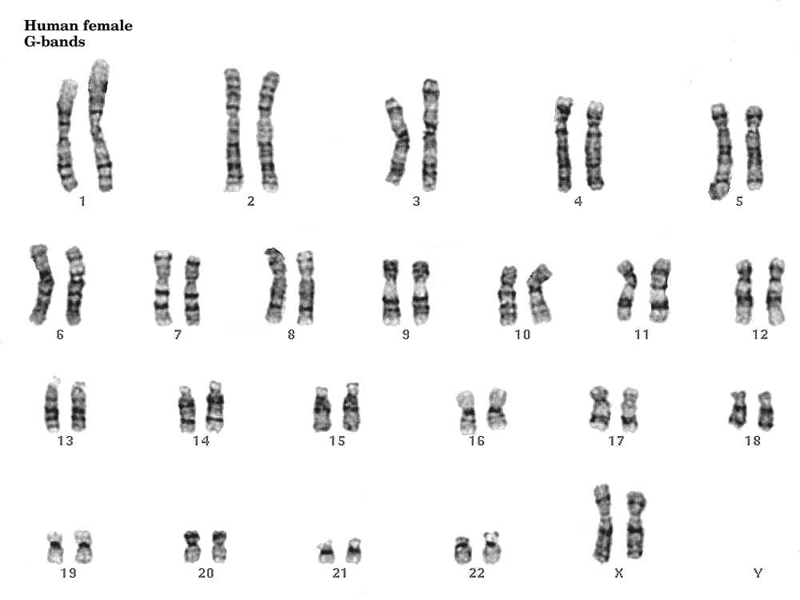

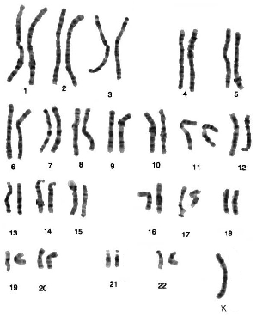
Abnormal Karyotype #1:
- Is this a male or a female?
- Which chromosome pair contains the
abnormal number of chromsomes?
- Is it a monosomy or trisomy?
- What is the name of the disorder?

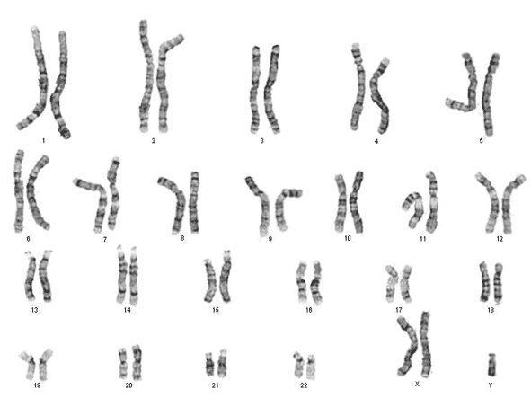
Abnormal Kartyotype #2:

- Is this a male or a female?
- Which chromosome pair contains the
abnormal number of chromsomes?
- Is it a monosomy or trisomy?
- What is the name of the disorder?

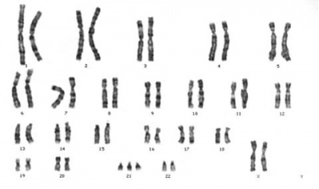
Abnormal Kartyotype #3:

- Is this a male or a female?
- Which chromosome pair contains the
abnormal number of chromsomes?
- Is it a monosomy or trisomy?
- What is the name of the disorder?

