Chemistry of Life Notes-

- Matter is anything that has ________ and takes up space (____________)
- Basic unit of matter is the ___________.
- Atoms are the __________ unit of matter made of _________, __________ and ____________.
- Atoms have very specific properties that make them the building blocks of everything we know.

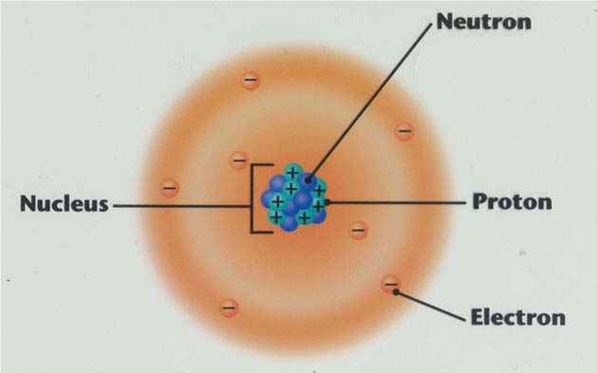
- Electrons- are small (1/2000 in mass to a proton and neutron) __________ charged particles found around orbiting the nucleus in the electron cloud.
- Protons- are __________ charged subatomic particles that are located in the nucleus
- Neutrons- are _________ in charge subatomic particles found in the nucleus

Atoms, Elements, and Isotopes
- Atoms of the same type are called _____________.
- Elements are placed together in a collection on _______________.
- Elements on the periodic table are organized by their properties.
- These ______ are MAJOR elements that make up living things
___________ (S), Phosphorus (P), _________ (O), ____________ (N), Carbon (C), _____________ (H)

How do I remember these 6 elements? _________________________
- Other elements that make up living systems are Calcium (Ca), Sodium (Na), Magnesium (Mg) and Potassium (K)
- All elements are given a ________ and a __________. The symbol may appear to not match up with its name but that is because the symbol is from its Latin name.

Practice
Element and Symbol | # protons | # electrons | # neutrons
Carbon
 | 1
 |  |  | 16
 |  | 7
, P
 | 16

Elements form Compounds
- ______________ are substances formed by chemical combination of ______ or more elements in definite proportions.
- Compounds are represented by _________________________ that contain the elements symbols and subscripts that determine the number of atoms.
CO CO₂
Elements form Compounds by chemical bonds
- Chemical bonds are interactions between two elements electrons
- The electrons involved in bonding are called valence electrons
- TWO TYPES of BONDS:
____________ BONDS
____________ BONDS

Ionic Bonds
- Bonds that are formed when 1 or more ___________ electrons are _____________ from one atom to another.
- Ionic bonds form between _______.
- Ions are atoms with a __________ that is __________ or ___________.
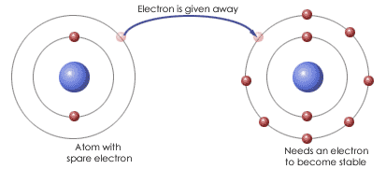

Covalent Bonds
- Bonds that are formed when two atoms “________________” electrons
- When electrons are shared the compound is called a MOLECULE
- Water is a molecule, H₂O
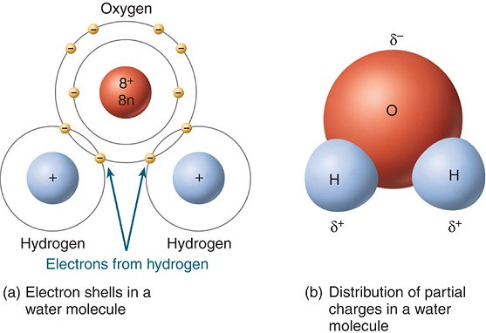
Others Forces
Compounds will also ____________ with molecules near them. This type of force is not a bond but can attract one compound to another compound.
