**Why do cells divide? What is the difference between**

**sexual and asexual reproduction?**

**The Cell Cycle**



Vocabulary Terms to Look Out For:

|  |  |
| --- | --- |
| Chromatin |  |
| Chromosome |  |
| Sister Chromatid |  |
| Centromere |  |
| Centrioles |  |

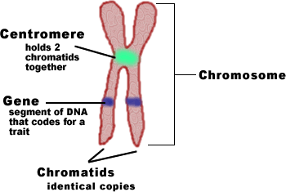

|  |  |
| --- | --- |
|  |  |
|  |  |
|  |  |
|  |  |
|  |  |
|  |  |

Cell Reproduction Review

1. Why do cells need to go through mitosis?

2. What types of cells are made in mitosis? (body or sex)

3. What is another name for a body cell?

4. What are the phases of mitosis in order?

5. In which phase are two new daughter cells produced?

6. In which phase does the nucleus break apart and chromosomes condense?

7. In which phase do chromosomes align in the middle?

8. What phase happens with Telophase?

9. How many daughter cells are formed at the end of mitosis?

10. Is interphase part of mitosis?

11. Use the following terms to describe the changes DNA goes through during the cell cycle. (Chromatin, Chromosome, Sister Chromatids, Centrioles, Centromere, and Kinetochore)

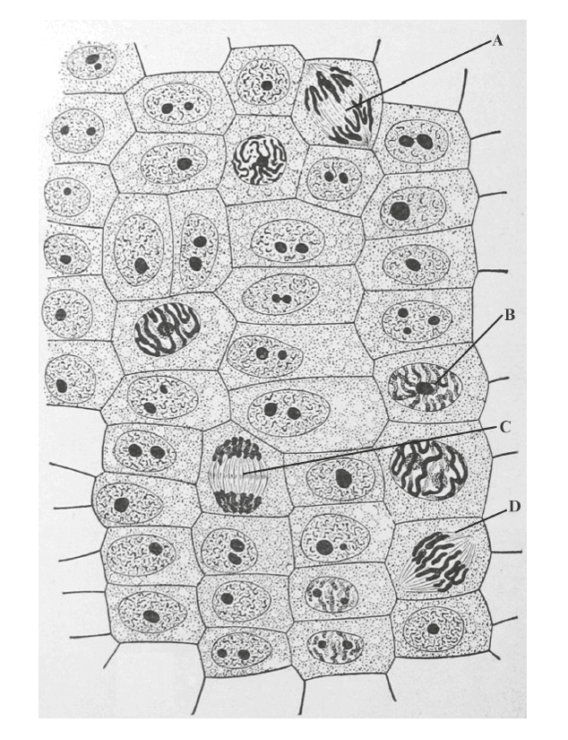For each cell A – D identify the stage of division and

Explain why you decided on that answer.

A –

B –

C –

D –

Most of the other cells are in which phase?

What does that tell you about the cell cycle?

**Checkpoint Control System and Cancer**

What is the point of these **checkpoints**?

3 Major Checkpoints:

|  |  |  |
| --- | --- | --- |
| G1/S | G2/M | Spindle Checkpoint |

Why is G1/S is important? What happens if the signal is not received?

How do cells know when to divide?

1)

2)

**Cancer**

Growth Factors and Cancer

Proto-oncogenes vs. Oncogenes Tumor Suppressor Genes

Cancer is essentially a failure of _______________________________________.

What are contributors to cancer?

Mutations caused by both environmental conditions, mutagens, and genetics.

Ex)

Types of tumors

|  |  |
| --- | --- |
| Benign | Malignant |

Treatments for Cancer

High-Energy Radiation

Chemotherapy