**Why do cells divide? What is the difference between**

**sexual and asexual reproduction?**

**The Cell Cycle**



Vocabulary Terms to Look Out For:

|  |  |
| --- | --- |
| Chromatin |  |
| Chromosome |  |
| Sister Chromatid |  |
| Centromere |  |
| Centrioles |  |

|  |  |
| --- | --- |
|  |  |
|  |  |
|  |  |
|  |  |
|  |  |
|  |  |

Mitosis Practice - Match the questions below with the proper answers from the answer bank.

1. What is mitosis?

2. In order, what are the four main stages of mitosis?

3. What is the name of the stage a cell goes through just prior to mitosis?

4. What is the main event of interphase?

5. What are two important events of prophase?

6. What is the main event of metaphase?

7. What structure is involved in moving chromosomes during mitosis?

8. What is the main event of anaphase?

9. What are two important events to telophase?

10. At the completion of mitosis when the cell divides, what name is given to the two new cells?

11. You began life as a one-celled structure called a zygote. What process then took place over and over to build a body containing billions of cells?

Answer Bank:

A. Interphase

B. The chromosomes in the nucleus of the cell make identical copies of themselves.

C. The chromosomes move toward and line up along the center of the cell, called the equator.

D. The nuclear membrane disappears and the chromosomes become distinct

E. Mitosis

F. New nuclear membranes from around each of the two set of chromosomes, and the cell divides into two daughter cells.

G. Prophase, Metaphase, Anaphase, Telophase

H. Daughter Cells

I. Spindle

J. Division of the nucleus of the cell (usually followed by the division of the cell itself)

K. The spindle fibers pull one set of chromosomes to one side of the cell and an identical set to the opposite side of the cell.

**Identify the phases of the cell cycle: Outline the cells in interphase blue, prophase green, metaphase yellow, telophase red, and cytokinesis orange.**

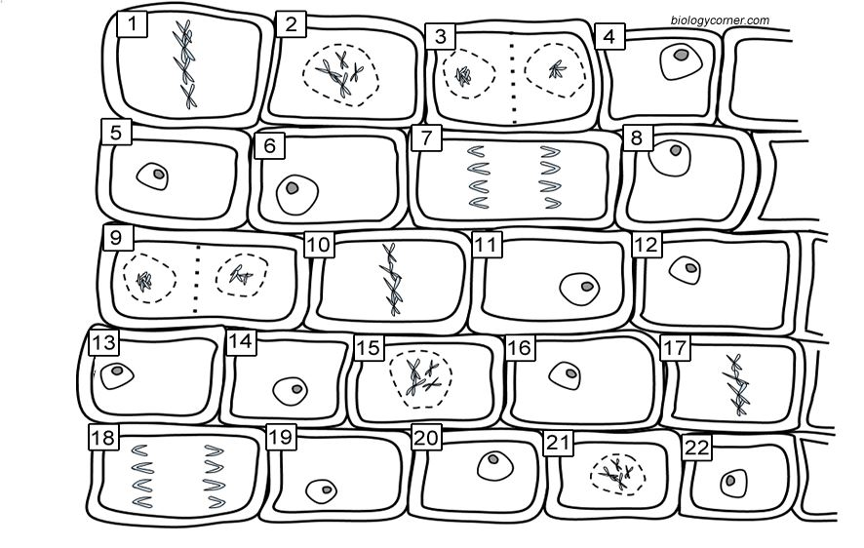

**What happens when division goes wrong? (Use the terms below)**

Cancer, Benign, Contact Inhibition, Cyclins, Tumors, Mutations, Carcinogens, Malignant, Metastasis

Cell Reproduction Review

1. Why do cells need to go through mitosis?

2. What types of cells are made in mitosis? (body or sex)

3. What is another name for a body cell?

4. What are the phases of mitosis in order?

5. In which phase are two new daughter cells produced?

6. In which phase does the nucleus break apart and chromosomes condense?

7. In which phase do chromosomes align in the middle?

8. What phase happens with Telophase?

9. How many daughter cells are formed at the end of mitosis?

10. Is interphase part of mitosis?