Name: _____________________________ Period: ______ Date: ____________________
CELL TRANSPORT STUDY GUIDE
The Cell Membrane
E
D
- Label the parts of the cell membrane using the following words:
- Fatty acid tails
B
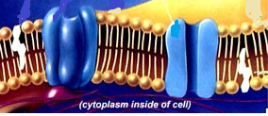
- Phosphate heads
- Hydrophobic
- Hydrophilic
C
- Transport Protein
- Cholesterol
A

F
- Another name for the cell membrane is:
  - Lipid monolayer b. phospholipid bilayer c. protein trilayer
- The cell membrane is made up of _____ layers of _____________________.
  - 3; proteins b. 2; nucleic acids c. 2; phospholipids
- The cell membrane is described as being __selectively__ ___permeable_____ which means it is picky about what comes in and what goes out of the cell.
- The model for how the cell membrane works is called the:
  - Moving Picture model b. Flexible Artwork model c. Fluid Mosaic Model
- A phospholipid is made out of:
  - Carbohydrates and Proteins b. Phosphate and Fatty Acids c. cholesterol
- The phosphate heads of the phospholipid bilayer are:
  - Hydrophilic and polar b. hydrophobic and nonpolar c. neither
- The fatty acid tails of the phospholipid bilayer are:
  - Hydrophilic and polar b. hydrophobic and nonpolar c. neither
- The phosphate heads face:
  - Outward toward the cell’s environment and inward toward the cytoplasm
  - Inward toward each other
- The fatty acid tails face:
  - Outward toward the cell’s environment and inward toward the cytoplasm
  - Inward toward each other
- The phosphate heads touch the cytoplasm.
  - True b. false
- The phosphate heads touch the cell’s watery environment.
  - True b. false
- The purpose of the transport proteins is to:
  - Move molecules through the cell membrane that couldn’t normally get through
  - Stabilize the phospholipids so they don’t stick together
  - Move molecules to the endoplasmic reticulum

- The purpose of the cholesterol in the cell membrane is to:
  - Raise the cell’s pressure
  - Stabilize the phospholipids so they don’t stick together
  - Allow molecules to pass through the membrane
Transport of Molecules across the Cell Membrane
- The type of transport that requires energy is called:
  - Passive b. Active
- The type of transport that does not require energy is called:
  - Passive b. Active
- Name the three types of passive transport.
  - _diffusion_______
  - Facilitated diffusion
  - __Osmosis ____________
- Diffusion is the movement of _________________ across the cell membrane.
  - Water molecules b. small molecules other than water c. large molecules
- Diffusion moves particles from areas of _______ concentration to ________ concentration.
  - High; low b. low; high c. high; high d. low; low
- Diffusion __________ require energy from the cell in order to happen.
  - Does b. does not
- Diffusion moves particles ________ the concentration gradient.
  - With b. against
- Facilitated diffusion is the movement of ____________ across the cell membrane.
  - Water molecules b. small molecules other than water c. large molecules
- Facilitated diffusion must use the help of ________________ to get the molecules across the cell membrane.
  - Transport proteins b. cholesterol c. phospholipids
- Facilitated diffusion ___________ require energy from the cell in order to happen.
  - Does b. does not
- Facilitated diffusion moves particles from areas of _________ concentration to _______ concentration.
  - High; low b. low; high c. high; high d. low; low
- Facilitated diffusion moves particles ________ the concentration gradient.
  - With b. against
- Which of the pictures below represents diffusion and which one represents facilitated diffusion?
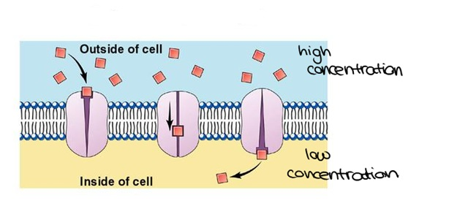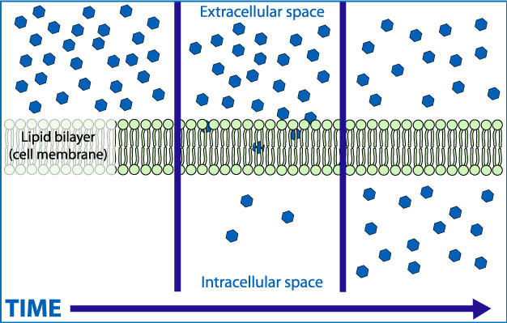
_______facilitated diffusion______ ____diffusion_____
- Osmosis is the movement of _____________ across the cell membrane.
  - Water molecules b. small molecules other than water c. large molecules
- Osmosis ___________ require energy to move water across the cell membrane.
  - Does b. does not
- Osmosis moves water molecules from areas of _______ concentration to ________ concentration.
  - High; low b. low; high c. high; high d. low; low
- Osmosis moves water ___________ the concentration gradient.
  - With b. against
- What are the three types of solutions that a cell can be placed in, in which water can move?
  - _isotonic_____
  - _hypertonic___________
  - _hypotonic_________
- In an isotonic solution, the concentration of water inside the cell is ______________ the concentration of water outside the cell.
  - Higher than b. lower than c. equal to
- In a hypertonic solution, the concentration of water inside the cell is ___________ the concentration of water outside the cell.
  - Higher than b. lower than c. equal to
- In a hypotonic solution, the concentration of water inside the cell is ____________ the concentration of water outside the cell.
  - Higher than b. lower than c. equal to
- If a cell is put into an isotonic solution, the size of the cell will ______________.
  - Shrink b. expand c. stay the same
- If a cell is put into a hypertonic solution, the size of the cell will ________________.
  - Shrink b. expand c. stay the same
- If a cell is put into a hypotonic solution, the size of the cell will ________________.
  - Shrink b. expand c. stay the same
- Identify each of the solutions below as isotonic, hypertonic, and hypotonic.
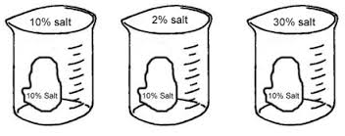
__isotonic__ ___hypotonic___ ___hypertonic____
- Identify each of the red blood cells from an animal as isotonic, hypertonic, and hypotonic.
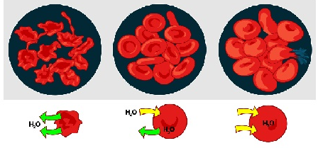
Hypertonic isotonic hypotonic
- Identify each of the plant cells below as being in an isotonic, hypertonic, and hypotonic solution.
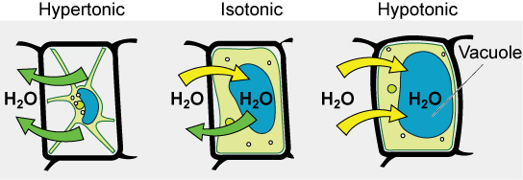
__hypertonic____ ____isotonic____ ___hypotonic___
- Which of the above plant cells shows plasmolysis?
  - First b. second c. third
- Which of the above plant cells shows turgor pressure?
  - First b. second c. third
- One-celled (unicellular) organisms like Paramecium (a protest) has what kind of special organelle to pump excess water out of the cell or into the cell? ___contractile vacuole____________
- Active transport:
  - Requires energy b. does not require energy
- Active transport moves molecules across the cell membrane from areas of _________ concentration to ___________ concentration.
  - High; low b. low; high c. high; high d. low; low
- Active transport moves molecules ___________ the concentration gradient.
  - With b. against
- What type of transport is shown by the diagram below and how do you know?
  - Active b. passive
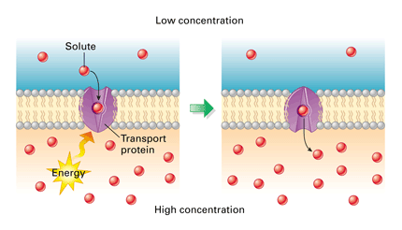
We know it is active transport because molecules are moving from high to low concentration with the use of energy.
- A type of active transport is called _bulk_ transport where several particles at one time are moved across the cell membrane.
- Two examples of bulk transport are _endocytosis___ (where particles are moved into the cell by the cell membrane pinching off to form a vesicle) and __exocytosis___ (where vesicles full of particles fuse with the cell membrane to release particles).
- Two types of endocytosis are called ___phagocytosis______ (cell eating) and ______pinocytosis________ (cell drinking).

