Cell Transport Student Notes

* The _________ of all cells are surrounded by a membrane made of ___________________.
* Nickname: “The __________________”

**Membrane Structure**

* 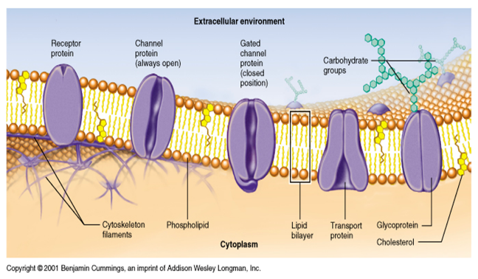There are __________ “stuck” in the membrane that __________ get things ______ and _______ of the cells.
* They also help to get ____________ into the cell.
* The Membrane is a lipid ___layer.
* Selective Permeability –membrane’s ability to allow __________ molecules through and keeps _________ molecules _______. Helps maintain ___________________.

**Transport Through the Membrane**

Two types

* + Passive Transport
    - Energy _______________________
  + Active Transport
    - Energy is __________________

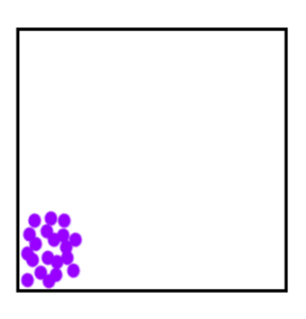Diffusion (Passive Transport)

* Movement of molecules from ______________ concentration ______________ concentration.
* Always higher to lower!
* _____ energy input required!

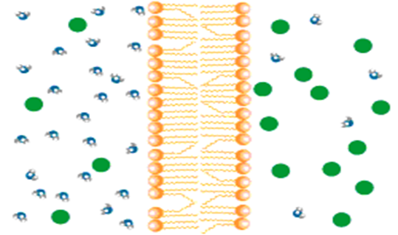_________(Passive Transport)

* Diffusion of water through a cell membrane

Solutions

Higher concentration of solutes outside of cell = ______________________.

Lower concentration of solutes inside the cell = ______________________.

Equal solute concentration inside and outside of the cell = _______________________.

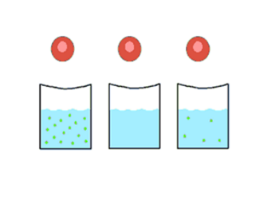3 types of Solutions

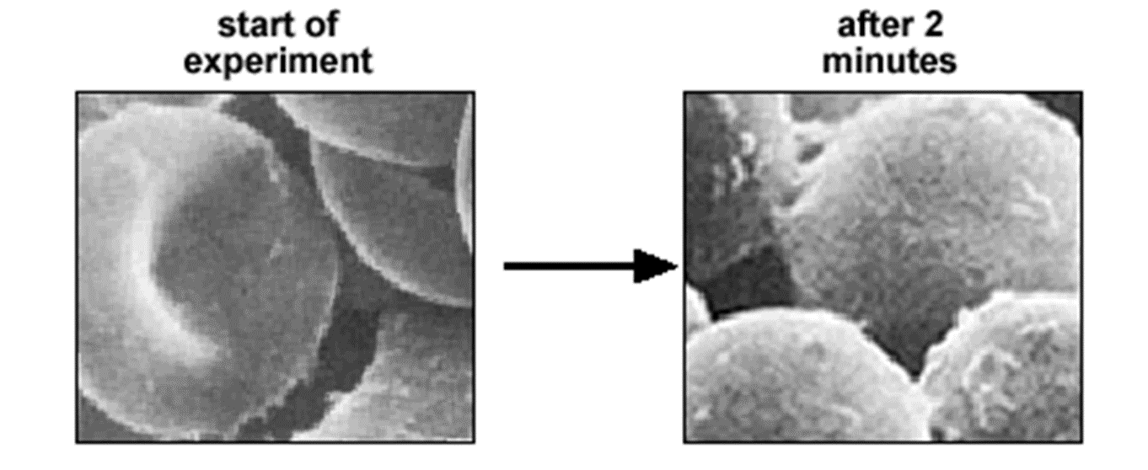What types of solution?

Hypertonic or Hypotonic

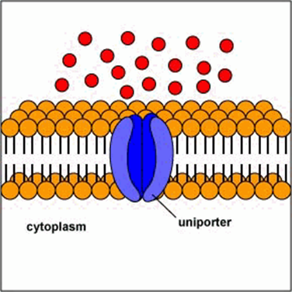

Facilitated Diffusion (Passive Transport):

* Energy is ______ required to move substances across the membrane, but a protein is needed due to the size of the molecule.

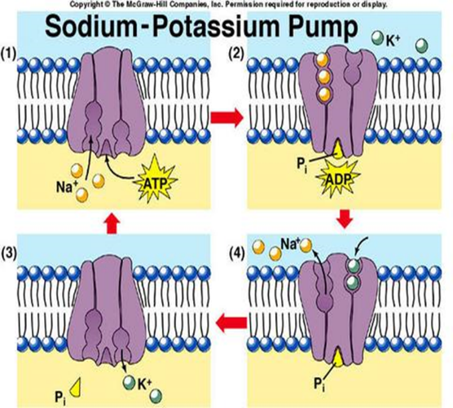Active Transport

* ____________________________.
* Need ________ - the universal energy molecule.
* ______ to _____
* Some molecules are too large to get through a protein, they use vesicles.

1. 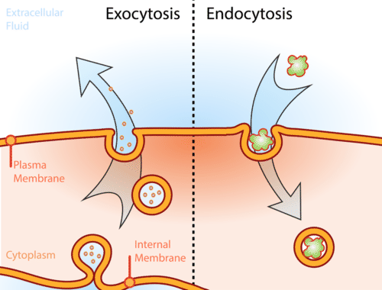___________________

* Into
* Pinocytosis (Liquid)
* Phagocytosis (Solids

1. ___________________

* Out of cell
* Waste

What is rate of transport? How many molecules can cross the membrane in a given amount of time.

|  |  |  |
| --- | --- | --- |
|  |  | Rate of Transport |
| Size | Large |  |
| Small |  |
| Temp. | Hot |  |
| Cold |  |
| Concentration | High |  |
| Low |  |

Effects on Transport

**Summary: Types of Cellular Transport**

* **Passive Transport**

Cell doesn’t use energy

* 1. **Diffusion**
  2. Facilitated Diffusion
  3. **Osmosis**
* **Active Transport**

Cell does use energy

* 1. Protein Pumps
  2. **Endocytosis**
  3. Exocytosis

**high**

**low**

**This is gonna be hard work!!**

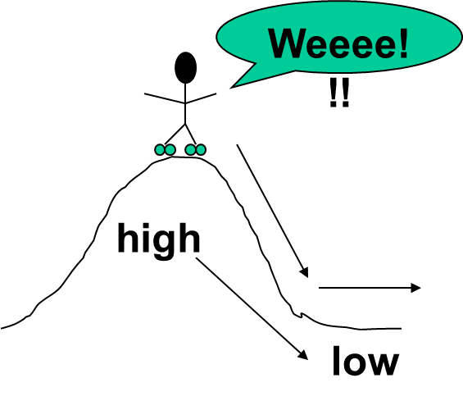

|  |  |  |  |  |
| --- | --- | --- | --- | --- |
| Types of Movement Through the Cell Membrane | | | | |
|  | Diffusion | Osmosis | Facilitated Diffusion | Active Transport |
| Definition… | Movement of particles freely through the membrane from an area of high concentration to an area of low concentration. |  | Movement of particles from areas of high concentration to areas of low concentration with the help of channel proteins. |  |
| Does this process require ENERGY? | No | No |  |  |
| Examples |  | H2O through the membrane |  | Endocytosis and Exocytosis |