Name ____________________

Period____Date____________

CELL TRANSPORT – Benchmark 2 Study Guide

**Match the definition on the left with the term on the right.**

1. diffusion
2. dynamic equilibrium
3. exocytosis
4. osmosis
5. _____ release of wastes or cell products from inside to outside a cell
6. _____ diffusion of water molecules through a selectively permeable membrane
7. _____ continuous movement of particles but no overall change in concentration
8. _____ movement of particles from an area of higher concentration to one

of lower concentration

**In the space at the left, write true if the statement is true. If the statement is false, change the italicized term to make the statement true. Write this answer in the blank provided.**

___________ 5. In *passive transport*, the movement of particles across a membrane requires energy.

___________ 6. *Endocytosis* is a process by which a cell membrane surrounds and takes in material from

the environment.

___________ 7. A membrane that allows only some materials to pass through shows *selective permeability.*

**Hi-lite or circle the word or phrase that best completes the statement or answers the question.**

8. The structure most responsible for maintaining cell ***homeostasis*** is the

**cytoplasm cell wall mitochondria cell membrane**

9. A cell membrane is made up of a(n)

**cholesterol layer enzyme layer lipid bilayer protein layer**

10. Which of the following is not a form of passive transport?

**diffusion endocytosis osmosis**

11. Diffusion continues until

**equilibrium is reached turgor pressure is reached one side has more**

12. If a cell is placed in salt water, water leaves the cell by

**osmosis diffusion active transport phagocytosis**

13. A cell moves particles from a region of lesser concentration to a region of higher concentration by

**diffusion osmosis passive transport active transport**

**Use the pictures provided to answer the associated questions.**

**14. After digestion:**

 = glucose molecule

a. Which side has the higher concentration of glucose? ________

b. Which way will the glucose go? ________________________

**cell**

**blood**

c. Does this require energy? ___________

d. Is this active or passive transport? _______________________

**15. Easter egg coloring**:

A blue food coloring tablet is placed in a cup of vinegar and water. The blue tablet will dissolve and spread evenly throughout the liquid.

Water and vinegar

Blue food color tablet

beaker

a. Is this diffusion or osmosis? _______________________

b. Does this require energy? _________________________

c. Is the blue dye going from a lower to a higher concentration,

or from a higher to a lower concentration? ______________

**16. Plant cell after being over-watered. 17. Plant cell after not being watered lately, so it**

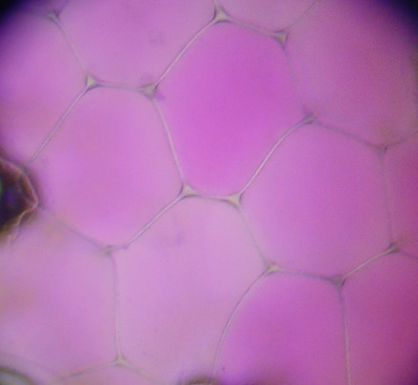 **has begun to wilt:**

[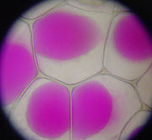](http://en.wikipedia.org/wiki/Image:Rhoeo_Discolor_-_Plasmolysis.jpg)

a. Water rushes into the plant cell’s a. Which way will the water go?

vacuole. Is this diffusion or Into the vacuole, or out of the vacuole?

osmosis? _________________________ vacuole? ______________________

b. By what process will the water move?

__________________

**18. An amoeba engulfs a particle of food.**

[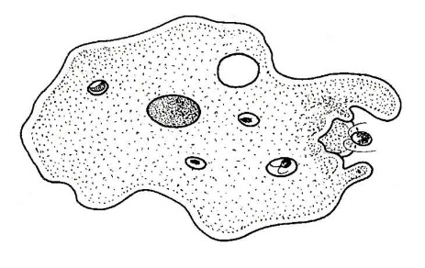](http://www.biology-resources.com/drawing-amoeba-breathing.html)

a. Does this require energy?_______________________

b. Is this active or passive transport? _________________

c. Is this endocytosis or exocytosis? _________________

**19. An amoeba expels waste.**

[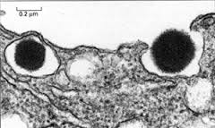](http://www.pitt.edu/~biohome/Dept/Img/graphics/diabetes2.jpg)a. Does this require energy? ____________________

b. Is this active or passive transport? ______________

c. Is this endocytosis or exocytosis? __________________

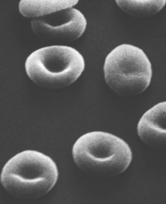**20. Red bloods cells placed in beaker of water**

a. Will water move from the red blood cells to the beaker of water, or from the beaker of water to the red blood cells? ___________________________________

b. Which has the higher concentration of water, the beaker of water

or the red blood cells?_______________

c. Does this require energy? _________________________

d. Is this diffusion or osmosis? _______________________

Identify each image as: **diffusion**, **osmosis**, **passive transport, active transport**, **exocytosis** or **endocytosis**.

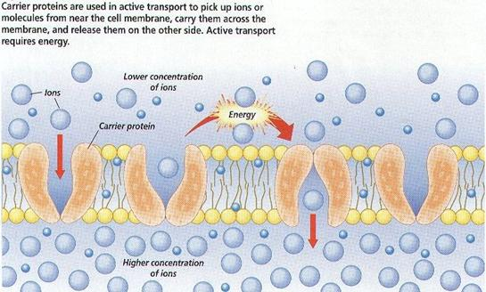

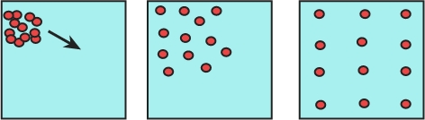

21. ________________________ 22. ________________________

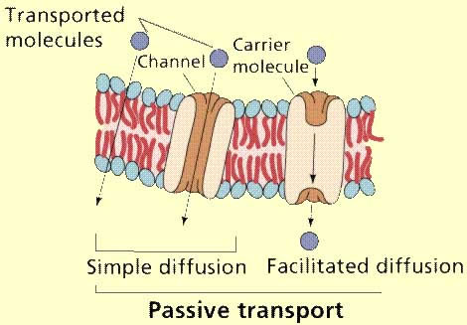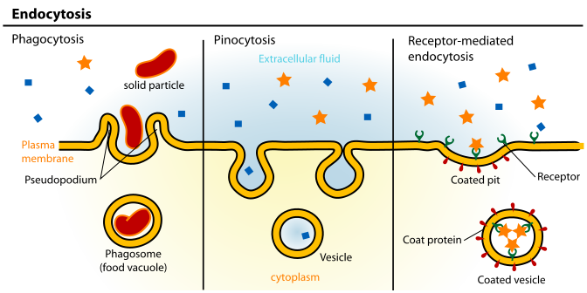

23. _________________________ 24. _____________________

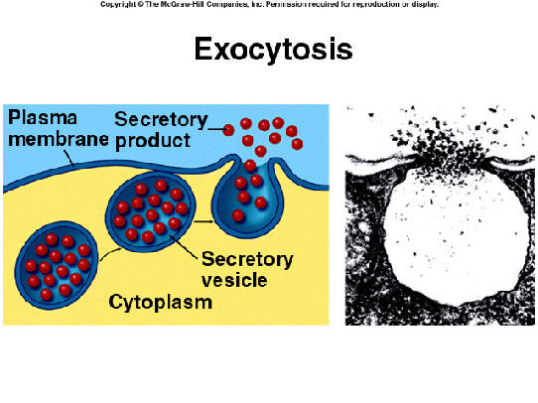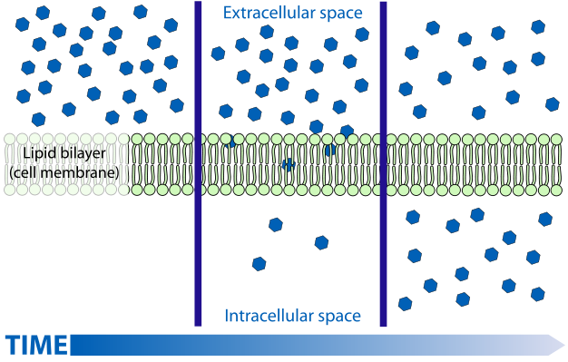

25. ______________________ 26. ____________________

27. Describe ***diffusion***:

* Moves things into/out of the cell (circle one or both!)
* Moves with/against concentration gradient (circle one)
* For large/small molecules (circle one or both!)
* Uses/does not use protein doorway (circle one)

28. Describe ***osmosis***:

* Moves things into/out of the cell (circle one or both!)
* Moves with/against concentration gradient (circle one)
* For large/small molecules (circle one or both!)
* Uses/does not use protein doorway (circle one)

29. Describe ***facilitated diffusion***:

* Moves things into/out of the cell (circle one or both!)
* Moves with/against concentration gradient (circle one)
* For large/small molecules (circle one or both!)
* Uses/does not use protein doorway (circle one)

30. Describe ***passive transport:***

* Moves things into/out of the cell (circle one or both!)
* Moves with/against concentration gradient (circle one)
* For large/small molecules (circle one or both!)
* Uses/does not use protein doorway (circle one)

31. Describe ***active transport***:

* Moves things into/out of the cell (circle one or both!)
* Moves with/against concentration gradient (circle one)
* For large/small molecules (circle one or both!)
* Uses/does not use protein doorway (circle one)

32. Describe ***endocytosis***:

* Example of active/passive (circle one)
* Moves things into/out of the cell (circle one or both!)
* For large/small molecules (circle one or both!)

33. Describe ***exocytosis***:

* Example of active/passive (circle one)
* Moves things into/out of the cell (circle one or both!)
* For large/small molecules (circle one or both!)