Names: | Date: | Period:

Cells - Gummy Bears Transport Lab

In this lab you will observe the movement of water in response to the concentration level of sugar.

PART 1 PROCEDURES

- Using a ruler measure, the length of your Gummy Bears in cm. Enter measurement into data table.
- Fill your cup to the appropriate line with water. 3cm
- Place the Gummy Bears into the cup of water and wait 10 minutes.
- Carefully remove the Gummy Bears from the cup.
- Measure the length of the Gummy Bears in cm again. Enter measurement into data table.
- Determine the change before and after placing the Gummy Bears in the water. (important to include + and – signs)
- Answer post lab questions.

Gummy Lifesaver Data Table (4 Points)
Trial # | Length (cm)  Before water | Length (cm)  After water | Change in Length | Which way did the water move?
Trial 1
Trial 2
Trial 3
Average

POST LAB QUESTIONS
- Explain the difference between active and passive transport. (2 Points)

- Is the Gummy Lifesaver lab a form active or passive transport? Justify your answer in complete sentences. (2 Points)

- Which way did the water travel, into the bear or out of the bear? (1 Point)

- Using the above information, in the beginning…. (2 Points)
Where was there a greater percentage of water? Where was there a smaller percentage of water?

Where was there a higher concentration of sugar? Where was there a smaller concentration of sugar?

- Based on the answers above, what did you notice about the relationship between the amount of water and the amount of sugar? (2 point)

- In this lab what was the solvent? _______________________ What was the solute? _____________________ (1 Point)

- Draw a picture of an animal cell placed in a hypertonic solution, hypotonic solution, and an isotonic solution. Draw arrows showing the movement of substances in or out of the cell. (6 Points)

Hypertonic Solution | Hypotonic Solution | Isotonic Solution

8. Looking at the pictures below, circle the images that demonstrates turgor pressure in green and those which
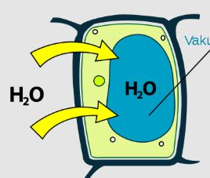
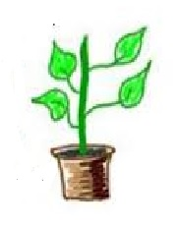
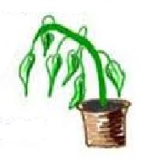
demonstrates plasmolysis in blue?
