Name: __Key_________________________ Period: __________ Date: ______________
MITOSIS STUDY GUIDE
Part A. The Cell Cycle
- What are the two main parts of the cell cycle?
__Interphase________ and ____Cell Division _______
- What are the three parts of interphase and what the cell is doing in each phase?
  - ___G1____ = __cell is growing________
  - ___S______ = __DNA is replicating______
  - ___G2______ = _cell is preparing for mitosis_________
- What are the two parts of the Cell Division Phase?
  - _Mitosis_________
  - _Cytokinesis___________
- What are the four parts of mitosis in order? Figure 1.
  - __Prophase_______
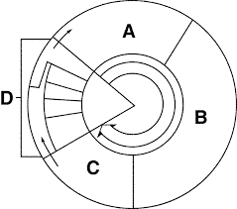
  - __Metaphase____________
  - __Anaphase___________
  - __Telophase_____________
- Label what A, B, C, and D represent in Figure 1.
  - _G1__________________
  - _S____________________
  - _G2_____________________
  - _Cell Division___________
- Using Figure 1, what are A, B, and C collectively called?
_____Interphase______________________
- Using Figure 1, what is happening in D?
__The cell is dividing and splitting into two_______
- Mitosis is the division of the cell’s __nucleus_________, while cytokinesis is the division of the cell’s ___cytoplasm________.

Part B: Mitosis
- Put the following stages of mitosis in the correct order: telophase, metaphase, prophase, anaphase
__prophase______, ___metaphase____, __anaphase____, ___telophase_______
- Label each of the following pictures as to the correct phase of mitosis:
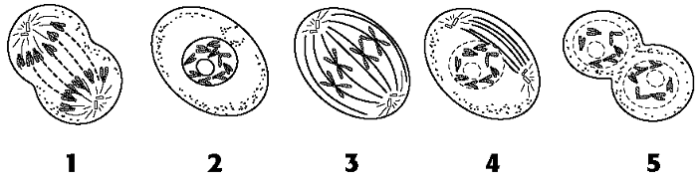
_anaphase __ _interphase _ _metaphase_ prophase__ __telophase___

- Match the following mitosis vocabulary:
  - Spindle 7 1. DNA making a copy of itself during the S-phase of interphase.
  - Chromatin 6 2. The 2 products of the process of cytokinesis.
  - Chromosomes 9 3. Body cells, such as heart, skin, brain, etc that undergo mitosis
  - DNA replication 1 4. Two chromosomes attached at the centromere
  - Diploid number 10 5. Structure joining sister chromatids until they are separated
  - Somatic cells 3 6. The form of disorganized DNA present in interphase
  - Centromere 5 7. Structure made of microtubules; pulls chromosomes apart
  - Centrioles 8 8. Attach to and anchor spindle fibers at the poles of the cell
  - Sister chromatids 4 9. Visible, separate forms of DNA present during mitosis
  - Daughter cells 2 10. (2n); having two sets of chromosomes in each cell
  - Cleavage furrow 12 11. Plate that becomes the future cell wall between plant cells
  - Cell plate 11 12. Pinching in of animal cells beginning cytokinesis

- Label the different types of DNA as they exist in interphase and mitosis and their parts: chromatin, doubled chromosome, centromere, sister chromatids, single chromosome
centromere
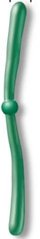
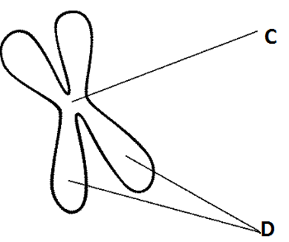
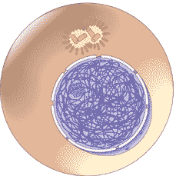

Sister chromatids

A ___chromatin____ B _doubled chromosome E ___single chromosome
- What kinds of cells do mitosis? ___somatic cells (all body cells except reproductive cells)
- Why do cells these cells do mitosis? Growth of organism (adding new cells), repairing damaged cells, replacing dead cells
- Write which phase of mitosis each of the following characteristics of cell division belong with: prophase, metaphase, anaphase or telophase.
  - Spindle fibers form _prophase_____
  - Chromosomes line up along the center (equator) of the cell _metaphase__
  - Nuclear membrane and nucleolus begin to disappear prophase_________
  - Nuclear membrane and nucleolus begin to reappear ___telophase___
  - Sister chromatids are pulled apart toward the poles ___anaphase______
  - Chromatin forms distinct doubled chromosomes ____prophase_____
  - Chromosomes that have been separated go back to chromatin __telophase_____
  - Spindle begins to break down __telophase________
  - Cell membrane begins cleavage furrow in animal cells or cell plate in plant cells ____telophase____
- Why do cells not continue to grow larger and larger? Because it becomes difficult to move substances into and out of the cell and move enough of those substances to provide for the cell; it places too much of a demand on the DNA.

17. Write whether the following statements matches with sexual reproduction (A) or asexual reproduction (B).
1. One parent B_ 5. Meiosis A__ 9. Cloning B_
2. Genetically identical offspring B_ 6. Mitosis B__ 10. Binary Fission B_
3. Sperm and egg (gametes) A_ 7. Somatic cells B_ 11. Conjugation A_
4. Two parents S_ 8. Genetically different offspring A_ 12. Genetic recombination A_

