Name: __________________________________ Period: __________ Date: ______________
MITOSIS WORKSHEET
Part A. The Cell Cycle
- What are the two main parts of the cell cycle?
____________________________ and __________________________
- What are the three parts of interphase and what the cell is doing in each phase?
  - ___________ = __________________________
  - ___________ = __________________________
  - ___________ = __________________________
- What are the two parts of the M-Phase?
  - ________________________
  - ________________________
- What are the four parts of mitosis in order? Figure 1.
  - ________________________
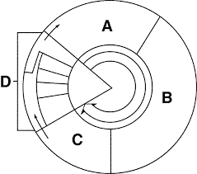
  - ________________________
  - ________________________
  - ________________________
- Label what A, B, C, and D represent in Figure 1.
  - ________________________
  - ________________________
  - ________________________
  - ________________________
- Using Figure 1, what are A, B, and C collectively called?
________________________________________
- Using Figure 1, what is happening in D?
________________________________________
- Mitosis is the division of the cell’s _____________________, while cytokinesis is the division of the cell’s __________________________.

Part B: Mitosis
- Put the following stages of mitosis in the correct order: telophase, metaphase, prophase, anaphase
____________________, __________________, __________________, ___________________
- Label each of the following pictures as to the correct phase of mitosis:
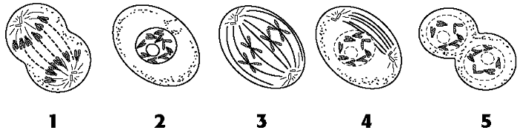
______________ ___________ __________ ____________ _______________

- Match the following mitosis vocabulary:
  - Spindle 1. DNA making a copy of itself during the S-phase of interphase.
  - Chromatin 2. The 2 products of the process of cytokinesis.
  - Chromosomes 3. Body cells, such as heart, skin, brain, etc that undergo mitosis
  - DNA replication 4. Two chromosomes attached at the centromere
  - Diploid number 5. Structure joining sister chromatids until they are separated
  - Somatic cells 6. The form of disorganized DNA present in interphase
  - Centromere 7. Structure made of microtubules; pulls chromosomes apart
  - Centrioles 8. Attach to and anchor spindle fibers at the poles of the cell
  - Sister chromatids 9. Visible, separate forms of DNA present during mitosis
  - Daughter cells 10. (2n); having two sets of chromosomes in each cell
  - Cleavage furrow 11. Plate that becomes the future cell wall between plant cells
  - Cell plate 12. Pinching in of animal cells beginning cytokinesis

- Label the different types of DNA as they exist in interphase and mitosis and their parts: chromatin, doubled chromosome, centromere, sister chromatids, single chromosome
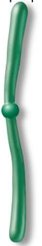
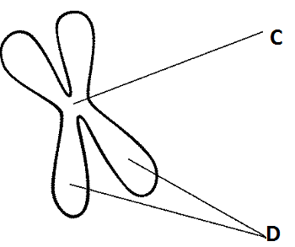
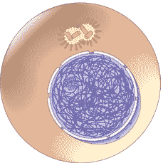

A ________________________ B ____________________________ E _______________________

- What kinds of cells do mitosis? ___________________________________
- Why do cells these cells do mitosis? ________________________________________________

- Write which phase of mitosis each of the following characteristics of cell division belong with: prophase, metaphase, anaphase or telophase.
  - Spindle fibers form ______________________
  - Chromosomes line up along the center (equator) of the cell _______________________
  - Nuclear membrane and nucleolus begin to disappear _______________________
  - Nuclear membrane and nucleolus begin to reappear _______________________
  - Sister chromatids are pulled apart toward the poles _______________________
  - Chromatin forms distinct doubled chromosomes ________________________
  - Chromosomes that have been separated go back to chromatin ____________________
  - Spindle begins to break down ________________________
  - Cell membrane begins cleavage furrow in animal cells or cell plate in plant cells __________________________
- Why do cells not continue to grow larger and larger? ____________________________________________
________________________________________________________________________________________

17. Write whether the following statements matches with sexual reproduction (A) or asexual reproduction (B).
1. One parent ___ 5. Meiosis ____ 9. Cloning ___
2. Genetically identical offspring ___ 6. Mitosis ____ 10. Binary Fission ___
3. Sperm and egg (gametes) ___ 7. Somatic cells ___ 11. Conjugation ___
4. Two parents ___ 8. Genetically different offspring ___ 12. Genetic recombination ___

