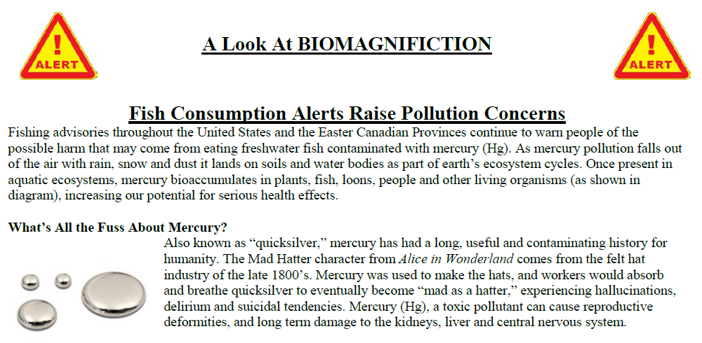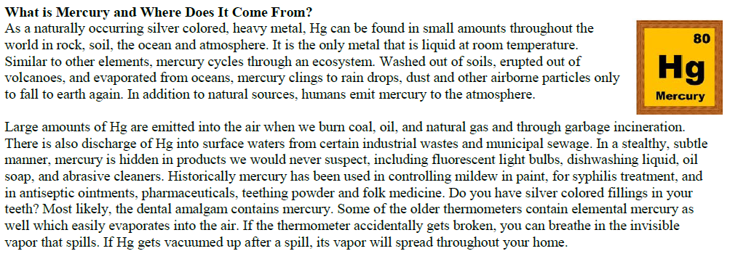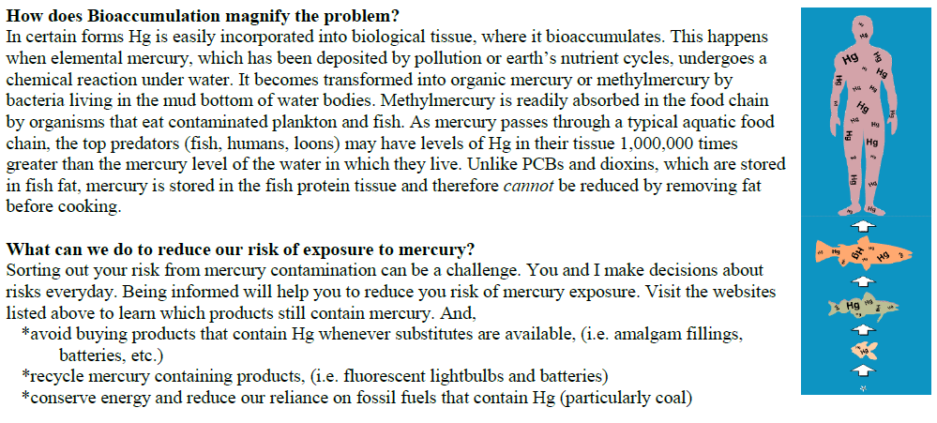
Questions:
1. How does bioaccumulation cause biomagnification?

2. Why should we be concerned with mercury biomagnifying through the food chain?

3. Identify 3 sources of mercury in the environment.

4. Indicate which trophic levels will have the lowest and highest concentration of a toxin like DDT, Dioxins, or Mercury.
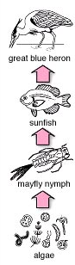

5. Writing Prompt: Using what you’ve learned about mercury and biomagnification, explain why pregnant women are advised to eat very little, if any, tuna while pregnant. (This should be 1 paragraph in which you explain why biomagfication occurs and why a pregnant woman would want to avoid mercury contamination.)

