Biology Unit 1 Notes Name: _______________________

**Characteristics of Living Things Notes**

**Living things are made up of units called cells.**

**Living things grow and develop.**

**Living things reproduce.**

**Living things maintain a stable internal environment.**

**Living things are based on a universal genetic code and macromolecules.**

**Taken as a group, living things change over time.**

**Living things obtain and use materials and energy.**

**Living things respond to their environment.**

NAME THE CHARACTERISTIC

READ EACH DESCRIPTION, AND USE YOUR CLASS NOTES TO DECIDE WHICH CHARACTERISTIC OF LIVING THINGS BEST MATCHES WITH THE DESCRIPTION. SOME DESCRIPTIONS MAY RELATE TO MORE THAN ONE CHARACTERISTIC.

1. PLANTS GOING THROUGH PHOTOSYNTHESIS:_______________________
2. DOING 50 JUMPING JACKS:_______________________
3. A POPULATION OF BIRDS WITH POINTY BEAKS ARE THE DOMINANT SPECIES IN GEORGIA:___________________
4. AVERAGE BODY TEMPERATURE IS 37 DEGREES CELCIUS:______________________
5. MY DOG HAD 5 PUPPIES:____________________
6. SQUINTING WHEN IT’S TOO SUNNY OUTSIDE:_____________________
7. BACTERIA, ANIMALS, PLANTS, AND FUNGI:_________________________
8. DRINKING WATER WHEN WE BECOME THIRSTY:_________________________
9. CACTI PLANTS ARE SEEN HAVING A THICKER THAN NORMAL OUTER COATING ____________________________
10. EATING BREAKFAST, LUNCH, AND DINNER:_________________________
11. MY EARS HAVE DOUBLED IN SIZE:__________________________
12. BECOMING SCARED WHEN HEARING THUNDER:__________________________
13. I HAVE TWO OTHER BROTHERS:__________________________
14. BREATHING HEAVILY WHILE EXERCISING:______________________________
15. PLANTS BENDING TOWARD THE LIGHT:______________________________
16. A HEALING CUT:____________________________

***Now that you understand the characteristics of living things, how would you explain to someone else why a tree satisfies all the characteristics of living things?***

**Virus Notes Virus: Latin for “poison”**

Viruses can affect ___ living things.

Examples of things caused by viruses: _____________________

Are all viruses bad? No Ex. Tulip Mosaic Virus produces variegated tulips.

**History:**

* 1872 – Mayer and Koch found that a filterable agent caused disease in tobacco.
  + Passed through filters that would trap bacteria.
  + Could not be grown in a laboratory.
  + Invisible even with the aid of a microscope.
* 1935 The first virus was isolated from diseased tobacco plants - The Tobacco Mosaic Virus

**Are they living or not?**

Living?

* They REPRODUCE at a fantastic rate, but only in __________ cells.
* They can mutate.

Non-Living?

* They are ACELLULAR, that is, they contain no cytoplasm or cellular organelles.
* They carry out no metabolism on their own and must replicate using the host cell's metabolic machinery.
* They possess ________or________ but never both.

They are ____________________________________________ by many scientists.

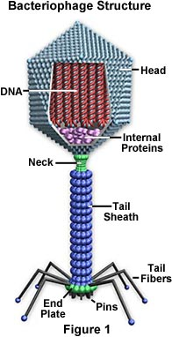**A Look at Viruses**

**Virus Structure:**

* Inside: __________or__________
* Outside: _______________________________
* Shape of Protein Coat
  + Spherical
  + Rod like
  + Cubical
  + Polyhedron
* May have an outside membrane

**Virus Size:**

* too small to be seen with a light microscope
* must use an electron microscope
* much smaller than _____________
* Ex. Parvovirus 10 nm Poxvirus 250 nm

**Virus Activities:**

* Viruses do not carry out respiration or other ____________ activities.
* Viruses can only reproduce when inside a host cell (*parasitic*).

**Virus Cycles (Lytic and Lysogenic):**

**Virus Motto: _____________ - _____________ - _______________**

**Lytic cycle** - virus takes over all metabolic activities of host, makes copies of itself & destroys host cell

**Steps to the Lytic Cycle**

1. Attachment _________________
2. Entry __________________
3. _________________
4. Assembly of new viruses
5. _____________: cell breaks open and releases new viruses into the organism or environment

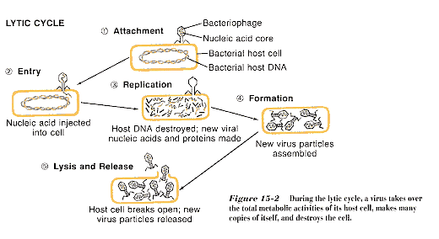

**Lysogenic cycle** - viral DNA becomes integrated with host DNA; **provirus**

**Steps to the Lysogenic Cycle:**

1. Attachment
2. Entry
3. Integration into the host cell’s DNA (prophage or provirus)
4. Replication of cells (including virus DNA)
5. Trigger to enter the __________________________
6. Replication of Virus
7. ____________________________
8. Lysis

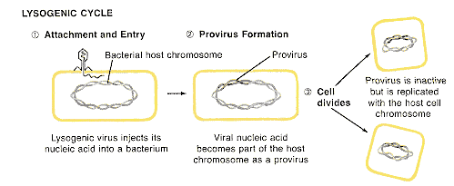

**RNA Viruses (________________________) ex. _________________**

* virus with RNA that can invade a cell with DNA
* RNA undergoes **reverse transcription** to produce _______________DNA & become a **provirus** inside the host's nucleus
* 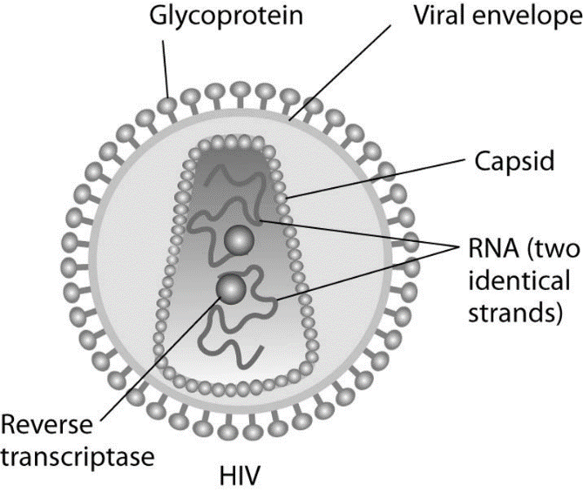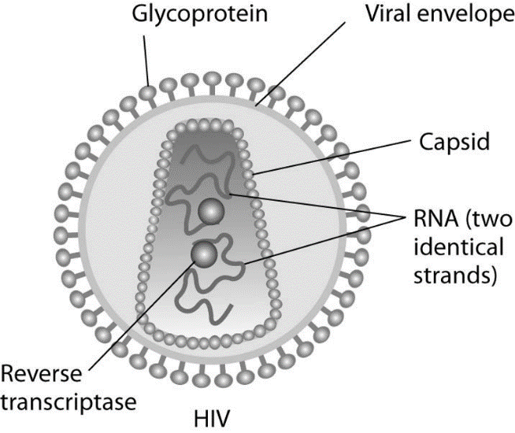These viruses have a HIGH MUTATION RATE
* There is no good PROOFREADING mechanism like there is when going from DNA to RNA
* These means there are many different STRAINS of RNA viruses and Retroviruses
* Makes VACCINES very difficult to develop

**Virus Review Questions**

1. A virus is composed of two parts, what are they?
2. List some types of viruses mentioned in these notes.
3. Can viruses reproduce on their own?
4. What are the two cycles of reproduction for a virus?
5. Why is the lytic cycle so harmful to a cell?
6. What are the characteristics of living things?
7. According to the characteristics, are viruses considered to be living? Why or why not.
8. Can a virus be cured with antibiotics?
9. What is used to protect against contraction of a virus?

1. Do viruses evolve? How do you know?

**Compare and Contrast the Lytic and Lysogenic Cycles**

**Classification of Living Things Notes**

Classify –

Why do we classify?

How do we classify?

**Little Known Facts**

* There are over _____________________________; and more are discovered each year.
* What do we classify? Somewhere between 2 and 100 million have yet to be discovered.
* **Classification serves as an organization system for all the existing and new organisms**
* The Science of Classification is called **__________________.**

**Early Classification System**

* 2 Groups: ___________ - _________________________________________

____________ - _________________________________________

Give an example of an organism that could not be classified by this system?

_____________________________ Why?

**Tools Used to Classify Organisms Today**

1. Comparative Anatomy - Compare physical structures (Traits)

2. Biochemistry – Analyze DNA and ___________

3. Embryology – Look closely at developing embryos of different species

4. Molecular Basis – Compare cellular ____________________

5. Phylogeny – Look at related organisms with _________________ ________________,

Look for derived characters

**Linneaus System of Taxonomic Classification (Still used today!)**

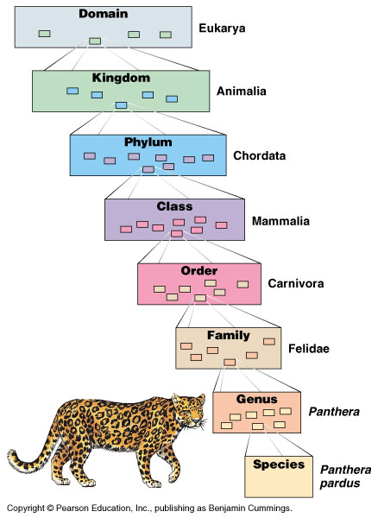**Our mnemonic device to help us remember:**

**________________ (Largest/Most Inclusive)**

**________________**

**________________**

**________________**

**________________**

**________________**

**________________**

**________________ (Smallest/Least Inclusive)**

Each step in this taxonomic system is called a ____________________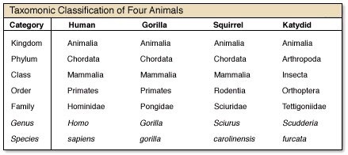

Which two animals are the most closely related?

At which Taxon do they show differences?

**Scientific Naming :______________________________________(2 Part Naming System)**

* + Uses **___________________** and **___________________**
* Genus is capitalized, not species, all *italicized* (In writing the name, can’t italicize, so underline)
  + *Homo sapiens* (*Genus* and *species* of Human)
  + *Panthera leo (Genus* and *species* of Lion*)*
* Used Latin –
  + - * + ***Felis concolor* or Felis concolor**

1. Using the chart above, what is the scientific name for humans?
2. Using the chart above, what is the scientific name for a squirrel?
3. Using the chart above, what is the scientific name for a gorilla?
4. Using the chart above, what is the scientific name for katydid?

**Dichotomous Key – What is it and how do you use it?**

A dichotomous key is a tool that allows the user to determine the identity of items in the natural world based on the items __________________________.

"Dichotomous" means “divided into ________ parts” Greek origin

Dichotomous keys always give two distinct choices in each step, often they are opposites

Ex) Black/white or antennae present/antennae not present

**How to Use a Dichotomous Key**

When you have determined which organism you are going to identify begin with statement one and determine which choice fits your organism. (Let’s use our example organism)



Since our organism has one eye we need to go to step 5

(so we can skip 2, 3, & 4)



Since our organism has one or more antennae we go to step 6. We continue this until we get a name.

This process must repeated starting at step #1 for each organism we need to identify.

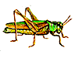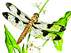 **Practice:**

**___________ ___________ ____________ _____________**

1. a. wings covered by an exoskeleton – go to step 2

b. wings freely observed – Go to step 3

2. a. body has a round shape ……….ladybug

b. body has an elongated shape ……….grasshopper

3. a. wings point out from the side of the body ……dragonfly

b. wings point to the posterior of the body ……….housefly

**Cladograms (Phylogenetic Trees)**

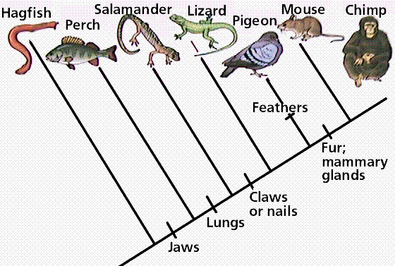

Cladograms are used to show relationships between organisms. They may or may not show derived characteristics.

Although the terms above are used interchangeably cladograms show relationships between organisms and phylogenetic trees are said to show evolutionary change based on the length of their branches.

You just need to know how to read these tools.

Answer these questions:

1. What was the first organism to have lungs? ________________________________
2. How many organisms have fur? _____________________________
3. Which organism contains none of these derived characteristics? ____________________

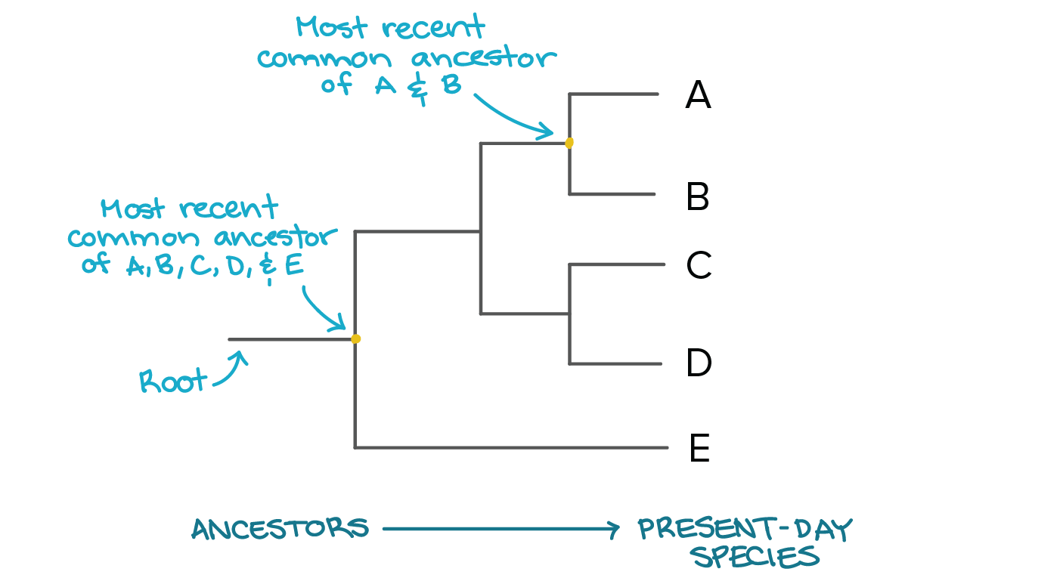

**Here is a different example of a phylogenetic tree.**

On this tree put a star to demonstrate the most recent ancestor of C and D.

Which organism is the least closely related to A?

What can you say about A and B in comparison to C and D?