Name: __KEY_______________________________ Period: ________ Date: ____________________
BIOLOGY SPRING FINAL EXAM STUDY GUIDE
1. What are the 3 main differences between DNA and RNA?
 | DNA | RNA
Number of Strands | 2 | 1
Nitrogen Bases | Adenine, Thymine, Guanine, Cytosine | Adenine, Uracil, Guanine, Cytosine
Sugar Present in nucleotide | Deoxyribose | Ribose

2. Use the following words to label 1-8 in the DNA structure below: double helix, hydrogen bonds, sugar-phosphate backbone (use twice), base pairs (use twice), deoxyribose sugar, phosphate, and nucleotide. When you have finished labeling 1-8, fill in the complementary bases.
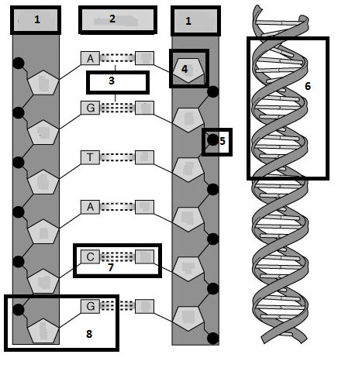
Double Helix
Nucleotide
Nitrogen Bases Guanine pairs with Cytosine
Phosphate
Deoxy- ribose
Hydrogen bonds
Base Pairs
Sugar Phosphate Backbone
a. What are the 3 parts to a nucleotide? Sugar, phosphate, nitrogen base
b. What are the 4 nitrogenous bases? In DNA, the four nitrogen bases are A, T, G, C
c. How do the bases pair? A—T C--G
d. What type of bond holds the bases together? Hydrogen
e. What makes up the sides of the DNA ladder? Sugar and phosphate
f. What makes up the steps of the DNA ladder? Nitrogen base pairs
g. What is the shape that Watson and Crick called DNA? Double helix

3. Using the ½ strand of DNA below, create the other ½ strand by matching the complementary bases. These are considered the parent strands. Highlight them in yellow. Now separate the parent strands and write in the new strands on both sides. Highlight the new strands in pink. These are called the daughter strands.
Parent: A T G C C C A T T T T A C C G Parent: A T G C C C A T T T T A C C G
Parent: T A C G G G T A A A A T G G C Daughter: T A C G G G T A A A A T G G C
Daughter: A T G C C C A T T T T A C C G
Parent: T A C G G G T A A A A T G G C
4. For the characteristics below, mark (A) for DNA only, (B) for RNA only, or (C) for both DNA and RNA.
___A__ a. Deoxyribose sugar __C___ j. Genetic Information
___C__ b. Phosphate groups __C___ k. Is a nucleic acid
___B__ c. 3 types __A___ l. Double stranded
___C__ d. Nitrogen bases (G, A, and C) __B___ m. Single stranded
___C__ e. Nucleotide is the monomer __A___ n. Function is contains instructions for making proteins
___A__ f. Double helix __B___ o. Function is to copy the instructions and make proteins
___A__ g. 1 type __A___ p. Located in the nucleus only
___B__ h. Nitrogen base (U) __B___ q. Located in nucleus, cytoplasm or ribosomes
___A__ i. Nitrogen base (T) __B___ r. Ribose sugar
5. What are the two stages in protein synthesis? Transcription and Translation.
6. What happens in transcription? DNA mRNA
7. Where in the cell does transcription take place? nucleus
8. Where does translation occur? ribosomes
9. What happens in translation? mRNA protein
10. What is the end goal of translation? To make a protein.
11. Using the diagram below, answer the following questions.
a. Label the following parts to the diagram.
1. mRNA
2. Ribosome
3. Amino Acid
4. Protein/Polypeptide chain
5. tRNA

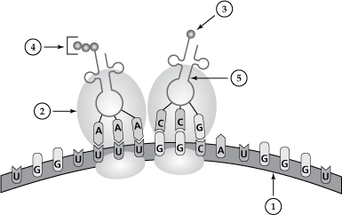
12. What process is shown by the diagram above? Translation
13. What types of chromosome mutations are shown below?
Deletion
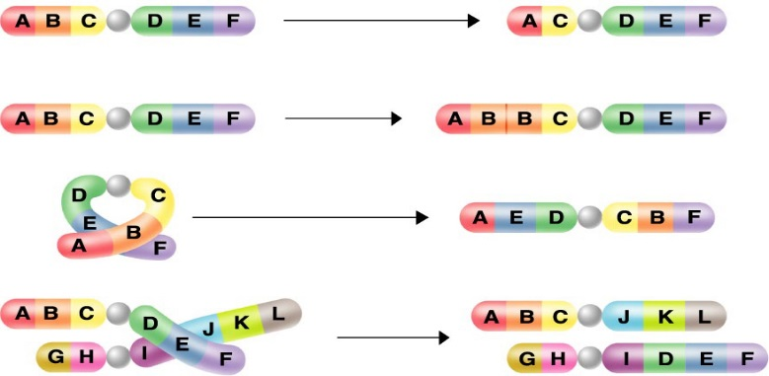
Translocation
Inversion
Duplication
14. Which male is the father of the child? Male 1
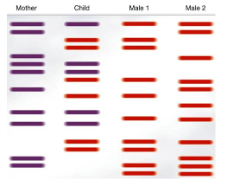
15. What type of genetic technology is shown by the diagram above? Gel electrophoresis
16. For the examples below, tell whether the type of inheritance is complete dominance, incomplete dominance or codominance.
a. In kittens, long whiskers (L) are dominant over short (l) . Complete
b. In ladybugs, color can be red (RR), yellow (rr) or orange (Rr). Incomplete
c. In humans, hair can be either straight (SS), curly (ss) or wavy (Ss). Incomplete
d. In a certain species of cow, fur color can either be black (BB), white (WW) or black and white spotted (BW). Codominance
e. In a certain species of bird, feathers can either be blue (BB), green (GG) or blue with green tips (BG). Codominance
17. Mrs. Clink has type A blood and Mr. Clink has type O blood. They have four children: Mo, Larry, Curly and Joe. Larry is blood type O. Curly is blood type A. Joe is blood type AB. Based on this information:
a. Mr. Clink must have the genotype OO.
b. Mrs. Clink must have the genotype AO.
c. Larry must have the genotype OO and Curly must have the blood type AO.
d. Joe cannot be the Clinks’ child because neither parent has a “B” allele.
18. Use the following pedigree to answer the questions below.
a. What do the circles represent? females
b. What do the squares represent? males
c. What do the shaded shapes represent? Affected by the trait/disease
d. How many generations are represented? Number them. 4. They are numbered with Roman numerals.
e. How many individuals are in each generation? Number them. They are numbered across the generations.
f. If this pedigree is for the sex-linked recessive trait of hemophilia, give the genotypes of each individual. They are listed in the boxes underneath.
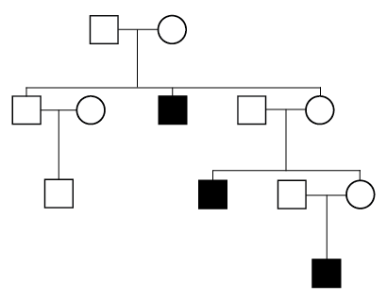
4. X^{H} X^{h}
1. X^{h} Y
2. X^{h} Y
3. X^{h} Y
5. X^{H} X^{h}
2. X^{H} X_
2. X^{H} X^{h}
3. X^{H} Y
1. X^{H} Y
4. X^{H} Y
1. X^{H} Y
1. X^{H} Y
IV.
III.
II.
I.
19. What are the four principles of natural selection?
a. Organisms over produce offspring.
b. Variations exist in the population.
c. There is a struggle for existence/competition.
d. Survival of the fittest—organisms that are the most fit or the best match to their environment survive and reproduce.
20. Describe why evolution cannot take place in one individual. Changes in an organism do not happen over one’s lifetime because the organisms’ traits are determined by its DNA, which does not change. They take place in a population as a group over time.
21. Classify each of the following adaptations as structural, behavioral or physiological.
a. Thick fur coating in polar bears Structural
b. Lizards moving onto a rock in the sun when they are cold Behavioral
c. When the elephant is overheated, blood vessels in the ear dilate so heat can be released Physiological
d. Animals moving around in herds for protection Behavioral
e. Hooked beak for meat-eating birds, useful for tearing flesh. Structural
f. Poison venom of a snake Physiological
22. Match the following terms with the correct definition.
__D__ 1. evolution a. the formation of a new species
__A__ 2. speciation b. a physical structure or part of an organism’s anatomy that helps it survive
__F__ 3. gene pool c. a behavior that an organism does that helps it survive
__B__ 4. structural adaptation d. the process by which living things change over time
__C__ 5. behavioral adaptation e. a response of internal body chemistry that helps an organism survive
__E__ 6. physiological adaptation f. the combined genetic information of all members of a population
23. Identify the following scenarios as directional selection, disruptive selection, or stabilizing selection.
- 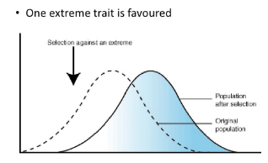 Directional
- 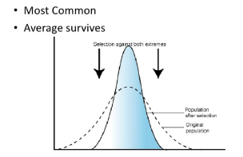 Stabilizing
- 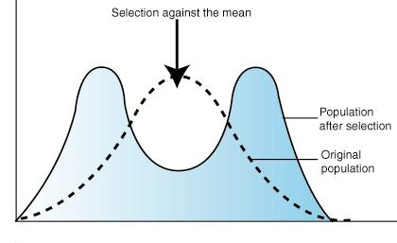 Disruptive

24. Identify the following examples as convergent or divergent evolution.
a. Grizzly bears and polar bears are very similar, genetically speaking. They share a common ancestor, but have evolved different characteristics as adaptations in their different habitats. Divergent
b. Dolphins, whales, and sharks all have similar body shapes and characteristics, adapted for life in an aquatic environment. However, dolphins and whales are mammals, and sharks are fish. No common ancestor, so Convergent
c. Associated with homologous structures. Divergent
d. Associated with analogous structures. Convergent
25. Which picture is of homologous structures and which picture is of analogous structures?
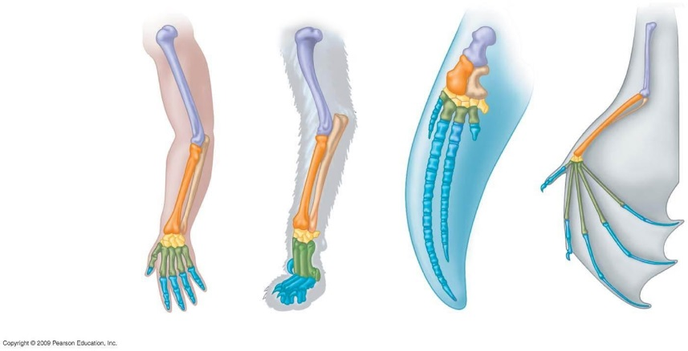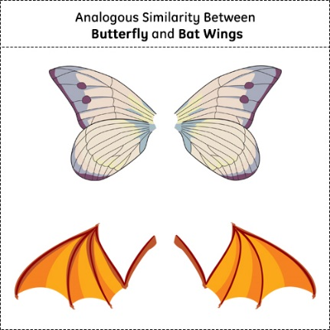
Homologous Structures Analogous Structures
26. What are two causes of genetic variation in a population? Mutations and Crossing over
27. Classify the following factors below as either biotic (B) or abiotic (A).
__B___ a. tree ___A__ c. soil __A___ e. water ___A___ g. sunlight
__B___ b. squirrel ___B__ d. deer __A___ f. rocks ___B___ h. mushroom
28. Match the following terms with the correct definition.
__B___ a. mutualism a. one benefits, one is harmed; give an example: tick and a dog
__C___ b. commensalism b. both benefit; give an example: bee and a flower
__A___ c. parasitism c. one benefits, one is unaffected; give an example: barnacle and a whale
29. The place where an organism lives is called the habitat and its job or role in the ecosystem is its niche.
30. Two factors that will cause a population to increase are: immigration and births
31. Two factors that will cause a population to decrease are: emigration and deaths
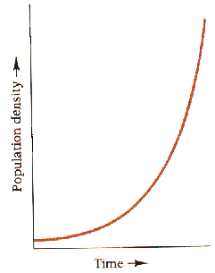
32. The J-curve is associated with exponential growth. Draw a J curve below.

33. The S-curve is associated with logistic growth. Draw an S curve below. Label the carrying capacity. Write out to the side what the carrying capacity means.
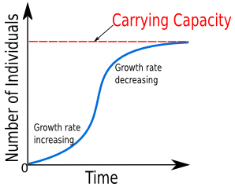

34. What are the two types of limiting factors that go with the S curve? Density Dependent Limiting Factors and Density
35. Which factor is associated with biotic factors that limit populations such as competition, disease or predation? Density Dependent
36. Which factor is associated with abiotic factors that limit populations such as fire, flood, or extreme temperatures? Density Independent
37. Put the following levels of organization for living things in order from smallest to largest: individual, biosphere, community, population, ecosystem, biome.
Biosphere
Biome
Ecosystem
Community
Population
Individual
38. List the 8 characteristics of living things in the spaces below. Is movement one of those characteristics?
a. Composed of cells d. Maintains Homeostasis f. Grow and Develop
b. Reproduce e. Responds to Stimuli g. Taken as a group, they change over time
c. Obtain and use energy f. Contains a universal genetic code/DNA
39. For each of the statements below, write (P) for primary succession or (S) for secondary succession or (B) for both.
  - Begins with bare rock __P___
  - Begins with soil __S___
  - Pioneer species are lichen __P___
  - Pioneer species are grasses/weeds __S___
  - Begins after a volcanic eruption __P___
  - Begins after a clear-cutting, fire, flood __S___
  - Results in a climax community _BOTH_
40. In the space below, create a food chain using the following organisms: grasshopper, grass, hawk, frog, snake. Label each of the following terms in your food chain: producer, herbivore, carnivore, 1st level consumer, 2nd level consumer, 3rd level consumer, 4th level consumer Grass Grasshopper Frog Snake Hawk
Producer 1st consumer/Herbivore 2nd consumer/Carnivore 3rd/Carnivore 4th Carnivore
41. Use the food chain you created above and fill in the pyramid below. If the producer level has 100% of the energy from the sun, write in the amount of energy that is passed up to all of the other trophic levels on the lines next to the pyramid.
a. Which level has the most energy? Grass
b. Which level has the least energy? Hawk
c. How much energy is passed from level to level? 10%
d. What happens to the other 90% of energy? It is lost as heat
Hawk
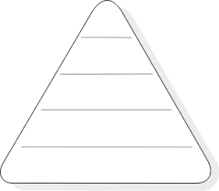
__0.01%__
Snake
___0.1%_
Frog
___1%__
___10%__
Grasshopper
___100%__
Grass

